KENYA ELECTRCITY SYSTEM IMPROVEMENT PROJECT
(KESIP)

VULNERABLE & MARGINALIZED GROUPS FRAMEWORK (VMGF)

April 2019

DISCLAIMER

This Vulnerable and Marginalized Group Framework (VMGF) was prepared by the Government of Kenya (GoK) through Kenya Power and Lighting Company (KPLC) as an account of work co-sponsored by the World Bank towards the implementation of the Kenya Electricity System Improvement Project (KESIP). Neither the WB nor GoK, nor any agency thereof, nor any of their employees, any of their contractors, subcontractors or their employees, makes any warranty, express or implied, or assumes any legal liability or responsibility for the accuracy, completeness, or any third party's use of the results or such use of any information, apparatus, product, or process disclosed, or represents that its use would not infringe privately owned rights. Reference herein to any specific product or otherwise, process, or service by providers, or otherwise, does not necessarily constitute or imply its endorsement, recommendation, or favoring by the WB or GoK or any agency thereof or its contractors or subcontractors or other service providers. The views and opinions of authors expressed herein do not necessarily state or reflect those of the WB or GoK thereof.

TABLE OF Contents
DISCLAIMER i
BASIC INFORMATION vii
EXECUTIVE SUMMARY viii
CHAPTER ONE: DESCRIPTION AND SCOPE OF THE PROJECT 1
1.1 Background Information 1
1.2 Kenya Electricity System Improvement Project (KESIP) 1
1.3 KESIP Objectives 2
1.4 KESIP Geographic Scope 2
1.5 Project Components 3
1.6 Project Beneficiaries 4
1.7 Project Implementation, Supervision and Management for KESIP 5
1.8 Monitoring and evaluation of Project Implementation 7
1.9 Project Development Impacts 8
CHAPTER TWO: METHODOLOGY FOR THE PREPARATION OF VMGF 9
2.1 Detailed and in-depth Literature review 9
2.2 Consultations with IPs/VMGs 9
2.3 Preparation of VMGP 10
Chapter THREE: Overview of the IPs/VMGs in Kenya 13
3.1 IPs/VMGs in Kenya 13
3.2 Brief highlight of IPs/VMGs in Kenya 13
3.3 Location of IPs/VMGs in Kenya 14
3.4 Electricity access by the IPs/VMGs in Kenya 15
Chapter fOUR: Relevant legal framework and regulations 16
4.1 Constitution of Kenya (CoK), 2010 16
4.1.1 Constitutional Implementation 17
4.2 Definition and treatment of the IPs/VMGs by World Bank’s Policy 18
4.3 Treatment of IP/VMG in Kenyan Legal and Policy Frameworks 18
4.4 Other Legal and Policy Provisions that Facilitate Operationalization of OP 4.10 19
4.5 Similarities and Differences between the CoK and OP 4.10 20
Chapter FIVE: KEY ISSUES AND potential impacts OF THE PROJECT ON IPs/VMGs 22
5.1 Potential positive benefits from KESIP 22
5.2 Potential Negative Impacts 24
5.3 Proposed Mitigation Measures 25
5.4 Plan for Carrying out a Social Assessment (SA) for Subprojects 27
5.5 Organization and Responsibility 28
VMGF implementation Organizations and Institutions 28
Chapter SIX: framework for ensuring free, prior and informed consultationS WITH IPs/VMGS 29
6.1 The Elements of Free, Prior and Informed Consultation 29
6.2 Consultations during Subproject Investment Screening 29
6.3 Preparation of Social Screening Form 30
6.4 Consultations during Social Assessment of Subprojects 31
6.4.1 Who conducts the SA? 31
6.4.2 Methodology for SA 32
6.4.3 Survey/Data Gathering Methods 32
6.5 Consultations during VMGP Preparation 33
6.5.1 Steering Committee for subprojects 33
6.5.2 Role of Subproject Steering Committee 33
6.6 Stakeholder Identification and Consultation 34
6.6.1 Stakeholder Consultation 34
6.7 Impact Identification 35
6.7.1 Determination of Mitigation Measures 35
6.7.2 Development of strategies for participation of IPs/VMGs 35
6.7.3 Strategies for inclusion of women and youth 35
6.8 Capacity Building 36
6.9 Establish Representation of IPs/VMGs in Relevant Organs within KESIP 37
6.10 Bank Decision on Subproject Investments 37
CHAPTER SEVEN: STRATEGY FOR PARTICIPATION AND CONSULTATION WITH IPs/VMGs 38
CHAPTER EIGHT: GRIEVANCE REDRESS MECHANISM 41
8.1 Overview 41
8.2 Grievance Redress Mechanism 42
8.2.1 Establishment of GRM 42
8.2.2 Further Redress - Kenya Courts of Law 43
8.2.3 Complaints’ Pattern 43
8.2.4 Grievance Log 44
8.3 World Bank Redress Service 45
CHAPTER NINE: Monitoring and reporting arrangements 47
9.1 Monitoring and Reporting Mechanisms 47
9.2 Participatory Impact Monitoring 48
CHAPTER TEN: DISCLOSURE ARRANGEMENTS FOR VMGPS 50
10.1 Communication Framework 50
10.2 Disclosure 50
10.3 Roles and Responsibilities 51
10.3.1 KPLC KESIP PIU 51
10.3.2 Non-Governmental Organizations 51
10.3.3 World Bank 51
CHAPTER ELEVEN: VMGf IMPLEMENTATION BUDGET 52
ANNEXES 53
ANNEX 1: VMG IN KENYA AS PER CONSTITUTION OF KENYA AND WORLD BANK CLASSIFICATION 53
ANNEX 2: SOCIAL SCREENING FORM 61
ANNEX 3: CONTENTS OF VULNERABLE AND MARGINALIZED GROUPS FRAMEWORK 63
ANNEX 4: THREE POINT RANK ORDER SYSTEM FOR VMGPS (SAMPLE) 64
ANNEX 5: SAMPLE TERMS OF REFERENCE FOR DEVELOPING A IP/VMGP 67
ANNEX 6: CONTENTS OF VULNERABLE AND MARGINALIZED GROUPS PLAN (IP/VMGP) 71
Annex 7: Minutes of Stakeholder Consultation Meeting and List of Attendance 74
REFERENCES 92

List of Tables
Table 1: Roles and responsibilities of PIU 5
Table 2: Concerns raised during the consultations 9
Table 3: Vulnerable and Marginalized Groups Framework 11
Table 4: Classification of IPs in Kenya by the WB 13
Table 5: Similarities between the Kenyan Constitution and OP 4.10 20
Table 6: Potential Adverse Project Impacts and Mitigation Measures 26
Table 7: Indicative IPs/VMGs Consultation Matrix 39
Table 8: Monitoring and Evaluation Indicators for KESIP VMGF 48
Table 9: Indicative Budget 52

List of Figures
Figure 1: Map showing the marginalized counties in Kenya (in red) 15

ABBREVIATIONS AND ACRONYMS

ACHPR African Commission on Human and Peoples’ Rights
ASALs Arid and Semi-Arid Lands
BP Bank Policy
CBO Community Based Organization
CoC Code of Conduct
CoK Constitution of Kenya
CPS Country Partnership Strategy
CRA Commission on Revenue Allocation
CSO Civil society organizations
DP Development Partner
DP Development Partner
EA Executing Agency
EIA Environmental Impact Assessment
EMP Environmental Management Plan
ERC Energy Regulatory Commission
ESIA Environmental and Social Impact Assessment
ESMF Environmental and Social Management Framework
ESMP Environmental and Social Management Plan
ESS Environmental and Social Specialists
EWC Endorois Welfare Council
FGD Focus Group Discussion
FPIC Free, Prior and Informed Consultation
GDP Gross Domestic Product
GoK Government of Kenya
GPOBA Global Partnership on Output Based Allocation
GRM Grievance Redress Mechanism
IA Implementing Agency
ICT Information and Communication Technologies
IDA International Development Association
IE Impact Evaluation
IFC International Finance Corporation
IPP Independent Power Producers
IPPF Indigenous Peoples Planning Framework
IPs Indigenous Peoples
IVA Independent Verification Agent
KEEP Kenya Electricity Expansion Project
KenGen Kenya Electricity Generating Company
KESIP Kenya Electricity System Improvement Project
KETRACO Kenya Electricity Transmission Company
KFS Kenya Forest Service
KNES Kenya National Electrification Strategy
K-OSAP Kenya Off-grid Solar Access Project
KPLC Kenya Power and Lighting Company
Ksh Kenyan Shilling
KURA Kenya Urban Roads Authority
KWS Kenya Wildlife Service
LCPDP Least Cost Power Developing Plan
LCPDP Least Cost Power Development Planning
M&E Monitoring and Evaluation
MoE Ministry of Energy
MPIDO Mainyoito Pastoralist Integrated Development Organization
MV Medium Voltage
NDMA National Disaster Management Authority
NEMA National Environment Management Authority
NES National Electrification Strategy (NES)
NGO Non-Governmental Organization
NLC National Land Commission
NLP National Land Policy
NMK National Museums of Kenya
O&M Operation and Maintenance
OP Operational Policy
PAD Project Appraisal Document
PAP Project Affected Persons
PDNK Pastoralist Development Network Kenya
PDO Project Development Objective
PIM Participatory Impact Monitoring
PIU Project Implementation Unit
PLO Project Liaison Officer
PPP Public Private Partnership
PRA Participatory Rural Appraisal
RAP Resettlement Action Plan
REA Rural Electrification Authority
RPF Resettlement Policy Framework
RRA Rapid Rural Appraisal
SA Social Assessment
SSA Sub-Saharan Africa
TORs Terms of Reference
UN United Nations
UNDRP Declaration on the Rights of Indigenous Peoples
US$ United States Dollars
VMG Vulnerable and Marginalized Groups
VMGF Vulnerable and Marginalized Groups Framework
VMGO Vulnerable and Marginalized Groups Organization
VMGP Vulnerable and Marginalized Groups Plan
WB World Bank
WBG World Bank Group

BASIC INFORMATION

- Country and Project Name: KENYA ELECTRICITY SYSTEM IMPROVEMENT PROJECT (KESIP)

- Project Development Objectives: to increase the capacity, efficiency and reliability of the electricity distribution system in Kenya.
- Expected Project Benefits: Beneficiaries will be households and business that will be connected to the electricity network for the first time. A second group of beneficiaries will be existing electricity consumers for whom the quality and reliability of electricity service will improve. Improved reliability of electricity service is especially important for existing business customers since they will experience less service interruptions and consequently their financial losses will reduce. Kenya Power Electricity & Lighting Company Ltd (KPLC) will be a beneficiary through the system loss reduction component

- Identified Project Social Risks: The project will experience social risks under the distribution component. The majority of low and medium voltage lines will mainly be constructed along the road reserve and existing rights of ways. These may not result in physical relocation but impacts to trees and crops are likely to occur. Anticipated impacts will include loss of property, restrictions to extent of use of land, loss of crops and or/trees which could be damaged during construction, among others. Acquisition of land for substations will be on a willing buyer willing seller basis.
Recipient: Government of Kenya – Ministry of Energy

Responsible Government/Country Agency for VMGF Implementation: Kenya Power and Lighting Company Limited (KPLC).
Total Project Cost (USD million): Approx. USD$ 235,000,000.00 (for KPLC implemented components)

Name/Contacts who prepared VMGF: Samuel Abaya; Kenya Power Electricity & Lighting Company Ltd

Date VMGF Prepared: April, 2019

EXECUTIVE SUMMARY

Introduction
1. Stimulation of economic growth and improved job creation for economic wellbeing of Kenyans is one of the top agendas of the current national government. Among the many interventions to implement this, is the improvement of the electricity transmission and distribution system to boost power supply and create alternative supply in case of outages or faults within the existing systems. The current mode of power supply is putting a strain on existing substations, feeders and high voltage lines, thus limiting the reliability of power supplied to customers.

2. To reduce the burden of financial loss to Kenya Power Limited Company (KPLC) resulting from frequent power outages and faults within the supply system, the strategy proposed through the Kenya Electricity System Improvement Project (KESIP) is to boost power supply by increasing and improving infrastructure through the generation of external funds. This will be achieved by the installation of new and improvement of existing supply infrastructure such as: putting in place additional feeders in existing substations; construction of new substations and associated lines; installation of additional low voltage lines to boost power supply among customers; and the installation of additional transformers. Distribution infrastructure shall also be considered in the project as distribution substations and lines shall be constructed to ensure an increase in additional step-down substations.

3. The KPLC has a total installed capacity of 2,333MW serving slightly over 6.2 million customers within the national grid and off grid stations according to the annual report 2016/2017. The Company’s power line infrastructure as at June 2017 was 1,527 km of 220kV, 3,239km of 132kV, 1,212km of 66kV, 30, 846km of 33kV and 37,234km of 11kV. New access levels for electricity imply increased demand for electricity, which requires major expansion in power generation, transmission and distribution infrastructure within the country. Due to increasing demand, KPLC intends to attain universal access by 2022.

4. While other maximization projects such as Last Mile Connectivity Project have increased customer connectivity within a radius of 600m from existing underutilized transformers; the existing power supply however needs to be reliable and efficient to ensure provision of quality service to all customers. This can be achieved by boosting the distribution and supply infrastructure to ensure availability of reliable power supply. As such, the World Bank (WB) plans to finance KESIP through International Development Association (IDA) funds to improve electricity transmission systems, electricity access and reliability in line with the Kenya Growth and Development Strategy (Kenya Vision 2030).

5. The KESIP is driven by the imperative to improve reliability of electricity supply to underpin economic activity and sustain electrification. KESIP shall address the transmission and distribution aspects to ensure quality and reliable supply by building resilience into the network and also increase electricity access.
Vulnerable and Marginalized Groups Framework (VMGF) Requirements
6. A VMGF is developed when a proposed project design is not yet finalized such that it is impossible to identify all of the impacts, as is required to prepare a Vulnerable and Marginalized Groups Plan (VMGP). This condition applies to this project since at the time of preparation of this VMGF: (i) host sites have not yet been identified; and (ii) those indigenous people/vulnerable and marginalized groups (IPs/VMGs), whose rights and livelihoods may be affected by the projects, have not yet been defined.

7. There is, however, a possibility that KESIP’s implementation will be undertaken in areas where indigenous people (IPs)/VMGs are present or have collective attachment to the project area. Therefore, to qualify for funding from the WB and following best practice documented in the WB’s policy on IPs (OP 4.10), the Government of Kenya (GoK) has commissioned the preparation of a VMGF to ensure that the development process fully respects the dignity, human rights, economies, and culture of IPs/VMGs and that KESIP subprojects have broad community support from the affected IPs/VMGs.

Purpose and Objective of VMGF
8. The VMGF has been prepared based on the OP 4.10 of the WB safeguard policy and the applicable laws and regulations of the GoK. The OP 4.10 is triggered when it is likely that groups of communities that meet the criteria of OP 4.10 “are present in or have collective attachment to the project area”. The VMGF includes: proposed types of interventions and activities; potential positive and negative effects on the IPs/VMGs; a framework for ensuring free, prior and informed consultation; institutional arrangements for assessing project supported activities and reviewing, identifying the presence of IPs/VMGs in project sites; monitoring and reporting arrangements; and disclosure arrangements for VMGF and VMGPs. This VMGF will be used to:

- Promote site selection process that does not exclude IPs/VMGs, and will thus contribute to the achievement of the mandate of the Commission on Equalization and Revenue Allocation by ensuring that IPs/VMGs are targeted for project benefits should a subproject be located within their areas; and
- In conjunction with the ESMF and RPF, address any adverse impacts on IPs/VMGs and/or their assets or resources.

Potential Users of the VMGF
9. This Framework has been prepared as a reference document for use by key stakeholders who will be involved in planning, implementing, managing and operating the proposed KESIP for KPLC. As a reference material, the Framework is useful to the following potential project key stakeholders:

- World Bank as the funding and development partner (DP);
- Senior government officials responsible for policy making, project and development planning;
- Government extension workers in the various ministries;
- Non-governmental organizations (NGOs) involved in natural resource management;
- KPLC, as the implementing agency;
- National and county government officials responsible for planning and resource management;
- Politicians and other local leaders;
- Potential consumers of electricity;
- The private sector;
- Planners and engineers involved in the preparation of plans and designs of the subproject activities;
- Project affected persons (PAPs) and host communities;
- Engineers, contractors and all technical persons to be involved in implementation of the subproject activities; and
- Consultants recruited to support the preparation of the instruments to be used to implement the VMGF, including the VMGPs.

CHAPTER ONE: DESCRIPTION AND SCOPE OF THE PROJECT

Background Information

1. Kenya’s economy is more diversified than most countries in sub-Saharan Africa (SSA). About 55% of Kenya’s Gross Domestic Product (GDP) comes from services, transport, finance, tourism, information and communication technology (ICT) and trade – sectors that critically depend upon reliable power supply. According to the Economic Survey (2017), Kenya’s GDP is estimated to have expanded by 5.8% in 2016 compared to a revised growth of 5.7% in 2015.

2. The country’s long-term development blue print, Vision 2030, aims at transforming Kenya into a globally competitive newly industrialized middle income and prosperous country. The goal of the Vision is to make Kenya a middle-income country enjoying a high quality of life by the year 2030. The objectives of the Vision have been adopted as GoK’s national development objectives. Under this Vision, Kenya expects to achieve an annual economic growth rate of 10% and above. The Second Medium Plan 2013-2017 identified energy as one of the enablers for transformation into “a newly-industrializing, middle-income country providing a high quality of life to all its citizens in a clean and secure environment”. Efficient, accessible and reliable infrastructure are identified as enablers for achieving sustainable economic growth, development and poverty reduction by lowering the cost of doing business and improving the country’s global competitiveness. About 70% of Kenyan population has electricity access from the national grid or mini-grids as at June 2017 annual report. To attain this universal coverage, the government is implementing development projects which are at various stages. The proposed Kenya Electricity System Improvement Project (KESIP), which is at its preliminary planning stages, is expected to accelerate the achievement of the Government’s goals.

Kenya Electricity System Improvement Project (KESIP)

3. The GoK is seeking financial support from the World Bank (WB) for KESIP. The proposed implementation period is 5 years, from 2019 to 2024. The project’s aim is to improve the power systems and electricity access and reliability, in line with the Kenya Growth and Development Strategy (Kenya Vision 2030).

4. The project is driven by the imperative to improve reliability of electricity supply to underpin economic activity and to sustain electrification. The project is designed to address the transmission and distribution system bottlenecks by increasing the transmission and distribution capacity to improve supply quality and reduce technical losses and also increase electricity access.

5. The KPLC supports the efforts of the GoK in electrification schemes including transmission and distribution. KPLC projects have contributed significantly to the construction of substations, distribution and transmission lines, but with minimal environmental impacts. The proposed energy enhancement and efficiency projects shall be subjected to environmental screening so as to determine potential environmental and social impacts and propose appropriate mitigation measures in line with the donor’s safeguard policies as well as relevant national environmental legislation.

6. Under the Least Cost Power Development Planning (LCPDP) process and through feasibility studies, KPLC (the implementing agency) has identified priority projects for implementation. The transmission and distribution projects will provide reliability, enhance security of supply to the existing demand hubs in the country; expand transmission and distribution capacity necessary to enhance electrification initiatives and reduce technical losses in areas currently served by long-medium voltage lines. KPLC plans to conduct detailed design, environmental and social studies on selected priority projects for development.

7. The proposed KESIP will be coordinated by the Ministry of Energy (MoE). The main implementers of the project are KPLC and KETRACO. It is notable that at this stage the specific project sites/locations have not been fully identified. The company anticipates that the project broader scope will cover mainly limited transmission lines (132kV), sub-transmission lines (66kV), several distribution lines (33kV) and associated substations.

KESIP Objectives

8. The proposed project development objectives (PDOs) are to: a) increase capacity of transmission system; and b) increase access to electricity. The proposed Project aims to address system bottlenecks in the medium voltage (MV) network to reduce technical losses and create capacity to support last mile electrification. The project will directly support connecting 92,000 new consumers in urban, peri-urban and rural areas and another 20,000 new consumers in slums and informal settlements. The project is also expected to support high-voltage transmission network and to provide technical assistance and capacity building support to KPLC and KETRACO, MoE and other sector agencies.

KESIP Geographic Scope

9. Driven by the imperative to provide equal opportunities across the entire Kenyan territory as key to achieving Kenya’s Vision 2030 and the national target of achieving universal access to electricity by 2022, the GoK seeks to close the access gap by providing electricity services which are reliable and flexible to ensure poorly served areas of the country are reached. The proposed KESIP directly promotes these objectives by supporting the strengthening and stabilization of the transmission and distribution networks through the introduction of more transmission and distribution lines and substations to drive electrification of industries, households, enterprises and community facilities.

10. The proposed project will entail both transmission and distribution power lines and substations with a component for slum electrification. The project will geographically cover various regions selected nationally including western Kenya covering North Rift, Central Rift and West Kenya regions; Nairobi covering Nairobi South, West and North; Mt. Kenya covering Mt. Kenya and North-Eastern regions and Coast.

Project Components

11. The KPLC component of the proposed KESIP will comprise of three major sub-components as summarized below.

12. Component 1: Access Expansion and Distribution Network Strengthening: Kenya National Electrification Strategy (KNES) has identified that to achieve universal access by 2022, some 2.3 million connections will need to be made through grid densification (extending the existing distribution network by 2km). Another 580,000 connections will need to be made through grid intensification within 600m radius of existing distribution network and some 270,000 connections through grid expansion (within 25km radial distance around the periphery of the existing distribution system of KPLC). The proposed project will aim to support mostly grid densification and intensification and some grid expansion to reach about 120,000 new connections benefiting about 450,000 people. The exact lines and substations to be supported under this component will be determined during project implementation.

13. This component, which will be implemented by KPLC with the support of consultants, has three sub-components: (i) new medium and low voltage infrastructure to help address system bottlenecks for reducing losses, improving reliability, and create capacity to support last mile electrification; (ii) connections of new consumers through last mile electrification; and (iii) slum electrification to connect consumers living in informal settlements.

- Sub-component 1.1: Medium and low voltage infrastructure strengthening. This sub-component will finance construction of new medium and low voltage infrastructure to address system bottlenecks, reduce technical losses, and create capacity to support last mile electrification.

- Sub-component 1.2: Last Mile Electrification. This sub-component will finance the design, materials and construction works required to electrify all households and businesses in rural and peri-urban areas located close to existing electricity networks. The componet will support extending the distirubtion network as per the least cost plan identified throught geospatial tool for the KNES to connect some 100,000 new consumers with 1,763 secondary transformers and 3,500 km MV and 4,400 km LV lines. KPLC has identified broad locations in seven geographical regions where the sub-component will be implemented. The final selection of sites within these locations will be made by KPLC and MoE during design of the low voltage networks based on population density and proximity to existing electricity networks, in order to maximize the number of connections in a given area.

- Sub-component 1.3: Slum Electrification. This is a scale-up of the successful component financed under (now closed) Kenya Electricity Expansion Project (KEEP) with resources from IDA and the Global Partnership on Output Based Aid (GPOBA) providing connections to low-income households in various informal settlement schemes in urban and peri-urban areas. This sub-component will reimburse the costs of KPLC for last mile connections that will include costs of low voltage network extension, installation of secondary distribution transformers, installation of service lines and prepaid meters to improve access to electricity to the residents of high-density settlements.

14. Component 2: Transmission Network Expansion and Strengthening. This component is expected to introduce high voltage network to areas that have been serviced by long-medium voltage lines to reduce technical losses and reinforce the existing medium voltage networks. The component will also increase transmission adequacy for interconnecting different regions of the country and improve reliability of power transmission and ensure compliance with N-1 contingency criteria. KETRACO has identified 10 subprojects involving 132 kV and 220 kV transmission lines and associated substations and construction of three new 400/220kV. The exact lines and substations that can be supported within the funding allocation for this category under the proposed project will be determined later based on priority, readiness, and results from environmental and social screening and assessment. This component is also expected to support an owner’s engineer (firm), which will help KETRACO with preparation of design, bidding documents, bid evaluation, and project supervision during the implementation phase.

15. Component 3: Technical Assistance and Capacity Building: This component will include sector studies, capacity building, and training activities to help sustain and enhance the policy, institutional and regulatory arrangements and reforms of the GoK as well as gender and citizen engagement. Some of the studies to be supported under the component will include optimal power market design, system operation and dispatch guidelines for the ERC. The capacity building will also include training and activities to strengthen governance, management, technical and operation capacity of the sector agencies including the ERC, KenGen, GDC and REA. Support to KETRACO will enable the company to develop the basic building blocks for a state-of-the art transmission company able to attract commercial financing. The component will also include consultancy support and incremental operating costs for KPLC and KETRACO Project Implementation Unit (PIU). Finally, this component will also support the incremental operational costs of the planning and coordination unit at MoE.

16. Specifically, KPLC is implementing component 1 which is mainly the subject of this VMGF. The component entails medium and low voltage distribution (11kV and 33kV) lines, primary substations, service lines and installation of secondary substations.

Project Beneficiaries

- Project beneficiaries include households and businesses that will be connected to the electricity network for the first time and whose use of electricity will replace consumption of kerosene and other fuels for lighting, and will enable productive activities, thus contributing to economic growth.

- A second group of beneficiaries will be the existing electricity consumers, including business customers of KPLC for whom the quality and reliability of electricity service will improve. Businesses suffer loss of sales, damage to equipment, and additional cost of electricity supply from standby generators when grid electricity supply is unstable.

- By providing public financing for the last mile electrification that has high economic returns but low financial return, as the remote rural consumers connected to the grid will take years to have a decent level of energy consumption to become viable consumers of KPLC, the project will help KPLC maintain its commercial viability while meeting the GoK social objective of universal access to electricity. By building capacity for KETRACO in public private partnerships (PPPs) and developing a cost reflective tariff initially for the PPP payments, and later for a gradual transition to full cost-recovery tariff, the project will help KETRACO on its path towards a state-of-the art transmission company able to leverage commercial financing for developing transmission infrastructure in Kenya. Leveraging private sector investment in the development of transmission assets through PPPs arrangement will benefit GoK by releasing the scare public resources for investments in other priority areas including the social sectors where opportunities for attracting private financing is limited.

- The supporting consultancies that will be required to fast track the project implementation will include the following:
  - Design, Procurement and Project Supervision Consultant: to assist in coordination of route and site selection, preliminary designs for distribution, procurement support and project supervision;
  - Environmental and Social Impact Assessment (ESIA) Consultant: for transmission lines - support KPLC's environmental and social specialists on the subprojects to be implemented;
  - Technical Consultant: to help in enhancing the technical skills of KPLC's system analysis and project planning; strengthen the technical skills of KPLC's project management teams; and develop associated project monitoring, evaluation and reporting software; and
  - Social science experts: to support the development of safeguard instruments for implementing this VMGF, if and when OP 4.10 is triggered.

Project Implementation, Supervision and Management for KESIP

- KPLC has a PIU with the necessary technical and managerial ability to implement projects as demonstrated by the on-going projects financed by the World Bank (KEMP and KOSAP) and various development partners (DPs). In addition, the Safety, Health and Environment (SHE) department of KPLC has six environmental specialists and three social safeguards specialists. The PIU will draw additional resources from this department when required to augment its social and environment capacity, and the consultants to be recruited through competitive bidding process on a needs basis will further augment the internal social and environmental capacity of KPLC and the PIU for KESIP implementation. The consultants will include an Independent Verification Agent (IVA) for the high-density schemes and slums electrification.

- KPLC’s responsibilities include but not be limited to:
- Project preparation;
- Appraising, approving and organizing the management and implementation of the subprojects;
- Ensuring adequate and capable management resources;
- Conducting appraisal and approval of technical design, total cost estimates and cost estimates of subprojects;
- Negotiating, signing and supervising the implementation of contracts;
- Implementation of safeguards activities including VMGPs if OP 4.10 is triggered;
- Substation land and wayleaves acquisition;
- Resettlement and compensation process, as necessary; and
- Monitoring and reporting to the MoE and the WB.

- The safeguards responsibilities of KPLC include the preparation of safeguard instruments, in this case, this VMGF, the VMGPs, Stakeholder Engagement Plans (SEP) and Grievance Redress Mechanism (GRM) in accordance to this VMGF. The KPLC PIU that is currently implementing KEMP will be responsible for KESIP implementation. The PIU is housed in the Infrastructure Development Division of KPLC. In order to ensure successful implementation of the project, KPLC will appoint senior staff with different expertise to the PIU as summarized in Table 1.

Table 1: Roles and responsibilities of PIU
Identity / profession | Roles and Responsibility
General Manager, Infrastructure Development | -Supervise technical designs and operations  -Approve technical works  -Supervise technical staff  -Bridge between the top management and project team
Manager Projects | -Project team leader  -Manages the contracts  -Liaises with WB and MoE
Project Engineer | -Has overall responsibility for the project  -Identify subprojects  -Approve project designs  -Ensure timely preparation and implementation of the EIA, RAP and IPs/VMGs prior to start of civil works  -Prepare project progress reports  -Coordinate work during construction  -Supervise contractors  -Disseminate information to contractors
Engineers | In-charge of various engineering works and designs- civil, electrical and mechanical
Supply Chain officer | -Prepare RFP documents for consultancy works  -Key member of the tender committee  -Supervise procurement procedures  -Issue contracts
Finance Officer/Accountant | -Project accounting officer  -Authorize payments  -Supervise accounting systems  -Process payments to consultants  -Process payments to PAPs  -Verify compensation details  -Make the actual payments
Legal officer | -Supervise wayleave and land acquisition  -Facilitate transfer of alternative land acquired for PAPs  -Draft contracts for outsourced RAP services and monitor the contract implementation  -Promote amicable settlement of any disputes that may arise during the resettlement process  -Facilitate the transfer of substation land to KPLC  -Register easements
Wayleaves officer | -Wayleaves acquisition  -Valuation and Compensation  -Resolve land related disputes  -Negotiate over compensation
Land surveyor | -Draw mutations for land transfers  -Ground trothing  -Rerouting the line  -Scaling of the trace for valuation  -Supervise contracted surveyors
Environmental and Social Experts | -Preparation of EIAs  -Acquisition of ESIA licenses  -Prepare RFPs, ESMFs and TOR for EIA  -Implementation and monitoring of Environmental Social Management Plans (ESMP)  -Supervise consultants
Social safeguards specialist | -Responsible for all social safeguard activities of the project, including:  -Link between the PAPs and KPLC  -Contact local administration (county and national government) and plans for sensitization meetings  -Hold sensitization meetings and sensitize communities on the project  -Handle the social, economic and cultural aspects of the project  -Prepare RFPs, RPFs and TOR for RAP  -Prepare RAP for the project  -Supervise RAP Consultants  -Responsible for supporting the project Engineer in ensuring timely implementation of the RAP  -Carry out a socio-economic survey of the project area  -Oversee resettlement
Consultants/contractors | -Provide professional services - survey work, construction, valuation, design, wayleave acquisition, ESIA, RAP, SA, among others

- The MoE will be responsible for the following functions:
- Procurement of resources;
- Project oversight;
- Coordination of activities between KETRACO and KPLC;
- Consolidation of progress reports;
- Report to the World Bank; and
- Soliciting KESIP implementation funds from the National Treasury.

- At the KESIP level, KPLC will also contribute to the achievement of the government’s strategy for universal access to electricity throughout the country by 2022, but at the subproject level. At the National level, the Government is committed to providing equal opportunities to the entire country as a key factor to achieving Vision 2030. This desire has led the GoK to seek to close the electricity access gap by providing electricity services to remote, low density and traditionally underserved areas of the country – 14 Arid and Semi-Arid Lands (ASAL) counties, which are overwhelmingly occupied by IPs/VMGs. In order to better serve the IPs/VMGs in these areas, which have not been reached by the national grid, the government, through financing support of the World Bank and other development partners, has prepared the Kenya Off-grid Solar Access Project (K-OSAP) which directly promotes these objectives by supporting use of solar technology to drive electrification of IP/VMG households (including host communities around the refugee camp), enterprises, community facilities and water pumps.

- For KESIP, however, if IPs/VMGs are present within a subproject area, the project will supplement the K-OSAP efforts by ensuring that IPs/VMGs are not excluded from the grid benefits, alongside the other communities among which they live. The IPs/VMGs will be consulted in culturally accepted manner, which will be spelt out in the SEP that will be prepared for the subproject. In addition, where appropriate, site specific IPs/VMGPs will be prepared to ensure project benefits reach the IPs/VMGs in culturally appropriate ways, in addition to including them in the subproject GRM to be prepared in consultation with them (see additional information in Chapter 8 para 143).

Monitoring and evaluation of Project Implementation

- KPLC will maintain comprehensive and robust consultation, monitoring and evaluation (M&E) systems. The PIU will ensure that the members are fully integrated into the management information processes of the project. The M&E system will track the performance indicators, scheduling and implementation data, and expenditure, as shall be agreed within the framework of the annual work plan and budget. The PIU will provide regular implementation reports.

Project Development Impacts

- The proposed project aims to support the expansion and strengthening of transmission and distribution capacity of KPLC to facilitate the achievement of GoK’s electrification goals and improve service delivery outcomes. The project is aligned with the Kenya County Partnership Strategy (CPS) FY2014-2018 whose overarching goal is sustainable reduction in poverty and shared prosperity. It will directly contribute to the creation of an enabling environment for competitiveness and sustainability through development of power infrastructure needed for expansion of electricity access for households and supply of reliable and efficient power supply to businesses, all of which are vital for promoting and sustaining economic growth and reducing poverty. By expanding the capacity of the transmission and distribution network and improving the quality of electricity supply to several counties of Kenya, the project will contribute to building consistency and equity, which is part of Kenya’s devolution agenda.

CHAPTER TWO: METHODOLOGY FOR THE PREPARATION OF VMGF

2.1 Detailed and in-depth Literature review

29. The preparation of this VMGF involved detailed and in-depth literature review of existing documents in order to gain a further and deeper understanding of the project. Among the documents reviewed were:
- World Bank Indigenous Peoples Operational Policy OP 4.10;
- Other relevant VMGF documents prepared in Kenya for World Bank projects;
- KESIP Project Appraisal Document (PAD);
- Constitution of Kenya (CoK) 2010;
- Relevant legislative documents in Kenya on IPs/VMGs;
- Legal and policy guidelines on energy and other relevant sectors;
- The Kenya Vision 2030; and
- Policy guidelines of relevance to IPs/VMGs’ social issues.

2.2 Consultations with IPs/VMGs

30. As per OP.4.10, it is a requirement that the project proponent puts in place measures to ensure that IPs/VMGs are consulted using the principle of Free, Prior, Informed Consultations (FPIC). The consultations towards the finalization of this VMGF took place on September 12, 2018. This consultation had representatives of the IP/VMGs from the following counties: Kilifi, Kwale, Lamu, Tana River, West Pokot and Baringo. There were other representatives during the consultation meeting from various organizations and lead agencies, namely: Energy Regulatory Commission (ERC), Endorois Welfare Council (EWC), Kenya Wildlife Service (KWS), Kenya Forest Service (KFS), Pastoralist Development Network Kenya (PDNK), Kenya Urban Roads Authority (KURA), Arid Land Institute, Kenya Electricity Generating Company (KenGen), Kenya Electricity Transmission Company (KETRACO), Mainyoito Pastoralist Integrated Development Organization (MPIDO), Nature Kenya, Vision 2030, MoE, Ministry of Interior, National Museums of Kenya (NMK), Communications Authority Kenya and Ilchamus Development and Human Right Organization.

31. The objectives of this consultation were to disclose information on the project, disclose the draft safeguard documents to relevant stakeholders, and provide opportunity to the stakeholders to voice their opinions and concerns on different aspects of the project. The main issues raised during the consultation meeting are summarized in Table 2 and the minutes are annexed to this Framework. KPLC will abide by the commitments given to the IP/VMGs as indicated in the “response” column of Table 2.

Table 2: Concerns raised during the consultations
Concern Raised | Response
Public consultation process | This is the initial consultation done for the proposed KESIP and a series shall follow during the implementation process based on arrangements with affected communities.
Involvement of stakeholder representatives | Stakeholder representatives present during the first meeting shall continuously be involved in subsequent meetings at community levels during project planning and implementation.
Employment opportunities | For projects being implemented in IPs/VMG areas, the IPs/VMGs and the larger local community where appropriate, shall be given priority during employment, especially for unskilled and semi-skilled labour. To this end, the contractors shall be made aware of this requirement as KPLC has always done, and they will be required to prepare an employment plan with clauses to this effect. These requirements will be included in the main contract which the contractor will sign with KPLC. KPLC will undertake regular monitoring to ensure compliance with the employment requirements.
Inclusion of IP/VMG communities | As per the Constitution of Kenya, only 14 counties are recognized to have vulnerable and marginalized communities, but KPLC is moving beyond the constitutionally recognized communities and that is why communities not listed in the Constitution were involved in the meeting.  This project intends to benefit all Kenyans where KESIP will be implemented without discrimination of the IPs/VMGs.
Destruction of vegetation cover | In areas with dense vegetation cover, the project could be redesigned to ensure that it does not result into intense loss of vegetation cover.
Grievance redress | In cases of grievances there will be methods for redress while involving the communities. Thus, KPLC shall work with communities to ensure their grievances are addressed in timely and satisfactory manner through the establishment of robust grievance redress systems.  The Company shall try to avoid areas that face land injustices until such a time that they are resolved.
Prior informed consent | Project activities shall be planned and implemented in consultation with the affected communities. It will be an open and transparent process.
Resettlement and compensation | The proposed project shall mainly involve construction of low voltage lines and substations thus the Company does not anticipate any form of resettlement to take place as the lines shall be constructed along road reserves and land for construction of substations shall be acquired on a willing buyer willing seller basis.  But for community lands affected by the project, the entire community shall be involved in the negotiation process
What is the status of implementation of the Kenya Off-grid Solar Access Project (KOSAP) | KOSAP is an ongoing project though still in preliminary stages.

32. The IPs/VMGs will be allowed to choose representatives to participate in the community-based project consultation forums. The membership shall include men and women, youth and a representative of persons with disabilities. Several consultative meetings will be held depending on the number and location of the IPs/VMGs during the preparation of the VMGPs. Validation meetings will then follow to share the feedback from the consultations and to generate broad ownership of the measures proposed.

33. The opinions and suggestions provided by the IPs/VMGs will assist in taking appropriate decisions for effective engagement of IPs/VMGs where the subprojects will be implemented. The consultations will be aimed at fostering an atmosphere of understanding about the project among individuals, groups and organizations that would potentially affect or be affected by the subprojects. As part of project implementation, an effective public consultation and access to information plan will be developed once the exact subproject sites have been identified. Individual VMGPs will be prepared per subproject as required by WB and further public consultations and stakeholder engagements will be conducted at this stage.

2.3 Preparation of VMGP

34. The preparation of site specific VMGPs will be guided by the sample terms of reference (ToRs) provided in Annex 5 and the final VMGP will have the contents as stipulated in Annex 5. This will involve the following activities, which are also summarized in Table 3:

- Collation of baseline data on the IPs/VMGs in specific areas including demographic, lifestyle, livelihood, history and education;
- Identification of positive and negative impacts of the proposed subprojects on the IPs/VMGs;
- Documentation of proposed grievance redress mechanism (GRM) in project implementation and management; and
- Formulation of a M&E plan.

Table 3: Vulnerable and Marginalized Groups Framework
Issues | Activity | Responsibility | Indicators
Screening | Carry out an inventory of IPs/VMGs in project areas | -Environmental and social specialists (ESS)  - IPs/VMGs  -PIU | Identification guided and verified by Constitution of Kenya 2010 and OP 4.10 on classification of IPs/VMGs
IPs/VMGs orientation and mobilization | Community meetings/outreach and sensitization on project components | -ESS team  -IP/VMG Organizations  -Elders/local leaders | -Population and dynamics of IPs/VMGs in screened areas well understood by key stakeholders and ESS Team  -IPs/VMGs in all areas identified give broad support for the project
Consultations with IPs/VMGs | -Focus group discussions (FGDs)  -Public barazas | -ESS team | Information from consultations verified by IPs/VMGs and VMGOs as correct
Mapping of community resources critical to IPs/VMGs which could benefit from the project e.g. labor, materials | Baseline surveys | -ESS team | Community transect reports Information from consultations verified by IPs/VMGs and VMGOs as correct and appropriate
Development of strategies for participation of IPs/VMGs and mitigation measures | Social Screening | -ESS team  -VMGOs | KESIP activities respect the rights, culture and dignity of the IPs/VMGs.  This will be achieved through non-discrimination of the IPs/VMGs especially during consultation and allocation of project benefits. Further positive discrimination will be adopted especially where there is conflict between the IPs/VMGs and right of project implementation.
Capacity building | Trainings/Information dissemination on policy requirements for IP/VMG and VMGOs | -ESS team | IP/VMG and VMGOs aware of policy and project requirements.
Representation of IPs/VMGs in decision making organs | Ensure Representation of IPs/VMGs in all stages of the project | -ESS team  -VMGOs | Active participation of IPs/VMGs in forums. These forums are purely for the IPs/VMGs location specific consultations that will be organized by KPLC on how the project shall be implemented and how it will benefit the locals within the IPs/VMGs locations where subprojects will be implemented.
Participatory M&E with IPs/VMGs | -Internal M&E  -External M&E | -ESS team  -VMGOs | -M&E reports accessible to IPs/VMGs and implementing agencies  -Mechanism for feedback  -VMGF in place and implemented
Training and capacity building for implementation of VMGF | Training of staff from partner executing agencies and VMGOs | KESIP Team | Participants are able to implement VMGPs

Chapter THREE: Overview of the IPs/VMGs in Kenya

3.1 IPs/VMGs in Kenya

35. Pastoralists, hunter-gatherers, some fishermen and some minority farming communities in Kenya can be considered to be IPs/VMGs. The pastoralists of Kenya are mainly found in the Northern part of the country, which is majorly arid within some sections bordering the United Peoples Republic of Tanzania. They include the Turkana, Borana, Rendille, Maasai, Ilchamus, Samburu, Somali, Pokot, Gabra, Endorois, among others. The hunter-gatherers comprise of the Sengwer, Waata/Watha, El Molo, Yaaku, Malakote, Ogiek, Wagoshi and Sanya. These IPs/VMGs suffer perennial droughts, insecurity, scarcity of water, pasture, cattle rustling, among other challenges. Access to infrastructure and facilities such as roads, hospitals, schools and markets remains a major challenge in the areas occupied by IPs/VMG.

3.2 Brief highlight of IPs/VMGs in Kenya

36. The IPs/VMGs in Kenya as per the CoK and based on the WB classification are described briefly in Table 4, while the detailed description is presented in Annex 1.

Table 4: Classification of IPs in Kenya by the WB
No. | Name | Key characteristics
1. | Sengwer | The Sengwer live in the three administrative sub-counties of Marakwet, West Pokot and Trans Nzoia and along Cherangany Hills. They are estimated to be 50,000 (30,000 of them live in their traditional territories and another 20,000 in the diaspora). They lived by hunting and bee-keeping. While most Sengwer are officially landless, a few, especially those in the northern parts of the Cherangany hills received some land, but even this land is contested.
2. | Ogiek | The Ogiek (Ogiot - sing.) ethnic group consists of 20-30 groups of former hunters and honey gatherers, mostly living in forested highlands in western Kenya. Traditionally the Ogiek had occupied most of the forests in the extreme west and south of Western Kenya, but today their main area of living is in and around the Mau forest, which is not part of the operational areas.
3. | Turkana | The Turkana people are the second largest of the pastoral people of Kenya with a population of 1,034,000. They occupy the far northwest corner of the nation, an area of about 67,000 square kilometers. Their animals are the main source of income and food. Turkana’s have also pursued other non-pastoral income-earning activity in both urban and rural environments.
4. | Rendile | The Rendile are a Cushitic tribe that inhabits the climatically harsh region between Marsabit hills and Lake Turkana in Northern Kenya where they neighbor the Borana, Gabbra, Samburu and Turkana tribes. They (Rendile) consist of nine clans and seven sub clans. The primary towns include Marsabet, Laisamis, Merille, Logologo, Loyangalani, Korr, Kamboi, Ngurunit, and Kargi.
5. | Gabra | The Gabra are an Oromo people who live as camel-herding nomads, mainly in the Chalbi desert of northern Kenya and the highlands of southern Ethiopia. They are closely associated with other Oromo, especially their non-nomadic neighbors, the Borana. The Gabra speak the Borana dialect of Oromo, which belongs to the Cushitic branch of the Afro-Asiatic language family and have a population of about 3,000.
6. | Ajuran | The Ajuran are ethnically Somalis. They were a kingdom that ruled Somalia before the advent of Europeans into Africa. They are about 59,000 located in Marsabit, Isiolo and Moyale Sub-countys and Wajir North.
7. | Maasai | the Maasai (or Masai) are semi-nomadic people located primarily in Kenya and northern Tanzania. Maasai’s population is about 684,000 and is located in the Rift Valley Province, Kajiado and Narok Sub-county.
8. | Illchamus | They are originally a pastoralist people who used to live on the mainland but due to clashes they have been forced to migrate to an island in Lake Baringo. They have a population of 34,000 and are located in Southeast and south shore of Lake Baringo, and southwest shore as far north as Kampi ya Samaki.
9. | Aweer/Boni | are a remnant hunter-gatherer group living along the Kenyan coast in Lamu sub-County on the mainland. The Aweer have a population of 8,000 and are located in the Coast Province, in Lamu, and Tana River Counties in forests.
10. | Pokot | they are basically divided into two sub-groups based on livelihood. Population: 662,000. The Pokot are located in the Rift Valley Province, Baringo and West Pokot sub-Counties
11. | Endorois | Endorois community is a minority community that was living adjacent to Lake Baringo and has a population of about 20,000. Once able to migrate with the seasons between Lake Bogoria and the Mochongoi forest, the Endorois are now forced to live on a strip of semi-arid land between their two traditional sites with no access to sustain their former cattle rearing and beekeeping livelihood.
12. | Watha | The Watha people are mostly found in the rural arid and semi-arid lands of the country. A minority of them live in thick forests scattered all over the country. The people are traditionally hunters and gatherers. In Malindi Sub-County a Watha community is found in four divisions (i.e. Malindi, Langobaya, Marafa and Magarini). In Tana River Sub-County, the Watha are found in Sombo and Laza divisions while in Mandera the Watha are found in Central division. The population of Watha community in the sub-Counties is estimated at approximately 30,000 persons.

3.3 Location of IPs/VMGs in Kenya

37. Out of 47 counties in Kenya 14 have been defined as “marginalized areas” by the CRA. The CRA defines these as “communities that have been excluded from social and economic life of Kenya for different reasons” and “geographic locations (County or sub-County) where significant populations of underserved communities live” (CRA, 2013). The 14 underserved counties include Mandera, Wajir, Garissa, Tana River, Samburu, Isiolo, Marsabit, Narok, West Pokot, Turkana, Taita Taveta, Kwale, Kilifi and Lamu as illustrated in Figure 1.

38. The 14 counties collectively represent 72% of the country’s total land area and 20% of the country’s population, including historically nomadic societies that even today continue to rely on pastoralism. Their population is highly dispersed, at a density four times lower than the national average. They present profound infrastructure deficits, including lack of access to social services. There is also significant insecurity in certain areas, giving rise to substantial numbers of displaced persons and livelihood adaptations that further undermine economic prosperity.

Figure 1: Map showing the marginalized counties in Kenya (in red)
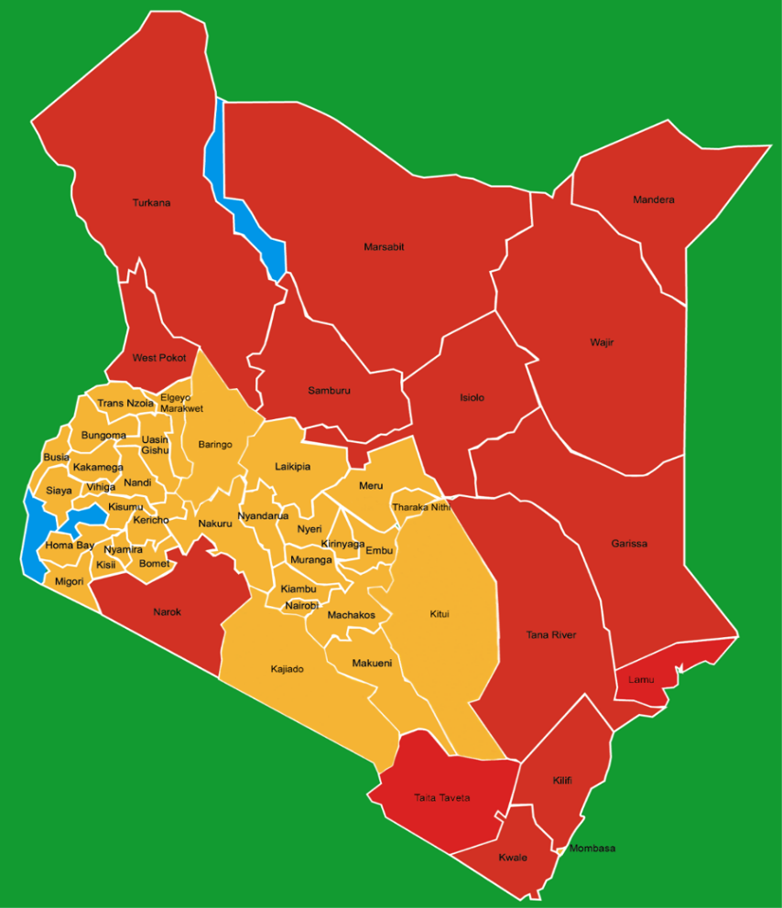

3.4 Electricity access by the IPs/VMGs in Kenya

39. Most of the IPs/VMGs are found in areas generally regarded as inaccessible, arid and semi-arid lands (ASALs) of Kenya. These areas were generally neglected over the years. The long years of economic and political marginalization have resulted in the ASALs being the most under-developed areas in the country. The colonial governments regarded them as non-productive. Successive independent governments saw the areas as too expansive to invest in. It is upon this realization that recent government initiatives have been established to address the development challenges in these areas.

40. In the recent past a project dubbed Kenya Off-grid Solar Access Project (K-OSAP) that is co-financed by the WB was initiated to allow the IPs/VMGs in 14 underserved counties of Kenya to access solar powered electricity. This project is being implemented by the MoE through REA and KPLC. This initiative will provide stand-alone solar panels and solar mini-grids to supply power to households and other establishments. Further, to ensure equitable distribution of benefits for the IPs/VMGs, KESIP will augment the efforts of KOSAP by giving first consideration of power connections to them should KESIP be implemented in their areas. The project team will also ensure that if KOSAP and KESIP are being implemented in the same locality where IPs/VMGs live, they will benefit from both projects without discrimination. Both KOSAP and KESIP will be prioritized in the IPs/VMGs areas in case they are within the technical reach of the grid as determined during screening of the subprojects.

Chapter fOUR: Relevant legal framework and regulations

41. This section describes Kenya’s legal and institutional framework with respect to IPs/VMGs and provides an analysis of the similarities and differences between OP 4.10 and Kenya’s legal frameworks.

4.1 Constitution of Kenya (CoK), 2010

42. The CoK uses the term “vulnerable and marginalized groups,” which the Constitution recognize as groups being in a disadvantaged position in relation to dominant communities in the country.

43. The CoK does not provide a definition of IPs but refers to “marginalized groups” and “marginalized communities.” In this regard, article 260 of the CoK defines a “marginalized group” as “a group of people who, because of laws or practices before, on or after the effective date, were or are disadvantaged by discrimination on one or more of the grounds in Article 27(4). Article 260 goes on to define a Marginalized Community as:

- “A community that because of its relatively small population or for any other reason, has been unable to fully participate in the integrated social and economic life of Kenya as a whole;
- A traditional community that, out of a need or desire to preserve its unique culture and identify from assimilation, has remained outside the integrated social and economic life of Kenya as a whole;
- An indigenous community that has retained and maintained a traditional lifestyle and livelihood based on a hunter-gatherer economy; and
- Pastoral persons or communities, whether they are (i) nomadic; or (ii) a settled community that, because of its relative geographic isolation, has experienced only marginal participation in the integrated social and economic life of Kenya as a whole.”

44. The CoK captures the disadvantaged position of IP/VMGs in relation to other dominant communities in Kenya. It “promotes and pledges to protect the diversity of language of the people of Kenya and promotes the development and use of indigenous languages” (Article 7 (3)). It spells out human dignity, equity, social justice, inclusiveness, equality, human rights, nondiscrimination and protection of the marginalized as national values and principles of governance (Article 10 (2)(b)). The CoK explicitly recognizes marginalized communities, minority, and vulnerable groups and provides the means to address their concerns.

45. The CoK requires the State to address the needs of vulnerable groups, including “minority or marginalized” and “particular ethnic, religious or cultural communities” [Article 21(3)]. It also provides for affirmative action programs and policies for minorities and marginalized groups [(Articles 27(6) and 56)]; rights of “cultural or linguistic” communities to maintain their culture and language [(Articles 44(2) and 56)]; protection of community land, including “ancestral lands and lands traditionally occupied by hunter-gatherer communities” (Article 63); and establishes an equalization fund to provide basic services to marginalized areas (Article 204).

46. Article 69(1)(a) compels the State to: “ensure sustainable exploitation, utilization, management, and conservation of the environment and natural resources”, and Article 69(1)(d) requires the State to “encourage public participation in the management, protection and conservation of the environment.” Article 56 requires the State to “ensure that vulnerable and marginalized groups have reasonable access to water, health services and infrastructure.” Representation and exclusion from participation in the governance and political life of the country are addressed in Article 56, which states that the State “shall put in place affirmative action programs to ensure that minorities and marginalized groups participate and are represented in governance.” Article 7(b) obligates the State “to promote the development and use of indigenous languages” and Article 11(2)(a) obliges it to promote all forms of cultural heritage.

4.1.1 Constitutional Implementation
47. The CoK provides a rich and complex array of civil and political rights, socio-economic rights and collective rights that are of relevance to indigenous communities. However, important constitutional provisions alone are not enough. They require a body of enabling laws, regulations and policies to guide and facilitate their effective implementation. In 2011, Kenya’s parliament enacted 22 laws, which are of general application and have a bearing on the way in which the State exercises power in various sectors, some of them of fundamental importance to indigenous communities.

48. Laws relating to reform of the judiciary, such as the Supreme Court’s Act 2011 as well as the Vetting of Judges and Magistrates’ Act 2011, are already transforming the way in which the judiciary is dealing with claims presented to it by local communities. The revamped judiciary is already opening its doors to the poorest and hitherto excluded sectors of Kenyan society.

49. Additionally, the adoption of a law establishing the Environment and Land Court 2011, is important for IP/VMG communities given that the Court will hear and determine disputes relating to environment and land, including disputes: (a) relating to environmental planning and protection, trade, climate issues, land use planning, title, tenure, boundaries, rates, rents, valuations, mining, minerals and other natural resources; (b) relating to compulsory acquisition of land; (c) relating to land administration and management; (d) relating to public, private and community land and contracts, chooses in action or other instruments granting any enforceable interests in land; and (e) any other dispute relating to environment and land.

50. The CRA is mandated by Article 204 of the CoK to earmark 0.5% of annual State revenue to the development of marginalized areas, in addition to 15% of national revenue for direct transfer to county governments. Specifically, the tasks of the CRA, as spelt out in the CoK, include: (i) recommend on equitable sharing of revenues between National and County Governments; and among counties, Article 216 (1)(b)); (ii) recommend on financing and financial management of County Governments (Article 216 (2); (iii) define and enhance revenue sources of National and County Governments (Art. 216 (3) (b); (iv) encourage fiscal responsibility by National and County Governments (Article 216 (3) (c); and (v) determine, publish and regularly review a policy in which it sets out the criteria by which to identify the marginalized areas for the purposes of Article 204 (2) (Article 216 (4)).

51. The CoK has further established the ‘Equalization Fund’ as the instrument with which CRA is to achieve its mandates. The objective of the Fund is to eradicate marginalization and other forms of economic inequalities in Kenya and to bring all groups into mainstream development within 20 years from the date of promulgation of the CoK. It is notable that there is clear overlap between the counties designated as marginalized by the CRA and the distribution of marginalized groups in the country.

52. Article 59 of the CoK established the Human Rights Commission, the Commission on Administrative Justice (CAJ) and the National Gender Equality Commission (NGEC), which are all tasked with increasing inclusion and equality in access to services.

4.2 Definition and treatment of the IPs/VMGs by World Bank’s Policy

53. The WB has a set of “Do No Harm” safeguard policies that are meant to protect PAPs from impacts and actions of Bank financed projects. Some of the WB’s development activities have significant impacts on the rights and livelihoods of IP/VMG, who worldwide constitute the “poorest of the poor and continue to suffer from higher rates of poverty, lower levels of education and a greater incidence of disease and discrimination than other groups” (World Bank, 2010). Since the early 1980s the World Bank Group (WBG) has adopted a number of policies, designed to mitigate harm to IPs in WBG-financed projects (Mackay, 2005). These have been referred to as safeguard policies.

54. The WB Operational Policy/Bank Procedures on Indigenous Peoples (OP/BP 4.10) requires that Bank-financed projects are designed not only to avoid adverse impacts but equally important to recognize “the distinct identities and cultures of IPs/VMGs who have remained inextricably linked to the lands they inhabited and the natural resources they depended upon to survive”. The policy provides processing requirements for IPs/VMGs that include: (i) screening; (ii) social assessment in consultation with the communities involved; (iii) preparation of IP Plan (IPP) or IP Policy Framework (IPPF); and (iv) disclosure. It also requires the borrower to seek broad community support of IPs/VMGs through a process of FPIC before deciding to develop any project that targets or affects them.

55. The WB, like the UN, has no definition of IP mainly because of the varied and changing contexts in which IPs live and because there is no universally accepted definition of IP. Paragraph 3 of OP 4.10 does not “define the term” instead it presents a set of characteristics for identifying IPs. For purposes of this policy, the term IPs is used in a generic sense to refer to a distinct, vulnerable, social and cultural group possessing the following characteristics in varying degrees:
- self-identification as members of a distinct indigenous cultural group and recognition of this identity by others;
- collective attachment to geographically distinct habitats or ancestral territories in the project area and to the natural resources in these habitats and territories;
- customary, cultural, economic, social, or political institutions that are separate from those of the dominant society and culture; and
- an indigenous language, often different from the official language of the country or region.

4.3 Treatment of IP/VMG in Kenyan Legal and Policy Frameworks

56. The CoK does not specifically use the term IP, it is nevertheless robust in articles that define vulnerability and marginalization, including issues that IP/VMGs cite as the reasons for their self-identification. It also addresses social exclusion in general as illustrated in sub-section 4.1 above. Articles 56 and 260 of the Constitution are a clear demonstration of the intentions of the country to deal with the concerns of minority and marginalized groups. The definition of marginalized communities and groups by the CoK and the provisions for affirmative action programs targeting these groups present the range of efforts to provide a legal framework for their inclusion into mainstream development of the country. These articles present the minority and marginalized groups, including groups that fit the OP 4.10 criteria, as a unique category of the Kenyan population that deserves special attention in order to bring the members at per with the rest of the country in development terms.

57. The CoK requires the State to address the needs of vulnerable groups, including “minority or marginalized” and “particular ethnic, religious or cultural communities” (Article 21.3). The specific provisions of the Constitution include: affirmative action programs and policies for minorities and marginalized groups (Articles 27.6 and 56); rights of “cultural or linguistic” communities to maintain their culture and language (Articles 7, 44.2 and 56); protection of community land, including land that is “lawfully held, managed or used by specific communities as community forests, grazing areas or shrines,” and “ancestral lands and lands traditionally occupied by hunter-gatherer communities” (Article 63); promotion of representation in Parliament of “…(d) ethnic and other minorities; and (e) marginalized communities” (Article 100); and an equalization fund to provide basic services to marginalized areas (Article 204).

4.4 Other Legal and Policy Provisions that Facilitate Operationalization of OP 4.10

58. Kenya’s legal and regulatory framework include several provisions, policies and instruments that if well developed and implemented hold promise for addressing marginalization and inclusion of IPs/VMGs. These include:
- The National Land Policy (NLP): The NLP was endorsed in 2009 while the Land Act, Land Registration Act and National Land Commission (NLC) Act were adopted in May 2012. The Community Land Act, provided for in the CoK, was passed in September 2016 (although not yet implemented). The NLP includes a key policy principle for restitution of land rights of minority communities as a way of restoration and protection of land rights which were violated by colonial and post-colonial governments (Articles 3.6.1.2 and 3.6.6 on restitution and land rights of minority communities, respectively). The policy calls on the GoK to secure community land and to “document and map existing forms of communal tenure, whether customary or non-customary, in consultation with the affected groups, and incorporate them into broad principles that will facilitate the orderly evolution of community land law” (Article 3.3.1.2, paragraph 66).
- The Forest Act of 2005 and Forest Policy of 2007 both provide some provisions for the customary rights of forest communities and community forestry: the Forest Act states that “nothing in this Act shall be deemed to prevent any member of a forest community from using, subject to such conditions as may be prescribed, such forest produce as it has been the custom of that community to take from such forest otherwise than for the purpose of sale” (Article 22), and “…may include activities such as ‘collection of forest produce for community based industries’’ (Article47.2.e) under a license or management agreement. The Act defines a "forest community" as “a group of persons who have a traditional association with a forest for purposes of livelihood, culture or religion […] (Article 3). The Forest Policy recognizes the “traditional interests of local communities customarily resident within or around a forest” (paragraph 4.3).
- The National Policy on Culture and Heritage (2009) aims to promote and protect the cultures and cultural diversity among Kenya’s ethnic communities. These include the protection of indigenous languages, the expression of cultural traditions, knowledge, and practices, traditional medicines, and community rights.
- National Policy for the Sustainable Development of Northern Kenya and other Arid Lands: the policy states that the Government will put in place an institutional and legal framework for the development of Northern Kenya and other arid lands. The policy thus calls on the government to establish a range of institutions that will provide long-term continuity in ASALs’ development, including a National Drought Management Authority (NDMA) and National Drought and Disaster Contingency Fund to increase responsiveness to drought, National Council on Nomadic Education, a Northern Kenya Education Trust, a Livestock Marketing Board, and a Northern Kenya Investment Fund.

4.5 Similarities and Differences between the CoK and OP 4.10

59. The similarities and differences between the CoK and Bank’s OP. 4.10 are summarized in Table 4. In case there will be a conflict between the CoK and Bank’s OP.4.10 the WB safeguard policies will take precedence over the Kenya constitution.

Table 5: Similarities between the Kenyan Constitution and OP 4.10
OP 4.10 | Constitution of Kenya | Similarity
Self-identification as members of a distinct indigenous cultural group and recognition of this identity by others | - Article 10(2): “The national values and principles of governance include: human dignity, equity, social justice, inclusiveness, equality, human rights, non-discrimination and protection of the marginalized.”  - Article 27(4): prohibits discrimination on any grounds: “the state shall not discriminate directly or indirectly against any person on any ground including; Conscience, belief, culture, dress, language or birth.” | The Constitution recognizes the existence the diverse and unique cultural communities within its borders, some of whom are marginalized and vulnerable. It does not explicitly mention self-identification of cultural community as a prerequisite to be considered as vulnerable and marginalized.
Collective attachment to geographically distinct habitats or ancestral territories in the project area and to the natural resources in these habitats and territories | - Article 63(1): “community land shall vest in, and be held by communities identified on the basis of ethnicity culture or similar community interest”.  - Article 63(2): “community land consists of… (d) land that is ii) ancestral land and lands traditionally occupied by hunter gatherer communities.”  - Article 63(4) protects community land from arbitrary disposal “except in terms of legislation specifying the nature and extent of the rights of members of each community individually and collectively.” | The Constitution includes a definition of “community land” which states that such land includes that which is held collectively by communities identified on the basis of ethnicity culture or similar community of interest and is therefore to be protected.
Customary, cultural, economic, social or political institutions that are separate from those of the dominant society and culture. | - Article 44(1): “Every person has the right to use the language and to participate in the cultural life of the person’s choice. A person belonging to a cultural or linguistic community has the right with other members of that community – (a) to enjoy the person’s culture and use the person’s language; or (b) to form, join and maintain cultural and linguistic associations and other and other organs of civil society. A person shall not compel another person to perform, observe or undergo any cultural practice or rite.” | The Constitution accepts a person’s right to participate in “cultural life”. If read broadly the “cultural life” of an individual may include culturally specific socio political institutions.
An indigenous language, often different from the official language of the country or region. | - Article 7(3)(b): “The state shall –(a)promote the development and use of indigenous languages.” | The Kenyan constitution upholds the right to speak an indigenous language.
Consultation and benefit – sharing related to the commercial development of natural and cultural resources. | - Article 11(1): “The Constitution recognizes culture as the foundation of the nation and as the cumulative civilization of the Kenyan people and nation.”  - Article 11(2)(a) obliges the state to “promote all forms of cultural expression through; arts, traditional celebrations….and other cultural heritage. Article 11(2)(c) obliges the state to recognize the role of... and indigenous technologies in the development of the nation.”  - Article 11(3): “Parliament shall enact legislation to-(a) ensure communities receive compensation or royalties for the use of their culture and cultural heritage.”  - Article 69(1) provides for participation in the management, protection and conservation of the environment: the state shall (d) encourage public participation in the management, protection and conservation of the environment.”
Consultation and protection to avoid or mitigate the effects of economic and physical displacement of Indigenous Peoples |  | The issue is not addressed in the Kenyan constitution.

60. The CoK, as shown in Table 3, has a lot of similarities with the tenets of OP. 4.10. There is considerable overlap between groups identified by the GoK as IPs/VMGs that have the potential to trigger OP 4.10. Similarly, the groups identified both by the government and in the context of Bank-supported operations align with some of the groups that have been identified by the African Commission on Human and Peoples’ Rights (ACHPR) in its conceptualization of the notion of indignity and what it means in the African context.

61. Overall, there is no contradiction between the objectives and key principles of the OP 4.10 and the Kenyan Constitution. The implementation of some key Constitutional provisions would create an environment supportive of the application of OP 4.10 in the country. Nationally, the people who identify with the indigenous movement are mainly pastoralists and hunter-gatherers, as well as a number of small farming communities. Pastoralists are estimated to comprise 25% of the national population, while the largest individual community of hunter-gatherer’s numbers approximately 30,000 people. Pastoralists mostly occupy the ASALs of northern Kenya and towards the borders between Kenya and Somalia, South Sudan, Ethiopia and Uganda.

Chapter FIVE: KEY ISSUES AND potential impacts OF THE PROJECT ON IPs/VMGs

62. All development projects have potential impacts both on the environment and on the people, which can either be positive or negative. The proposed KESIP project is also expected to have both positive and negative impacts as described in this section. However, the project has been considered for implementation since the positive outweigh the negative impacts, and there are specific measures to be implemented to minimize the negative effects.

5.1 Potential positive benefits from KESIP

63. The positive impacts of the project will be realized in the economic, education, social, health, security and environmental sectors in the project sites and nationally. Positive impacts are also anticipated on gender, beliefs and culture. In this regard, it is anticipated that the KESIP will have the positive benefits enumerated below.

64. Employment and wealth creation: KESIP will have a positive impact on both direct and indirect employment levels in the country although the bulk of the jobs will be on temporary basis during the construction phase. These job opportunities will be made available to the local people thereby easing unemployment in the targeted counties. In areas where there are IPs/VMGs, efforts will be made to provide opportunities for employment as appropriate. Employment creation will translate into incomes at the household levels, which will trigger other spending and demand in the local economy.

65. Local material supplies: the project will utilize mainly local materials and only import those which cannot be found locally. Therefore, it will generate new income revenues for the local populations through supply of materials. It is anticipated that the new income revenue streams will create demand for other goods and services causing a trickledown effect to the entire economy.

66. Social inclusion: The project aims at increasing access of electricity to the various communities and counties within the country. This is in line with the tenets of social inclusion which the WB defines as the process of improving the terms for individuals and groups to take part in society. Further, social inclusion aims to empower poor and marginalized people to take advantage of burgeoning global opportunities. It ensures that people have a voice in decisions which affect their lives and that they enjoy equal access to markets, services and political, social and physical spaces.

67. Awareness on HIV/AIDS: KPLC’s HIV/AIDS policy underscores the fact that HIV/AIDS has no cure and the only way to stop its spread is through attitudinal and behavioral changes as well as management that can be secured effectively through education (awareness and information campaigns). One of the positive impacts of this project will be disseminating of HIV/AIDS information to communities and workers who otherwise would not have had the correct information on several levels. Direct beneficiaries of the project, i.e. those who will be connected to electricity will have the benefit of health education messages through use of radios and TV since using electricity to power these gadgets is more reliable. The beneficiaries will also benefit from experts’ opinion on the pandemic such as listening to doctors and nutritionists regarding HIV/AIDS.

68. The other method of disseminating HIV/AIDS information during project implementation will be through the contractors, who will be expected to disseminate information to the workers as part of their daily toolbox talks. The SHE department will liaise with the National AIDS Control Council (NACC) to get materials (if they are available at the time) on HIV/AIDS that can be distributed by the contractors during the toolbox talks. This will reach more people as the project is being implemented across multiple counties. Finally, during the ESIA for other projects the SHE department disseminates HIV/AIDS information to the public during public consultations meetings.

69. Health benefits of the project: According to the 2009 population census, access to electricity stood at 23%, while 31% of the population used lantern lamps and 39% used tin lamps for lighting. This indicates that 70% of the population was using kerosene for lighting. Although access to electricity has improved over time, a majority of Kenyans are still using kerosene for lighting. This poses health problems as reported by WB in 2008 on the Welfare of Rural Electrification. The report notes that kerosene lamps emit particles that cause air pollution as measured by the concentration of the smallest particles per cubic meter (PM10).

70. Burning a liter of kerosene emits PM51 micrograms per hour, above the World Health Organization (WHO) 24-hour mean standard of PM10 of 50 micrograms per cubic meter. But these particles do not disperse, so burning a lamp for four hours can result in concentrations several times the WHO standard. The health risks posed by this indoor air pollution mainly include acute lower respiratory infections, but also low birth weight, infant mortality and pulmonary tuberculosis. Additionally, available data suggest that insufficient illumination (low light) conditions can cause some degree of eye strain, and reading in these conditions over long periods of time may have the potential to increase the development of nearsightedness (myopia) in children and adults. This project will result in many families replacing kerosene lamps for lighting with electricity thereby reducing disease burden at the family level and on the government.

71. Benefits to education: Access to electricity at the household level and schools will create opportunities for children to study. For example, children from households with electricity have an advantage because they have more time for study and doing homework in the evening as opposed to children from households without electricity. This benefit will in the end translate to better education outcomes. Additionally, children in households with electricity can also access television, which gives them an advantage of benefiting from education programs being aired through such communication channels. Appropriate lighting through electricity will provide school-going children in homes an opportunity to study after household chores, especially girls who have to assist their mothers/guardians in preparing dinner, among other responsibilities.

72. Improved standard of living: The implementation of this project will result in connecting more customers to electricity. Access to electricity will change the standard of living of the people as they can use domestic appliances like iron boxes, fridges, television sets, washing machines, among others. Use of electricity for lighting implies that the people will not be exposed to smoke arising from use of kerosene lamps which predisposes people to respiratory diseases.

73. Security: There will be enhanced security in the targeted counties arising from well-lit social, commercial and individual premises. With the implementation of the project, the level of security will improve across the country due to increased security floodlights which will deter opportunistic crimes and gender-based violence (GBV).

74. Communication: Access to electricity will lead to improved communication for the beneficiaries. This will be enabled by the fact that charging of mobile phones will be easier and cheaper. Access to mass media like radio and television will also provide opportunity for the households to access a wide range of information which is useful for decision-making. Some of the information beneficiaries will access include: markets, farm inputs, livestock and crop management and local affairs, nutrition, diseases, investments and entertainment, among others.

5.2 Potential Negative Impacts

75. Project activities may result into an infinite loss of use of property, vegetation, or land by the PAPs including loss of land, labor influx, loss of housing and loss of businesses as further described below.

76. Loss of land and related economic or livelihood opportunities: where all or a significant part of a person’s farm or grazing land is lost, he/she will lose his/her income and often a significant part of his/her food supply. In the case of linear projects, as is the case for this project, the farmers may not loss the land in the actual sense but there are restrictions on the right of way where the transmission lines pass. For instance, no one is allowed to build or plant trees on the wayleave. If the need for wayleaves will render the remaining land uneconomical, physical relocation of the PAPs from the land will be necessary. In the process of the PAPs moving they will also incur significant transitional costs, including transport for themselves and their personal effects, legal fees, taxes and so on.

77. Labor influx: civil works for some of the proposed infrastructure works may attract labor (skilled, semi-skilled and unskilled) from outside the project area. This in turn may have negative social impacts, such as increase in infectious diseases, teen pregnancies or youth dropping out of school to take up menial jobs (such as provision of food to workers, etc.). Sexual Exploitation and Abuse (SEA), GBV, erosion of cultures and social dynamics and competition for resources could result from labor influx. The IP/VMGs have raised concerns that these will impact them negatively hence they will become more vulnerable than they are at the moment before project implementation. The IPs/VMGs will be sensitized on the potential negative effects before the project starts its implementation. They will be appraised of the project mechanisms such as the Code of Conduct (CoC) and GRM. It will also be necessary for KPLC to make special arrangements with contractors working in or near IP/VMG areas to take special precautions and to engage with project and local leadership to agree on norms of interaction.

78. Loss of housing: this denotes loss of physical structure of the house and associated services/facilities: water supply; drainage; road access; and electricity. In this project many people are likely to move within their land and all amenities and structures within the wayleave will need to be accounted for. These may include structures such as kitchens, granaries and cow sheds, among others.

79. Loss of businesses: this would imply loss of physical premises. Small businesses may be affected by the loss of business locations and loss of clientele, especially their regular customers. In the process of relocating they will lose business and may incur significant transitional costs, including the transport of equipment, stock, etc.

80. Loss of employment: if an affected business closes, the employees will lose their jobs. Other people may lose employment if they are obliged to move a long distance from their existing workplaces.

81. Loss of communal assets/services and cultural heritage: this includes loss of facilities such as schools, clinics, religious/places of worship, cemeteries, cattle dips, social halls, among others.

82. Loss of vegetation (crops and trees): this will denote loss of crops and trees in the land that will need to be cleared to make way for the project.

5.3 Proposed Mitigation Measures

83. To avoid or minimize adverse impacts and, at the same time, ensure enhancement of benefits and full participation of the IPs/VMGs, the PIU in collaboration with the IPs/VMGs, will apply the following measures.

- Through design, avoid the need for land acquisition in IP/VMG areas which would result in their displacement while still ensuring project benefits to them. Where land acquisition is inevitable, the provisions in the RPF will be followed and will be implemented in consultation with the IPs/VMGs. However, where such displacement may portend more harm to the IPs/VMGs in relation to any good that may come with power connections, the subproject will be excluded after screening. Subprojects deemed to be potentially detrimental to the IPs/VMGs will also not be implemented. Projects that benefit IPs/VMGs but would also have some adverse impacts will proceed only if through consultations with the IPs/VMGs they indicate that they want to proceed, and the impacts are agreed to be minimal or can be mitigated in a manner that is acceptable to the IPs/VMGs.
- As much as possible, the project will promote the use of local labour (both skilled, semi-skilled and unskilled). During the consultation forum held in September 2018 the IPs/VMGs requested to be considered in employment opportunities that will arise as they are willing to work, and this request will be honored during project planning and contracting. However, if labour must be ‘imported from outside the project area’, the project will:
    - Mount sensitization and awareness strategies to dissuade families from allowing their school children to become laborers and ensure that the contractors do not engage underage workers;
    - Safeguards will be built into the contractors’ contracts to ensure that workers are not engaging in activities or vices that could disrupt the socio-cultural set-up of the local communities; and
    - Ensure that vulnerable groups in general and their organizations are informed of the selection, design, and implementation processes of the various activities and are provided an opportunity to make input and to provide clarification.
- The PIU, through environmental and social experts of SHE department within KPLC, will carry out an analysis of socio-economic impacts of proposed subprojects on IPs/VMGs through a transparent process with the affected communities. The unit will also seek consultancy services to augment its expertise as necessary.
- The PIU will ensure that the interventions do not unnecessarily and unintentionally exacerbate factors outside the scope of planned impacts.
- The PIU will screen the subproject activities for a preliminary understanding of the nature and magnitude of potential impacts and explore alternatives to avoid or minimize any adverse impacts as detailed in the ESMF and RPF.

84. Table 6 summarizes the expected adverse impacts and their possible mitigation measures.

Table 6: Potential Adverse Project Impacts and Mitigation Measures
Impact | Possible Actions | Responsibilities and Issues
Loss of access to water and pasture as a result of land acquisition | -Ensure that adequate benefits and/or compensation is provided based on agreements reached through FPIC. | KPLC will implement agreements reached under this framework.
Loss of Land | -A subproject that would result in the physical displacement of IPs/VMGs will be excluded after screening and determination that it is not possible to avoid the displacement of IPs/VMGs. Projects deemed to be potentially detrimental to the IPs/VMGs will also not be implemented. Projects that benefit IPs/VMGs but would also have some adverse impacts will proceed only if through consultations with the IPs/VMGs they indicated that they want to proceed, and the impacts are agreed to be minimal or can be mitigated in a manner that is acceptable to the IPs/VMGs.  -Land for proposed substations will be acquired on a willing-buyer-and-willing-seller basis. The component that is likely to cause economic displacement is transmission lines (distribution lines normal utilize the road reserves hence do not cause displacement) and efforts will be made to avoid displacement of IP/IPs/VMGs. In exceptional circumstances, when it is not feasible to avoid relocation, the KPLC will not carry out such relocation without obtaining broad support for it from the affected IP/IP/VMG communities. The RAP will also provide for agreements that allow the affected IP/VMG to return to the lands and territories they traditionally owned, or customarily used or occupied, if the reasons for their relocation cease to exist. | KPLC PIU
Increased risk of exposure to communicable diseases such as HIV/AIDS | -Disseminate public health messages and measures to combat spread of diseases. | KPLC PIU
Physical/economic displacement of IP/VMG | -No physical displacement of IPs/VMGs, thus exclude all subprojects screened and determined to trigger physical displacement of IPs/VMGs.  -Compensate the IPs/VMGs who are economically displaced. | KPLC PIU
Loss of traditional livelihoods | -The negative impacts will be minimal. Consultations will be key to determine and avoid such losses. | KPLC PIU
Encroachment on and degradation of land, territory and natural resources | The subprojects will not encroach or degrade land or natural resources. Where temporary impacts occur, they will be mitigated through the ESMF and RPF guidelines. Communication with communities is also key.
Increased marginalization and exclusion of the IP/VMG | -Adequate communication framework to ensure IP/VMG voices are heard, pending issues resolved and grievances heard. The project will ensure there is a functioning GRM.  -If IPs/VMGs fall within the subproject area of implementation they will not be excluded but considered alongside with other project beneficiaries. The IPs/VMGs will be consulted in a culturally accepted manner. The GRM will be prepared in consultation with IPs/VMGs to ensure that it is culturally appropriate, accessible and working for them. | KPLC PIU

5.4 Plan for Carrying out a Social Assessment (SA) for Subprojects

85. If, based on the screening, the KESIP PIU concludes that IPs/VMGs are present in, or have collective attachment to a subproject site, the KPLC will undertake a social assessment (SA) to evaluate the subproject’s potential positive and negative effects on the IPs/VMGs, and to examine project alternatives where adverse effects may be significant. The breadth, depth, and type of analysis required for the SA will be proportional to the nature and scale of the proposed subproject’s potential effects on the IPs/VMGs. KPLC will prepare detailed ToRs for the SA once it is determined that IPs/VMGs are present in the project area. The SA TOR will also focus on differentiated impacts of the projects on IP/VMGs such as cultural considerations, safety, employment opportunities and exposure to new technologies, capacity to pay for connection and services; maintenance, etc.

86. The KPLC will conduct free, prior and informed consultations with IPs/VMGs. This refers to a process whereby affected vulnerable and marginalized communities, freely have the choice, based on sufficient information concerning the benefits and disadvantages of the project, of whether and how these activities occur, according to their systems of customary decision-making.

87. Projects affecting the IPs/VMGs that meet the OP 4.10 criteria, whether positively or negatively, need to be prepared with care and involvement of the affected communities. The policy requires that KPLC engages the affected communities in a FPIC process at every stage of the subproject. This will facilitate the identification of their views on the potential impacts of the subproject and obtaining their broad community support for the subprojects. Similarly, the development of subproject-specific measures and mitigations to avoid the adverse impacts and enhance culturally appropriate benefits should be in consultation with the IP/VMG.

5.5 Organization and Responsibility

VMGF implementation Organizations and Institutions

88. Several organizations and institutions will be involved with the implementation process of the VMGF at different levels as discussed below.

(i) Ministry of Energy (MoE): The Ministry is responsible for procuring resources from the National Treasury and other developmental partners, such as the WB in this case, for the overall project. The Ministry is also responsible for harmonizing the VMGF and VMGPs with other government policies on the same subject. Also, the Ministry is responsible for coordinating the actions of the implementing agencies to ensure they are geared to meeting the project’s development objective. In this regard, the Ministry will provide oversight to ensure that the overall approach to IPs/VMGs issues between KPLC and KETRACO is well coordinated.

(ii) KPLC: It is responsible for the implementation of component 1 of the project, which is the access expansion and distribution network strengthening. The Company is also responsible for the preparation and implementation of all the relevant safeguard instruments under the project, including this VMGF, as well as their disclosure as appropriate. As soon as the VMGF is finalized by KPLC and cleared by the Bank, KPLC will formally disclose it on its website and to the affected IPs/VMGs. For this purpose, KPLC will organize sessions along the proposed project areas for the affected IPs/VMGs and the general community at large. The sessions will be chaired by the project manager assisted by social specialists from KPLC and attended by PIU members and representatives of national and county governments at all levels. KPLC will ensure that all IPs/VMGs affected by the project are consulted prior to project start.

(iii) The Office of the County Commissioner: Due to its responsibilities for coordinating National Government activities at the grassroots level, the Office of County Commissioner will assist in liaising with various chiefs at the location level to mobilize IPs/VMGs for participation in the project’s activities. This office will also chair meetings and settle disputes as it consults the general public to support the project. The chief (local national government representative at grassroots levels) has the role of disseminating information on various aspects of the project for effective implementation of the VMGF. This office has vast experience in dealing with matters of dispute that need not be referred to the Environmental and Land court of law.

(iv) IPs/VMGs CBOs and elders: The IP/VMG CBOs and elders at the location/sub-location/village levels within the proposed subproject area will be the main focal points for VMGF implementation. The IP/VMG leaders, in particular, the elders and CBOs will work with the chiefs and assistant chiefs towards the effective implementation of this VMGF and subsequent VMGPs for the success of this project. Any complaints from the PAPs will be presented to the elders and/or chiefs and assistant chiefs for resolution or escalation as appropriate. The local community representatives from IPs/VMGs will be members of GRM that will be established for addressing grievances from the PAPs at the lowest level of project implementation.

Chapter SIX: framework for ensuring free, prior and informed consultationS WITH IPs/VMGS

89. The OP 4.10 requires that a process of FPIC with the affected IP/VMG communities be undertaken. Although it is unlikely that the proposed investments will result in significant adverse impacts for IPs/VMGs, the policy and good practice require that the IPs/VMGs/PAPs be informed of the project and be consulted prior to project implementation.

90. Free, prior and informed consultation refers to a process whereby affected vulnerable and marginalized communities, freely have the choice based on sufficient information concerning the benefits and disadvantages of the project and how these activities occur, to accept or reject the implementation of a project or subproject. This VMGF establishes an appropriate gender and inter-generationally inclusive framework that provides opportunities for consultation at each stage of project preparation and implementation with the affected communities.

91. Free, prior and informed consultations of the IP/VMG communities will be conducted at each stage of the project, and particularly during project preparation, to fully identify and document their views and ascertain their broad community support for the project.

6.1 The Elements of Free, Prior and Informed Consultation

92. Below is a summary description of FPIC as applied in this VMGF.

Free: people are able to freely make decisions without coercion, intimidation or manipulation.

Prior: sufficient time is allocated for people to be involved in the decision-making process before key project decisions are made and impacts occur.

Informed: people are fully informed about the project and its potential impacts and benefits, and the various perspectives regarding the project (both positive and negative).

Consultation: there are effective uses of consultation methods appropriate to the social and cultural values of the affected IP/VMG communities and their local conditions. In designing these methods, it is essential to give special attention to the concerns of indigenous women, youth, and children and their access to development opportunities and benefits.

6.2 Consultations during Subproject Investment Screening

93. Screening of all the KESIP project investments will be a mandatory requirement, prior to implementation, to determine if IPs/VMGs are present (the subproject investment locations have not yet been identified at the moment). The PIU, in coordination with the WB, will screen for the presence of IPs/VMGs in the project areas as part of its due diligence once subproject sites have been identified. Any subproject investment involving involuntary resettlement that is not excluded according to Table 5, land acquisition or physical relocation of IP/VMG will be dealt with according to the provisions of the RPF that has been prepared by KPLC for KESIP.

94. Prior to subproject preparation, screening will be undertaken to determine whether IP/VMG are present in or have collective attachment to the subproject site. In conducting this screening, the technical judgment of qualified social scientists with expertise on the social and cultural groups in the subproject area will be sought. Consultations with the IPs/VMGs concerned and the implementing agency will be undertaken. However, some subprojects that are selected may not impact the entire group or may impact non-IPs/VMGs living around them (several IP/VMG appear to be dispersed among other ethnic groups). In view of this, it is necessary to carefully identify who will be adversely affected by subprojects which may turn out to be part of IPs/VMGs or parts of several different groups only some of which may be IPs/VMGs.

6.3 Preparation of Social Screening Form
95. The PIU and ESSs will prepare the screening forms in collaboration with the executing agency for the specific subproject considered for implementation. The OP 4.10 of the WB suggests “using the term ‘indigenous peoples’ in a generic sense to refer to a distinct, vulnerable, social and cultural group possessing characteristics in varying degrees as described in section 4.2 para 55 of this framework.

96. Therefore, during the screening exercise, while referencing the GoK recognition of IPs/VMGs, the stated definition and characteristics of IPs according to the WB will be used to screen and determine if the IPs/VMGs meet the threshold for OP 4.10. If the results show that there are IPs/VMGs in the zone of influence of the proposed subprojects, a SA will be planned for those areas.

97. Screening Criteria: The PIU, in liaison with ES staff who are members, with other environmental and social experts within SHE Department of KPLC, will be responsible for subproject preparation and implementation. They will visit all IP/IP/VMG settlements near the selected subproject areas, which may be affected and influenced by the subproject activities. Public meetings will be arranged in selected communities by the ESSs with the IP/VMG and their leaders to provide them information about the respective subproject and document their views on the subproject.

98. During this visit, the screening team, referred to above, will undertake screening of the IPs/VMGs with the help of the community leaders and local authorities. The screening will cover the following aspects:
- Name(s) of IPs/VMGs in the area;
- Total number of IPs/VMGs in the area;
- Percentage of IPs/VMGs to that of total area/locality population;
- Number and percentage of IP/VMG households along the zone of influence of the proposed subproject;
- Any land acquisition required from any IP/VMG for the subproject;
- Amount of land required from any IPs/VMGs;
- If so, any alternatives to avoid land acquisition; and
- The need for or lack thereof of VMGPs if a subproject passes through any IP/VMG areas.
- Whether VMGs are within an area covered by the national grid and/or KOSAP

6.4 Consultations during Social Assessment of Subprojects

99. If, based on the screening, the PIU concludes that IPs/VMGs are present in, or have collective attachment to the proposed project site, the implementing agency of that subproject will conduct a SA to evaluate the subproject’s potential positive and adverse effects on the IP/VMG and examine alternatives if the potential adverse effects are considered significant. The breadth, depth, and type of analysis required for the SA will be proportional to the nature and scale of the proposed subproject’s potential effects on the IPs/VMGs present. The PIU will prepare detailed ToRs for the SA study once it is determined that IPs/VMGs are present in a particular subproject site.

100. The SA will also identify if the proposed investment will involve change in use or management of commonly held properties in the community, as well as involving the commercial development of natural and cultural resources on lands or territories that IPs/VMGs traditionally owned, or customarily used or occupied. The SA will ensure FPIC with the IPs/VMGs during project planning and implementation. It will ensure that mitigation of potential adverse impacts deriving from project activities will be based on a participatory and consultative process acceptable to the WB and the IPs/VMGs themselves.

101. Beyond social screening, the subproject investments will comply with the following:
- Conserve and sustainably use land and other natural resources that impact on IPs/VMGs and other communities;
- Mitigate any possible adverse impacts;
- Be socially and culturally acceptable to the IPs/VMGs and economically feasible;
- Be institutionally feasible - the local institutional capacity should be adequate to take up activities;
- Be environmentally sustainable and avoid detrimental impacts from those activities that cannot be mitigated;
- Be supported by the IPs/VMGs and other communities through participatory consultation; and
- Be supported by training and capacity building, if necessary, to enhance IP/VMG and community development.

6.4.1 Who conducts the SA?
102. The SA will be undertaken by social experts from KPLC who have been extensively trained by the World Bank on OP 4.10 issues. However, if deemed necessary, due to other commitments by the KPLC experts or as agreed with the WB, KPLC will recruit external social experts - whose CVs will be shared with the WB - to support this exercise. KPLC PIU will avail the budget for any expertise who will be recruited to assist in the implementation of KESIP on social safeguards. The TORs for SA will also be shared with WB for clearance. The SA experts will gather relevant information from separate group meetings. Discussions will focus on subproject impacts, both positive and negative; and recommendations for design of the subproject. The social consultants will be responsible for analyzing the SA and for leading the development of an action plan with the IPs/VMGs, project engineers and other staff.

6.4.2 Methodology for SA
103. Combined qualitative and quantitative analysis method: usually SA is comprehensive and involves complex social issues. Quantitative analysis is preferred, such as for population structure, educational level and socio-economic indicators. These indicators are analyzed arithmetically and evaluated objectively. Qualitative indicators, such as the perceptions of the IPs/VMGs towards the project, that cannot be quantified should be analyzed and evaluated through qualitative analysis. However, in the case of KESIP the impacts are expected to be minimal and the SA will be in line with the scope of impacts identified and focus more on how to enhance coverage to more IPs/VMGs.

104. Comparative analysis method: The comparative analysis method is designed to ascertain the social profile of a project area in the absence of the project, and the impacts of the project on the area after its completion, thereby identifying the nature and degree of different benefits and impacts.

105. Stakeholder analysis method: Stakeholders refer to all parties directly or indirectly interested in the project and affecting the success of the project directly or indirectly. The stakeholder analysis method identifies different stakeholders involved in the project and prepares a stakeholder table, detailing the expected project roles and responsibilities for successful project implementation.

106. Participatory assessment: Participatory assessment is a method that involves all stakeholders in the SA. The key points include listening to all stakeholders’ opinions, respecting all participants, showing interest in their knowledge, speeches and behavior, and encouraging them to share their knowledge and ideas. Through a semi-structured survey and whole-process participation, this method will make compensation and resettlement programs, measures for mitigating social risks, and other programs concerning the affected persons’ immediate interests more operable and acceptable.

107. Other methods: An additional number of data collection and analysis tools may be used in undertaking a SA, including: (i) socio-economic survey; (ii) institutional analysis; (iii) social gender analysis; (iv) social impact analysis; (v) poverty analysis; and (vi) social risk assessment.

6.4.3 Survey/Data Gathering Methods
108. The process of gathering baseline information on demographic social, cultural, and political characteristics of the affected IPs/VMGs, the land and territories that they have traditionally owned or customarily used or occupied, and the natural resources on which they depend will be through a participatory rural appraisal mapping exercise involving the IPs/VMGs in the proposed project investment area. Mapping the community resources where the project investments are targeted will determine the sphere of influence, how the IP/VMG communities utilize the said resources so as to identify how the project can enhance utilization of these resources.

109. Regarding customary rights of IPs/VMGs to common resources, the mapping will provide information on: (i) location and size of the area and condition of resources; (ii) primary users, including those that belong to IPs/VMGs that currently use or depend on these common resources; (iii) secondary users and the types of uses they have; (iv) the effects of these uses on the IPs/VMGs; and (vi) mitigation measures of adverse impacts, if any. The following survey methods should be used mainly in SA for subproject investments where a VMGP is required.

110. Literature review: is intended to provide information on the history and background of the project and the social and economic development of each subproject area, which is an important basis for in-depth field survey. The SA team should collect feasibility study reports, plans and other documents related to the project according to the WB policies of IPs and Involuntary Resettlement, including the following subtitles.

- Statistics: social and economic development statistics of the subproject area; census and sampling population survey data; and statistics on social relief.
- Document reviews: documents of construction; project implementation, etc.
- Review of Legal Framework: A review, on a scale appropriate to the project, of the legal and institutional frameworks, applicable to IPs/VMGs.
- Research findings: research findings on construction planning and other findings related to the project design documents: project proposals, feasibility study reports and other relevant documents.
- Focus Group Discussions: Should be held with officials and technicians of competent authorities aimed at documenting their attitudes to ideas and suggestions for the project.

6.5 Consultations during VMGP Preparation

6.5.1 Steering Committee for subprojects
111. A subproject steering committee will be established in the subproject area once it has been determined that IPs/VMGs are present in an area and that a VMGP is needed. The steering committee will comprise the following representatives from the area:

- County Administrator/representative;
- Sub-County Commissioner;
- Representative of CBOs/NGOs active in the area;
- Representative of the IPs/VMGs;
- Women representative from the IPs/VMGs;
- Youth representative from the IPs/VMGs;
- Government ministries representatives e.g. Ministry of Lands, Ministry of Environment and Mineral Resources, Ministry responsible of Youth and Gender, Ministry Culture and National Heritage, Ministry of Labor and Social Protection, etc.;
- Consultants - social specialists; and
- Representative from KPLC, e.g. Social Development Specialist.

6.5.2 Role of Subproject Steering Committee
112. This committee will play the following roles in relation to the development of VMGPs:

- Identification of the IPs/VMGs;
- Support in undertaking the SA;
- Facilitate meetings with IPs/VMGs and consultants;
- Recommend mitigation measures for the IPs/VMGs impacts;
- Address grievances from IPs/VMGs; and
- Monitor implementation of the VMGPs.

6.6 Stakeholder Identification and Consultation

113. All the interested and affected stakeholders will be identified with specific focus on the IPs/VMGs. This process will include an elaboration of a culturally appropriate process for consulting with the IPs/VMGs at each stage of project preparation and implementation. A stakeholder mapping exercise will be conducted for each of the proposed investments where there is a likelihood of IPs/VMGs being affected. The stakeholder mapping process will ensure that all the interested and affected stakeholders are identified and added in the SA, including impact identification and mitigation.

6.6.1 Stakeholder Consultation
114. Once screening has been conducted and an investment found to be located in an area where IPs/VMGs are present, the existing administrative structures - county and sub-county leaders - will be used to inform the IP/VMG communities about the proposed subproject. County offices in collaboration with the executing agencies will facilitate and arrange for consultative meetings with members of the IPs/VMGs and in these areas, there will be free and prior information about the proposed subproject, the proposed location(s), and potential adverse impacts of the project on the IPs/VMGs.

115. Such consultation will include use of indigenous languages, allowing time for consensus building, and selecting appropriate venues to facilitate the articulation by IPs/VMGs of their views and preferences. Representatives of the IPs/VMGs, in collaboration with the local administration in the subproject area, will select a venue that is considered, by way of mutual consensus, as appropriate.

116. Engagement will be based on honest and open provision of information, and in a form that is accessible to IPs/VMGs. Engagement will begin at the earliest possible stage, prior to substantive on-the-ground activity implementation. Engagement, wherever possible, will be undertaken through traditional authorities and structures within communities and with respect for traditional decision-making structures and processes. However, recognition of the limitation of these structures sometimes pose for some groups, such as women and young people, will be considered.

117. Good practice community engagement, in the context of IPs/VMGs and projects, will aim to ensure that:

- The IPs/VMGs understand their rights;
- The IPs/VMGs are informed about, and comprehend the full range (short, medium and long-term) of social and environmental impacts – positive and negative – that can result from the proposed investment;
- Any concerns that the IPs/VMGs have about potential negative impacts are understood and addressed by the KESIP executing agency;
- Traditional knowledge informs the design and implementation of mitigation strategies and is treated respectfully;
- There is mutual understanding and respect between the KESIP PIU and the IPs/VMGs as well as other stakeholders;
- The IPs/VMGs aspirations are considered in project planning so that people have ownership of, and participate fully in decisions about community development programs and initiatives;
- The subproject has broad, on-going support of the IPs/VMGs; and
- The voices of all IPs/VMGs are heard; that is, engagement processes are inclusive.

6.7 Impact Identification

118. The assessment of each subproject investment’s beneficial and adverse impacts will be conducted based on FPIC with the affected IPs/VMGs. This will entail an analysis of the relative vulnerability of, and risks to, the affected IPs/VMGs given their distinct circumstances and close ties to land and natural resources, as well as their lack of access to opportunities relative to other social groups in the communities, regions, or national societies in which they live.

119. An additional concern is that while subprojects may consider short-term positive or negative impacts, they usually fail to consider the long-term impacts on the livelihood, social organization and cultural integrity of IPs/VMGs, such as irrigation, dams or road improvement projects that may open up remote areas and increase pressure on indigenous lands and resources. Therefore, the identification of impacts should consider the long-term impacts as well.

6.7.1 Determination of Mitigation Measures
120. The identification and evaluation, based on FPIC with the affected IPs/VMGs of measures necessary to avoid adverse effects, or if such measures are not feasible, the identification of measures to minimize, mitigate, or compensate for such effects, and to ensure that the IPs/VMGs receive culturally appropriate benefits under the project will be conducted in a participatory manner. The use of the methods articulated earlier in the SA process will be used to determine mitigation measures and compensation requirements.

6.7.2 Development of strategies for participation of IPs/VMGs
121. Participation will be through meetings with the different groups of the IP/VMG communities primarily to ensure that:
- The IPs/VMGs are aware of the project and its impacts;
- Aware of any restrictions and negative impacts;
- Can discuss compensatory measures, if any;
- Provide support to IPs/VMGs participation arrangements in the project;
- Are aware of the GRM; and,
- Provide broad community support.

6.7.3 Strategies for inclusion of women and youth
122. While it is important to acknowledge the role of elders and other traditional community leaders, it should not automatically be assumed that those who occupy formal leadership positions, whether they are traditional, or government appointed, represent all interests in the community. In particular the KESIP PIU needs to be sensitive to those sections of the community who are frequently excluded from the decision-making process, such as women, persons with disabilities, older persons, widows and young people.

123. During the SA, where it is determined that traditional decision-making structures exclude some members of the society, it may be necessary to obtain input from these groups by less direct means. For example, and where possible, via community needs surveys and baseline studies, or through informal discussions with small groups or with their member organizations, e.g. associations of people with disabilities.

124. Overall KESIP PIU will have to consider and apply the following strategies in order to avoid many of the challenges associated with addressing IPs/VMGs:

- Confer with the IPs/VMGs at the outset on how they wish to be engaged;
- Understand and respect local entry protocols as they relate to permission to enter a community and access traditional lands;
- Commit to open and transparent communication and engagement from the beginning and have a considered approach in place;
- Ensure that all representatives of KESIP and executing partner agencies (including third party subcontractors and agents) are well briefed on local customs, history and legal status, and understand the need for cultural sensitivity;
- Regularly monitor performance of engagement; and
- Enlist the services of reputable advisers with good local knowledge.

125. KESIP executing agencies will be present at initial meetings whenever possible to interact with the traditional heads of communities to demonstrate respect and build long-term trust and relationships with them. These meetings will review the following aspects of the subprojects.

- Timeframes to make decisions throughout the lifetime of the subproject, taking into consideration logistics, local customs, commercial requirements and time needed to build trusting relationships. There will be need to ensure that the timetable for involvement links into when subproject decisions are made. Ideally IPs/VMGs initial involvement should be sought well in advance of commencement or authorization of activities, considering IPs/VMGs own decision-making processes and structures.
- Mechanisms to resolve disputes or grievances in order to proactively address the likelihood that differences of opinion and conflict may arise.
- Terms and conditions for the provision of any ongoing community support with affected vulnerable and marginalized stakeholders and any associated reciprocal obligations.
- Record the process and decisions reached where IPs/VMGs are involved, including the results of any monitoring activities or reviews, to provide a record on who may be affected by the decisions, and to ensure transparency in the decision-making process. Support the communities’ capacity to engage in decision-making, e.g., by providing access to independent expert advice, capacity building, facilitation and mediation, or involving external observers.

6.8 Capacity Building

126. During the IP/VMG’ orientation and mobilization process, it will be important to enhance their capacity to articulate their interests and fears through training individuals and their institutions (CBOs and NGOs). If required the IP/VMGF proposes the provision of awareness creation for the IP/VMG in, among other skills, resource mapping, information gathering, reporting and planning, among others.

127. The staff within the MoE/PIU will organize and provide training for the KPLC ESSs in SA, implementation of the VMGF with special attention on developing their knowledge on VMGF background, OP 4.10, history and areas of concern. In addition, the project will enhance their skills in community orientation, FPIC planning, participatory rural appraisal (PRA) tools and techniques.

6.9 Establish Representation of IPs/VMGs in Relevant Organs within KESIP

128. The PIU will ensure that the IPs/VMGs are represented in the county and sub-county steering committees if and when screening ascertains that IPs/VMGs are likely to be affected. IPs/VMGs will articulate their needs and priorities with facilitation and guidance from KESIP and the executing agencies. In so doing, representatives of IPs/VMGs will take the following into account:

- Conservation of natural resources by adopting specific, tangible actions that demonstrate sustainable use and management, linked with improving their livelihoods while upholding their rights, culture and dignity;
- Social sustainability ensuring that their livelihoods and way of life are not adversely impacted but rather improved;
- Ensure that measures to mitigate or eliminate adverse impacts on them, if any, are adequate and do not discriminate against the IPs/VMGs; and
- Environmental sustainability ensuring that detrimental environmental impacts, such as depletion of biodiversity, are avoided or appropriately mitigated.

6.10 Bank Decision on Subproject Investments

129. In deciding whether to proceed with the project, the KESIP team will then ascertain, on the basis of the SA and the FPIC, whether the affected IPs/VMGs provide their broad support to the project. Where there is such support, the ESSs will prepare and submit to the WB a detailed VMGP that documents:

- The findings of the SA/analysis;
- The process of FPIC with the affected IPs/VMGs;
- Measures, including project design modification, that may be required to expand access to or address adverse effects on the IPs/VMGs and provide them with culturally appropriate project benefits;
- Recommendations for FPIC with and participation by IPs/VMGs during project implementation, M&E; and
- Any formal agreements reached with IPs/VMGs communities and/or the VMGOs.

130. The WB will review the process and outcomes of the consultations carried out by the KESIP team to ascertain that the affected IPs/VMGs have provided their broad support to the project and subprojects, as appropriate. The WB will pay particular attention to the SA, the records and outcomes of the FPIC with the affected IPs/VMGs as a basis for ascertaining whether there is such support.

CHAPTER SEVEN: STRATEGY FOR PARTICIPATION AND CONSULTATION WITH IPs/VMGs

131. Participation of IPs/VMGs in the selection, design and implementation of the subprojects will largely determine the extent to which the VMGP objectives would be achieved. To ensure benefits have as wide a reach as possible, the KESIP team will undertake FPIC with the IP/VMG communities likely to be affected by the project and those who work with and/or are knowledgeable of IPs/VMGs’ development issues and concerns. To facilitate effective participation, the IP/VMGP will consult IPs/VMGs communities at different stages of the project cycle, especially during preparation and implementation of the VMGPs. The primary objectives would be to achieve the following:

- Seek their inputs/feedback on how to maximize access to benefits and how to avoid or minimize the potential adverse impacts associated with the required works;
- Identify culturally appropriate impact mitigation measures; and
- Assess and adopt economic opportunities, which the executing agency could promote to complement the measures required to mitigate the adverse impacts.

132. Consultations will be carried out broadly in two stages. First, prior to final selection of any subproject located in an area inhabited by IPs/VMGs, the KESIP team will consult them about the need for, and the probable positive and negative impacts associated with the expansion/renovation works. Second, prior to detailed impact assessment, ascertain how the IPs/VMGs in general perceive the need for undertaking physical works for the subproject and gather any inputs/feedback they might offer for better outcomes, which would eventually be addressed in VMGPs and design of the physical works.

133. The VMGPs’ communication strategy will:
- Facilitate participation of IPs/VMGs with adequate gender and generational representation; customary/traditional VMGOs; community elders/leaders; and CSOs on IPs/VMGs development issues and concerns;
- Provide them with relevant information about the subproject, including that on potential adverse impacts, organize and conduct consultations in a manner to ensure free expression of their views and preferences; and
- Document details of all consultation meetings including details on IPs/VMGs’ perceptions of the proposed works and the associated impacts, especially the adverse ones and any inputs/feedback offered by the IPs/VMGs; and an account of the broad community support by IPs/VMGs.

134. The SA will assess the detailed impacts at household and community levels, with a particular focus on the adverse impacts perceived by IPs/VMGs and the probable (and feasible) mitigation and community development measures. To ensure continuing informed participation and more focused discussions, the communication strategy will provide affected IPs/VMGs with the impact details of the proposed project works. Consultations will cover topics/areas concerning cultural and socioeconomic characteristics, as well as those IPs/VMGs consider important. Consultations will continue throughout the preparation and implementation period, with a focus on the households directly affected. Consultation stages, probable participants, methods, and expected outcomes are suggested in the IPs/VMGs consultation matrix presented in Table 7.

Table 7: Indicative IP/VMG Consultation Matrix
Consultation  Stages | Consultation Participants |  | Consultation | Expected
 | Project Authority | IPs/VMGs Community | Method | Outcome
Reconnaissance  & ground verification of existing and location/sites for subprojects | KESIP team, project consultants  (social scientist) and other stakeholders | IPs/VMGs, including organizations, community leaders/elders | Open meetings & discussions visit of proposed subproject sites, IP settlements & surroundings | First-hand assessment of IPs/VMGs’ perception of potential social benefits and risks, and prospect of achieving broad base support for the civil works
Screening of the  proposed subprojects | KESIP team, APs Consultants (social scientists) & other stakeholders | IPs/VMGs, including likely affected IPs, IP  organizations, community leaders/elders, key informants | Open meetings, FGDs, spot interviews, etc. | Identification of major impact issues, feedback from IPs/VMGs and would-be affected persons for the civil works
In-depth study of  risks and  benefits taking  into consideration,  inter alia the  conditions that  led to community  consensus | KESIP team project consultants  (social scientist),  NGOs/CBOs,  other knowledgeable persons | Would-be affected IPs/VMGs, VMGOs, Community leaders/elders, key informants | Formal/informal interviews, FGDs; hotspot discussion on specific impacts, alternatives, and mitigation; etc. | More concrete view of impact issues & risks, and feedback on possible alternatives and mitigation and development measures
Social Assessment/analysis | KESIP team project  Consultants (social  scientist) | Adversely affected individual IPs/VMGs, /households | -Questionnaires  -Qualitative data collection | Inputs for VMGP, and  identification of issues that could be incorporated into the design delivery
Preparation of civil works and  VMGP | KESIP team, project consultants (social scientist) and Other stakeholders | IPs/VMGs, organizations,  Community leaders/elders, adversely affected IPs/VMGs | Group consultations, hotspot discussions, etc. | Preparation of VMGP, and incorporation of SA inputs into engineering design to avoid or minimize adverse impacts, and IPs/VMGs development programs
Implementation | KESIP team, APs, Consultants (social scientists) & other stakeholders | Individual IPs/VMGs,  organizations, community  leaders/elders & other  stakeholders | Implementation  Monitoring committees (formal or informal) | Quick resolution of issues, effective implementation of  VMGP
Monitoring &  Evaluation | KESIP team, APs, consultants  (social scientists),  NGOs & CBOs | IP/VMGs organizations/  groups and individuals | Formal participation in review and monitoring | Identification & resolution of implementation issues,  effectiveness of VMGP

135. The following strategies should also be included in the project to support the participation of the IPs/VMGs:

- The project should explore how to accommodate the most vulnerable and destitute members of IPs/VMGs (e.g. widows, older persons, persons with disability, etc), especially those who have been living in the project area;
- Encourage members of IPs/VMGs to get involved in various development planning, implementation, operation and maintenance (O&M) activities in the project through organizing related training;
- Assist IPs/VMGs to develop their capacity and capability to enable them to participate in the proposed subprojects;
- Explore avenues for creating employment opportunities for IPs/VMGs, women and youth;
- Ensure adequate resources and technical support for the implementation of the action plan for IPs/VMGs;
- At all stages, culturally appropriate communication methods (verbal and non-verbal, in local language) should be used to ensure meaningful consultation; and
- Provision to ensure involvement of IP/VMG community members in various training activities as part of the subproject to enhance livelihoods.

136. Once the IPs/VMGs are identified in the project area, the VMGPs will provide measures for mitigating any adverse impacts of the subproject. The subproject should ensure benefits to the IPs/VMGs by providing, in consultation with them, opportunity to get them involved in various income earning opportunities and activities.

137. The following issues will be addressed during the implementation stage of the project:

- Provision of an effective mechanism for monitoring implementation of the VMGF and any VMGPs;
- Development of accountability mechanisms to ensure the planned benefits of the project are received by IPs/VMGs;
- Ensuring appropriate budgetary allocation of resources for the VMGPs;
- Provision of technical assistance for sustaining the VMGP; and
- Ensuring that IPs/VMGs traditional social organizations, cultural heritage, traditional political and community organizations are protected.

CHAPTER EIGHT: GRIEVANCE REDRESS MECHANISM

8.1 Overview

138. Even with the best-designed social impact assessments, agreements, engagement projects and risk mitigation strategies, conflicts and disagreements can still occur, in some cases with the potential for rapid escalation. GRMs are required to ensure that IPs/VMGs are able to lodge complaints or concerns, without cost, and with the assurance of a timely and satisfactory resolution of the issue. Stakeholders will be informed of the intention to implement the GRMs, and the procedures will be communicated at the time that the VMGPs are finalized.

139. The IPs/VMGs local communities and stakeholders may raise a grievance at any time to the KESIP PIU and KPLC about any issues covered in this Framework and its application. The IPs/VMGs should be informed about this possibility and contact information of the respective organizations at relevant levels should be made available. These arrangements should be described in the project-specific SA and VMGPs, along with the more project-specific grievance and conflict resolution mechanism. Many factors can give rise to conflict between IPs/VMGs and proposed project investments, but these will be mitigated through the implementation of: (i) SEP that will clearly spell out the consultation process with IPs/VMGs; (ii) the VMGP and the GRM that will be prepared for the project; and (iii) the FPIC principles that will be applied for consultations with the IPs/VMGs throughout the project implementation process.

140. Some of the factors that may lead to conflict, if not well managed include but are not limited to:

- Establishing a project investment in the absence of broad community support;
- Inadequate engagement or decision-making processes;
- Inadequate or inequitable compensation for land;
- Inequitable distribution of benefits;
- Broken promises and unmet expectations of benefits;
- Failing to generate opportunities for employment, training, supply or community development;
- Environmental degradation;
- Disruption to amenities and lifestyle;
- Loss of livelihood;
- Violation of human rights; and
- Social dislocation.

141. In addition, however, there are some contextual factors that have particular salience for IPs/VMGs and their relations with subproject investments. For example, a lack of respect, perceived or actual, for indigenous customary rights or culture, history and spirituality, is likely to trigger strong reactions. Similarly, issues around access to and control of land and the recognition of sovereignty are very important for many IPs/VMGs and can lead to serious conflict if they are not handled sensitively and with due respect for the rights of affected groups.

142. A key element during the development of the subproject investment VMGPs will be the development and implementation of a GRM. Grievances will be actively managed and tracked to ensure that appropriate resolution and actions are taken. A clear time schedule will be defined for resolving grievances, ensuring that they are addressed in an appropriate and timely manner, with corrective actions being implemented, if appropriate, and the complainant being informed of the outcome. The grievance procedures will be simple and will be administered as far as possible, at the subproject level by KPLC, IP/VMGs, Government Local Administrators (County Commissioners, Deputy County Commissioners, Assistant County Commissioners, Area Chief, Assistant Chief and Village Elders) and PAPs.

143. It is notable that the project-based grievance procedure does not replace existing legal processes. Based on consensus, the project GRM will seek to resolve issues quickly in order to expedite the resolution, without forcing the community to resort to expensive and time-consuming legal actions. The complainants have recourse to the courts of law in the country any time they feel aggrieved. However, given the fact that legal process can be daunting, expensive and at most confusing especially for the poor and vulnerable, the project GRM should endeavor at all times to be the first point of call for grievances. If the grievance procedure fails to provide a result, complainants are free to seek legal redress.

8.2 Grievance Redress Mechanism

144. All people in the communities where a subproject investment is identified, including those with low levels of literacy, should be able to access the GRM easily. The KESIP PIU and executing agencies should facilitate access by maintaining and publicizing multiple access points to complaint mechanisms, such as at the project site and in key locations within communities, including remote areas.

145. The procedures for the GRM will be incorporated in the project information pamphlet to be distributed prior to implementation. Participatory consultation with affected households will be undertaken during project planning and implementation stages.

146. The VMGP will establish a mechanism to receive and facilitate resolution of affected IPs/VMGs concerns, complaints and grievances about the subproject’s safeguards performance at each subproject having IPs/VMGs impacts, with assistance from the PIU and/or relevant NGO.

8.2.1 Establishment of GRM
147. A GRM will be established in the subproject area once it has been determined that IPs/VMGs are present in an area and that a VMGP is needed. The GRM will be established in consultation with the respective IP/VMG communities in line with the suggestions made by the IP/VMG representatives who gave input during the development of this Framework. In this regard, the project will seek to support the establishment of culturally appropriate yet robust, inclusive, accessible and time-bound GRMs with socio-cultural grievance redress systems as the first and lowest level followed by the community level administrative system as the second level of grievance redress. The third level will be established at the sub-county level and should be composed of relevant sub-county officials, representatives of relevant NGOs/CBOs, representatives of the PIU and representatives of IP/VMGs with the sub-county. Decisions on the composition of the respective levels of the GRM will be reached in consultation with the relevant stakeholders at each level.

148. The grievance redress systems are to be formed and activated during the VMGPs’ implementation process to allow IPs/VMGs sufficient time to lodge complaints and safeguard their recognized interests. The IPs/VMGs will be assisted to document and record the complaints, and if necessary advocate services will be provided to address the grievances. The GRM is designed with the objective of solving disputes at the earliest possible time which will be in the interest of all parties concerned for resolution.

149. As is normal practice under customary law, attempts will be made to ensure that the traditional and/or religious leaders have the first opportunity to resolve all disputes in communities after a thorough investigation of the facts. The traditional/communal dispute resolution structures existing for each of the IPs/VMGs will be used as the first step in resolving grievances. They will be handling issues regarding rightful property ownership where there is a dispute especially where there is no legal documentation of those properties in question.

150. The IP/VMG communities will be provided with a variety of options for communicating issues and concerns, including in writing, orally, by telephone, over the internet or through more informal methods as part of the GRM. In the case of marginalized groups, such as women, persons with disabilities, older persons and young people, a more proactive approach may be needed to ensure that their concerns have been identified and articulated. This will be done, e.g., by providing for an independent person to meet periodically with such groups and to act as an intermediary. Where a third-party mechanism is part of the procedural approach to handling complaints, one option will be to include the vulnerable groups on the body that deals with grievances.

151. It should be made clear that access to the GRM is without prejudice to the complainant’s right to legal recourse. Prior to the approval of individual VMGPs, all the affected IPs/VMGs will have been informed of the process for expressing dissatisfaction and seeking redress. The grievance procedure will be simple and administered as far as possible at the local levels to facilitate access, flexibility and ensure transparency.

152. How conflicts and disagreements are interpreted and handled is shaped by culture, both indigenous and corporate. For this reason, it is important that subproject executing agency in the KESIP understand the cultural preferences that IPs/VMGs have for dealing with disputes.

8.2.2 Further Redress - Kenya Courts of Law
153. In addition to the project level grievance redress mechanisms, PAPs will also have recourse to the country’s judicial systems should they wish to do so. In this regard, all land or environmental related grievances not resolved by the agreed internal levels described in 8.1.1 above or which the IPs/VMGs are dissatisfied with in terms of resolution, will be channeled to the existing structures in Kenya for handling grievances, which include the courts of law and the Kenyan Environmental and Land Courts, whose mandate includes resolving the following disputes:
- Relating to environmental planning and protection, climate issues, land use planning, title, tenure, boundaries, rates, rents, valuations, mining, minerals and other natural resources;
- Relating to compulsory acquisition of land;
- Relating to land administration and management;
- Relating to public, private and community land and contracts; and
- Any other dispute relating to environment and land.

8.2.3 Complaints’ Pattern
154. If a pattern emerges in the complaints, KESIP, sub-county and county administrations, with the traditional leaders will discuss possible remediation. The local leaders will be required to give advice concerning the need for revisions to procedures. Once they agree on necessary and appropriate changes, then a written description of the revised process will be made. KESIP, regional and local administrators and the traditional leaders and representatives will be responsible for communicating any changes to future potential PAPs when the consultation process with them begins.

155. In selecting a grievance structure, the IPs/VMGs should consider their customary dispute settlement mechanisms, the availability of judicial recourse and the fact that it should be a structure considered by all stakeholders as independent and capable of resolving issues.

156. The aim will be to integrate both indigenous and corporate ways of resolving problems. Systems and procedures must adequately reflect IPs/VMGs preferences for direct or indirect interaction, negotiation, debate, dialogue, and application of indigenous traditional management and/or ceremony, with external agents to ensure mutually acceptable processes and outcomes.

157. Where a subproject is dealing with more than one group of IPs/VMGs, there may well be multiple culturally appropriate methods for dealing with problems by different interests. Given the often-marked differences between project and indigenous cultures, it is highly desirable to utilize processes that focus on dialogue, building cross-cultural understanding and through this, finding mutually agreeable solutions. Such approaches are more equitable and, on a practical level, are more likely to facilitate viable, long-term resolution of community issues and concerns.

8.2.4 Grievance Log
158. Documentation and Recording: Documentation of complaints and grievances is important, including those that are communicated informally and orally. These should be logged, assessed, assigned to an individual for management, tracked and closed out or “signed off” when resolved. These should be done ideally with the complainant(s) being consulted, where appropriate, and informed of the resolution. Records provide a way of understanding patterns and trends in complaints, disputes and grievances over time. While transparency should be maintained – for example, through regular reports on issues raised and rates of resolution – provision should also be made for confidentiality of information or anonymity of the complainant(s) whenever necessary.

159. A grievance log will be established by the KESIP team and copies of the records kept with all the relevant authorities at the county, sub-county and village levels and will be used in monitoring of complaints and grievances.

160. In each subproject investment, the implementing agency will appoint a IPs/VMGs Project Liaison Officer (PLO) who will ensure that each complaint has an individual reference number, and is appropriately tracked and recorded actions are completed. The log also contains a record of the person responsible for an individual complaint, and records dates for the following events:
- Date the complaint was reported;
- Date the grievance log was uploaded onto the project database;
- Date information on proposed corrective action was sent to complainant (if appropriate);
- The date the complaint was closed out; and
- Date response was sent to the complainant.

161. Responding to complaints: Once parties agree on the procedures – such as an apology, compensation or an adjustment to operations – an action plan should be formalized and implemented. Depending on the issue, responses may vary from a single task to a program of work that involves different parts of the operation. Effective responses will also include engagement with parties involved to ensure that the response continues to be appropriate and understood. Communities should also be advised of the close-out of the issue and what has been done to achieve it. This feedback provides an opportunity for the PIU to demonstrate that it is responsive since it has addressed the issue, as well as confirming that the community considers the responses satisfactory and the matter closed.

162. Understanding root causes: As outlined above, there are many factors that can potentially lead to conflict or disagreement between subprojects and communities, both IPs/VMGs or otherwise. Although it is not always possible to identify root causes, some issues will warrant deeper analysis in order to better understand the issue and avoid its further escalation. In the absence of a tailored methodology for analyzing community-related disputes and grievances, these methods may be adapted to guide this analysis.

163. Monitoring Complaints: It is important to collect data on community interactions – from low-level concerns and complaints to ongoing disputes and higher-order grievances – so that patterns can be identified, and project management alerted to high-risk issues. Effective monitoring may also help to prevent the escalation of lower-level disputes into more serious conflicts.

164. Information related to monitoring of the VMGPs will be gathered through various channels, such as formal review, evaluation and analysis or through day-to-day interaction with IPs/VMGs. Monitoring will help determine the effectiveness of processes for responding to community concerns; for example, by tracking complaint resolution rates over time. This information can then be used to refine the system and improve the outcomes being achieved. The outcomes of monitoring will be reported formally to the community on a regular basis, in addition to being used for internal management purposes.

165. The IPs/VMGs Project Liaison Officer for this project will be responsible for tracking the complaints on a monthly basis. He/she will also provide the PIU with a quarterly report detailing the number and status of grievances. He/she should also establish the pattern of complaints to prompt more inclusive approach/resolution from the PIU in order to reduce complaints and any outstanding issues.

166. Grievances that cannot be resolved by the subproject GRM structure will be channeled to KPLC social specialist who will assess and direct it to the relevant officers in PIU for redress. The PIU should also work closely with institutions involved in alternative dispute redress (ADR) to avail mediators that could be used to resolve disputes at the community level.

8.3 World Bank Redress Service

167. The Bank has a Grievance Redress Service (GRS) whose objective is to make the Bank more accessible for project affected communities and to help ensure faster and better resolution of project-related complaints. The GRS is open to all those who believe they have been affected or harmed by a Bank-financed project and who feel their issues have not been resolved by the implementing agency’s PIU. During consultations, the agency should create awareness on the existence of the WB GRS to the PAPs. The RAP should discuss the GRS procedures in detail and should clarify that the system:
- Is available to the PAPs but it does not deal with matters already considered by the GRS unless the complainants have new evidence previously not available to them;
- Does not deal with Bank financed projects that have already been closed; and
- Does not award damages nor provide direct compensation.

8.4 World Bank Inspection Panel

168. The Inspection Panel is the World Bank’s independent complaints mechanism. Its mandate is to ensure that the voices of people who may be adversely affected by Bank-financed projects are heard, and to promote accountability at the Bank. The Inspection Panel independently, impartially and objectively evaluates the process followed by the Bank. The Panel does not investigate unless it receives a formal, written Request for Inspection. The Panel has the power to review Bank-funded projects and determine whether Bank Management is following the operational policies and procedures put in place in order to provide social and economic benefits, and avoid harm to people or to the environment. The individual VMGPs/RAPs should also document the process of filing complaints to the Panel for the benefit of the PAPs.

CHAPTER NINE: Monitoring and reporting arrangements

9.1 Monitoring and Reporting Mechanisms

169. Monitoring and Evaluation (M&E) are fundamental components of any development project. Monitoring should be participatory and include the monitoring of beneficial and adverse impacts on IPs/VMGs within project impact areas. The M&E process should be based on FPIC with the IPs/VMGs who should play an integral role on its implementation.

170. All monitoring activities will principally remain the responsibility of KESIP PIU. KPLC will be responsible for compiling the data and auditing for completeness of the records, and submitting comprehensive reports to the management, MoE and WB.

171. The overall goal of the M&E process for the VMGP is to ensure that:
- Effective communication and consultation take place;
- Reporting of any grievances that require resolution;
- Documenting the performance of KESIP as regards the IPs/VMGs; and
- Provide data to program managers and participants to evaluate whether the affected IPs/VMGs have maintained their rights, culture and dignity and that they are not worse off than they were before the project.

172. The specific objectives of evaluation will include:
- An assessment of the compliance of activities undertaken in relation to the objectives and methods identified in the VMGF;
- An assessment of the consultation procedures that have taken place at the community and individual levels;
- An assessment on whether the affected communities have had access to mitigation activities;
- The occurrence of grievances and extent of resolution of disputes;
- An evaluation of the impact of the project on income and standard of living IP/VMG communities; and
- Identification of actions that can improve the positive impacts of the project and mitigate potential negative impacts.

173. The VMGPs will indicate parameters to be monitored, institute monitoring milestones and allocate resources necessary to carry out the monitoring activities. The KESIP PIU will institute an administrative reporting system that will:

- Provide timely information about all grievances arising as a result of KESIP activities;
- Identify any grievances that have not been resolved at a local level and require resolution through the involvement of the KESIP team; and
- Document the timely completion of project obligations for all IPs/VMGs’ grievances.

174. The M&E reports for each subproject investment will be prepared by KPLC each year and presented to IPs/VMGs for review and feedback before being handed over to the VMGP committees at sub-county or county level for discussion and preparation of recommendations on how to fine-tune the VMGP. There will be a subproject steering committee, which will be established for each subproject area where IPs/VMGs will be involved. A representative of IPs/VMGs will serve on this committee. The M&E report will be submitted to this committee for review and then submitted to KESIP team and the WB.

175. Every year an independent external evaluation will be carried out to further cross-check the quality and to guarantee that the IPs/VMGs dignity, human rights, economies, and cultures are respected by the KESIP. It will also assess whether all decisions which affect the IPs/VMGs are based on:
- FPIC with the IPs/VMGs;
- That the IPs/VMGs receive social and economic benefits that are culturally appropriate, and gender and inter-generationally inclusive; and
- That adverse effects on the IPs/VMGs communities are, as much as possible, avoided, and if unavoidable negative impacts have been effectively minimized, mitigated, or compensated in a culturally appropriate manner, based on broad support by the IPs/VMGs.

Participatory Impact Monitoring

176. The M&E framework of the VMGP implementation, as well as the implementation of the subprojects in the operational areas inhabited by IPs/VMGs, is an important management tool, which should include arrangements for FPIC with the affected IPs/VMGs. The implementation of the Participatory Impact Monitoring (PIM) at sub-county or county levels will be an important element to assist the various structures to fine-tune their interventions in view to maximizing culturally appropriate benefits and providing space for the IP/VMG communities to voice their concerns.

177. The PIM will be based on the data gathered through the screening process and social assessments, the organizations of the IPs/VMGs, the relevant governmental structures (lands, forests, development and social) at county or sub-county levels, etc. The organizations representing the IPs/VMGs will play a key role as facilitators of the PIM process. The selection of the facilitators will be in close collaboration with the decision-makers of the communities, but it is advised to choose people who are able to elaborate on the basis of the PIM reports, which reflect the situation on the ground in a transparent and plausible way. The M&E indicators are summarized in Table 8.

Table 8: Monitoring and Evaluation Indicators for KESIP VMGF
Issues | Indicator | Responsibility | Data Sources
Capacity Building for implementation of VMGP | Number of individuals & institutions trained | KESIP PIU | Training workshops reports
IPs/VMGs orientation and mobilization | Number of IPs/VMGs meetings;  Number of IPs/VMGs sensitized | KESIP PIUs  VMGOs  Elders | Reconnaissance survey reports  Community meeting reports
Consultations with IPs/VMGs | Number of PRA/Rapid Rural Appraisal (RRA)  Attendance of PRA/RRA  PRA reports acceptable to IPs/VMGs | KPLC PIUs  VMGOs | RRA reports PRA reports
Mapping of community resources critical to IPs/VMGs | Level of IPs/VMGs participation  Reports verified and accepted by IPs/VMGs | KESIP PIUs  VMGOs | Baseline survey reports  Community transect reports
Development of strategies for participation of IPs/VMGs and mitigation measures | Number of projects passed by social screening  Number of subprojects implemented | KESIP PIUs  ESSs  VMGOs | Implementing agency reports
Capacity Building | Types of training  Number of Trainings  Attendance by IPs/VMGs | KPLC ESSs  VMGOs | Training reports
Equitable representation of IP/VMG in decision making organs | Number of meetings attended by IPs/VMGs representatives  Number and types of IPs/VMGs issues articulated | KESIP team  ESSs  VMGOs | County Level and National Steering  Committee reports  VMGO reports
Participatory M&E with IP/VMG | Internal M&E  External M&E | ESSs  KESIP team  VMGOs

CHAPTER TEN: DISCLOSURE ARRANGEMENTS FOR VMGPS

10.1 Communication Framework

178. A PIU housed in the KPLC will manage KESIP and specific arrangements for administering project activities by the PIU at other levels will be established during project design. To ensure compliance with the WB’s safeguards, KESIP will recruit or retain the current environmental and social safeguard specialists. These specialists will provide technical support and ensure compliance with the VMGF by coordinating and working with the executing agencies. In subprojects with the presence of IPs/VMGs, PLO will be recruited to ensure that all matters affecting them are adequately addressed. This communication framework elaborates principles, strategies and structures on how KESIP and the affected IPs/VMGs should interact at each stage of project preparation and implementation to satisfy the criteria of FPIC.

179. A subproject steering committee will be formed if a determination is made during the screening that the subproject is likely to be located in an area with IPs/VMGs, hence likely to interfere with their livelihood and rights. The committee will comprise of MoE, KESIP PIU representative, county and sub-county representatives and a representative from the IPs/VMGs. In addition, in each affected county, sector ministries including Environment and Mineral Resources, Lands, Gender, Sports, Cultural, Social Affairs, and Labor and Social Protection will be incorporated in this committee, as appropriate. This committee will provide the linkage between KESIP, the IPs/VMGs and the county and sub-county administration. It should meet monthly and work as the focal point for all VMGF related issues during the implementation of the subproject.

180. The committee will be informed about all KESIP activities and communicate relevant information through the IP/VMG representatives to the communities. It should also gather information and feedback from the IP/VMG communities and channel them to the relevant governmental structures and KESIP.

181. The elected representatives of the IPs/VMGs for a particular subproject will be responsible for facilitating the communication between the IPs/VMGs in their area. They will be elected during the pilot phase of the VMGP after a further introduction and general discussion on the VMGP, the communication channels, etc. to ensure that the elected representatives have broad community support and are elected on the basis of FPIC.

10.2 Disclosure

182. This VMGF and subproject VMGPs will be made available to the affected IPs/VMGs in an appropriate and accessible form, manner, and language. Before project appraisal, the KESIP PIU will send the SA and draft VMGP to the WB for review. Once the WB accepts the documents as providing an adequate basis for project appraisal, the WB will make them available to the public in accordance with WB Policy on Disclosure of Information, and the GoK will also make the documents available to the affected communities in the same manner as the earlier draft documents.

183. Each subproject VMGP will be disclosed to the affected IPs/VMGs with detailed information of the investment. This will be done through public consultation and made available as brochures, leaflets, or booklets, using Kiswahili and local languages, as necessary. A summary of the VMGP will be made available in hard copies in both English and Kiswahili at the: (i) Offices of the EA; (ii) sub-county or county offices; and (iv) any other local level public offices. Electronic versions of the Framework, as well as the IP/VMGPs, will be placed on the official website of MOE and the WB after approval and endorsement by the WB.

10.3 Roles and Responsibilities

10.3.1 KPLC KESIP PIU
184. Specifically, the environment and social safeguard specialists in SHE Department within KPLC will be responsible for:
- Screening for projects affecting IPs/VMGs;
- Review and approve project proposals, ensuring that they adequately apply OP 4.10;
- Assess the adequacy of the assessment of subproject impacts and the proposed measures to address issues pertaining to affected IPs/VMGs. This should entail an assessment of project impacts and social risks, circumstances of the affected IP/VMG communities, and the capacity of the applicant to implement the measures; and
- Assess the adequacy of the consultation process and the affected IP/VMG communities’ broad support to the project. They should monitor subproject implementation, and include constraints and lessons learned concerning IP/VMG and the application of this VMGF in the progress and monitoring reports. In addition, they should ensure that the affected IPs/VMGs are included in monitoring and evaluation exercises.

Non-Governmental Organizations
185. The CBOs/NGOs present and active in the area will be engaged during the SA studies as well as during the M&E of each subproject. The formation of GRM and Steering Committees for each subproject investment will also include representation by CBOs/NGOs.

World Bank
186. The WB will receive all the VMGPs prepared, review and provide a ‘No Objection’ or otherwise prior to subproject implementation. During implementation, the WB will also conduct field monitoring and evaluation. The WB will also approve the VMGF and the VMGPs for KESIP.

cHAPTER ELEVEN: VMGf IMPLEMENTATION BUDGET

187. All costs for implementation of this VMGF, including preparation and implementation of VMGPs will be financed by KESIP budget. The costs will be estimated during feasibility missions based on interviews with community members and relevant government officials. The costs will be updated after the detailed survey and investigation as well as further consultations with IP IPs/VMGs.

188. The budget for the implementation of the VMGP mainly includes costs for capacity building, training of the PIU staff and IP/VMG committee members, consultation meetings, information dissemination, CBO/NGO/Agency hiring for VMGP implementation and monitoring, GRM, etc. Once a subproject has been appraised and finalized in the context of the VMGF, the required budget is to be allocated by KPLC for proper implementation of the VMGP. The VMGPs’ budget will also include costs for implementation of IP/VMGPs, such as travel costs of the relevant KESIP PIU and other KPLC officers, where necessary, for the subproject development. The KPLC and KESIP will finance all the costs of developing the VMGPs. As the scope of VGMPs becomes known, the budget will be reviewed and updated periodically, e.g., every six months to ensure adequate funding is allocated to ensure effective and efficient VMGPs implementation.

189. At this stage, it is not possible to estimate the exact number of IPs/VMGs who may be affected under KESIP since the technical designs and details of all investments have yet to be finalized. Consequently, it is not possible to provide an estimated budget for the total cost of VMGF that may be associated with KESIP implementation. However, when these locations are known, and after the conclusion of the site-specific socio-economic studies, a detailed and accurate budget for each VMGP will be prepared. Each VMGP will include a detailed budget, using the template presented in Table 9 as a guide.

Table 9: Indicative Budget
 | Indicative Budgetary Item | Indicative Unit cost (USD)
1. | Implementation of the VMGF, including Stakeholder Engagement Plan | 20,000.00
2. | M&E activities on the implementation of VMGPs under KESIP | 5,000.00
5. | Evaluation of livelihood empowerment programs under KESIP | 6,000.00
6 | Implementation of the livelihood empowerment programs | 30,000.00
7. | Stakeholder consultation for preparation of, and Implementation of the site specific VMGPs that will be prepared under KESIP, including development of Implementation Manual | 65,000.00
8. | Annual VMGPs audit | 4,000.00
9. | GRM preparation and implementation | 10,000.00
 | Total | 140,000.00

aNNEXES

ANNEX 1: VMG IN KENYA AS PER CONSTITUTION OF KENYA AND WORLD BANK CLASSIFICATION

The VMG groups in Kenya as per the CoK and based on the WB classification are described below in summary.

(i) Sengwer

The Sengwer live in the three administrative sub-counties of Marakwet, West Pokot and Trans Nzoia and along Cherangany Hills. They are estimated to be 50,000 (30,000 of them live in their traditional territories and another 20,000 in the diaspora). They lived by hunting and bee-keeping. In his evidence before the 1932 Kenyan Land Commission, Mr. C.H. Kirk, stated how they used to go over Cherengany shooting and the only people with whom they came into contact along Cherengany Hills were the Cherengany Dorobo, a small tribe of Dorobo (Sengwer). Similar to other ethnic minorities, the Sengwer were considered by the British to be served best if they were forced to assimilate with their dominant neighbours. Hence, their traditional structure was not recognized and integrated as an independent ethnic group in the system of indirect rule, but as a sub-structure of their neighbours.

Since the Sengwer’s land is in the plains of Trans Nzoia, which turned out to be the best area for agricultural production in Kenya, they were displaced entirely from there to make way for white farmers. A minority stayed behind as farm workers, but the majority went up into the forests of the Cherangany hills. Since they were not considered as independent group, they were not invited to join the settlement schemes in which the independent Kenya redistributed the white farms to the farm workers and the dominant ethnic groups of the area. While most Sengwer are officially landless, a few, especially those in the northern parts of the Cherangany hills received some land, but even this land is contested.

Livelihood: Before the colonial time, Sengwer used to be hunters and honey-gatherers. Following their contacts with the Arabs and the Maasai some adopted small-scale agriculture (shifting cultivation) and/or livestock rearing, but it is said that hunting remained their main source of livelihood until the 1920s. The elders reported collective as well as individual hunting techniques. Gathering of fruits and other non-timber-forest-products is mostly done by women, while honey collection from beehives as well as from natural places such as holes in trees etc. is traditionally a male activity. It has - besides being eaten - a variety of uses: Honey is mixed with water as a daily drink (breakfast), and used to brew beer; Honey plays a major role in marriages and other ceremonies. Before marriage, honey is given to the mother of the bride as part of the dowry. Honey has also medical use. People apply it to their body to drive away mosquitoes and against muscle pains. Another smelly mixture is spread around the compounds to keep wildlife at distance. Millet and Sorghum are the “traditional” crops, which were inherited from the Arab traders and mostly planted in the lowlands.

The current status of indigenous sengwer: The sengwer have increasingly been restricted to areas with home ‘bases’ involving agriculture and livestock rearing and outlying areas where some honey gathering is still practiced. The sengwer continue to experience expropriation of their land and restrictions on access to natural resources especially forests and water- which have further increased their sedentarization, marginalization, social discrimination, and impoverishment. Even though they are considered, from the formal legal point of view, as citizens equal to all other Kenyans, they do not have the same access to land and other resources, protection against cattle rustlers, social and political influence, legal status and/or organizational, technical or economic capacities as other Kenyan citizens.

(ii) Ogiek
The Ogiek (Ogiot - sing.) ethnic group consists of 20-30 groups of former hunters and honey gatherers, mostly living in forested highlands in western Kenya. Local groups have more specific names, e.g., Kaplelach, Kipsang'any, Kapchepkendi etc. Okiek, a Kalenjin language of the Southern Nilotic group, is the mother tongue of most Ogiek people, but several groups now speak Maasai as their first language. Traditionally the Ogiek had occupied most of the forests in the extreme west and south of Western Kenya, but today their main area of living is in and around the Mau forest, which is not part of the operational areas. Nevertheless, some Ogiek groups are found in the Upper Yala catchment near the villages Serengoni, Senghalo (Nandi South), in the Kipkurere forest (Nandi South) and some live scattered in the Uasin Gishu Sub-County.

Livelihood: Traditionally the Ogiek divided land into lineage-owned tracts stretching along the escarpment slope. Tracts transacted four or five ecological zones, giving families access to honey and game during each season. Residence groups were small extended families, patrilineal cores that might be joined by affine and matrilineal relatives. Six to ten adjacent lineages constituted a named local group, i.e. a significant unit of cultural identity and history. Unlike many other hunter-gatherers, beside of honey, Ogiek collect hardly any plants, fruits or non-timber-forest-products from the forest. Honey is eaten, stored for future use, brewed into beer and traded. It is said to have been the main product for the barter with their agricultural and/or pastoralist neighbours. Starting in the 1920s the Ogiek stated to cultivate small millet and maize gardens due to reduced production from the forest. This led to a more sedentary lifestyle in mid altitude forest and – in turn - a further increase of agriculture and/or pastoralism.

Today, agriculture is the main source of subsistence and income, which is supported through some livestock rearing, hunting (which is illegal) and bee-keeping. Honey gathering is still a key activity and carried out the traditional way, with few Ogiek using modern bee-hives and/or processing the honey for regional markets. Blackburn concludes: "without honey and condition of getting it, Ogiek life would be entirely different. This explains why the Ogiek live in the forest" (Blackburn 1974:151). Their access to land varies very much from village to village. Before independence most Ogiek lived on state or trust land (i.e. in the forests) with all usufruct rights, but no letters of allotment. Following independence, the land reform and the general land demarcation in 1969 usufruct rights were out-ruled. Legal access to land is now channeled through individual and titles and - in the Maasai-dominated Sub-Countys – group ranches. Group-ranch demarcation began in the 1970s, crossing lineage land boundaries, incorporating non-Ogiek into some groups, and registering significant parts of Ogiek land to nonOgiek. During the same time, the Ogiek were evicted from the forest reserves. As they were not provided with any land or compensation most had to go back and live illegally in the forests until the next eviction-team would show up. The regular evictions, arrests and loss of property, crops and even lives further increased the poverty of the Ogiek, underlined their social discrimination and cemented their marginalization.

(iii) Turkana
The Turkana people are the second largest of the pastoral people of Kenya with a population of 1,034,000. They occupy the far northwest corner of the nation, an area of about 67,000 square kilometers. This nomadic community moved to Kenya from Karamojong in eastern Uganda. The Turkana tribe occupies the semi Desert Turkana Sub-County in the Rift valley province of Kenya. Around 1700, the Turkana emigrated from the Uganda area over a period of years. They took over the area, which is the Turkana Sub-County today by simply displacing the existing people of the area. Turkana warriors today still take pride in their reputation as the most fearless fighters in East Africa. Adherence to the traditional religion is weak and seems almost nonchalant among the Turkana. Location in the Country - Rift Valley Province, Turkana, Samburu, Trans-Nzoia, Laikipia, Isiolo Sub county, west and south of Lake Turkana; Turkwel and Kerio rivers.

Livelihood: Like the Maasai and tribes, Turkana people keeps herds of cattle, goats and camel. Livestock is a very important part of the Turkana people. Their animals are the main source of income and food. Turkana’s have also pursued other non-pastoral income-earning activity in both urban and rural environments. This includes various forms of wholesale and retail trade (e.g. selling livestock, milk, hides and skins, honey, and artisan goods etc.), traditional rental property ownership and sales, waged employment (local and non-local, including working as a hired herder, farm worker, and migrant laborer), farming (subsistence and commercial), and the gathering and selling of wild products (e.g. gum Arabic, firewood, or medicinal plants). Fishing in Lake Turkana is another, long standing form of diversification. Fishermen along Lake Turkana migrate to follow the patterns of fish movement. The pastoralists also supplement their livelihoods by selling the fish. Many of them have also taken up weaving mats and baskets particularly near the lake where weaving material is readily available from the Doum Palm. Other natural resource-based livelihood diversification activities have included the collection and sale of aloe, gum Arabic, honey, wild fruits, firewood, and the production and sale of charcoal and alcohol.

(iv) Rendille
The Rendille are a Cushitic tribe that inhabits the climatically harsh region between Marsabit hills and Lake Turkana in Northern Kenya where they neighbour the Borana, Gabbra, Samburu and Turkana tribes. They (Rendile) consist of nine clans and seven sub clans. They are culturally similar to the Gabbra, having adopted some Borana customs and being related to the Somali people to the east. Rendile are semi-nomadic pastoralists whose most important animal is the camel. The original home of the Rendille people was in Ethiopia. They were forced to migrate southwards into Kenya due to frequent conflicts with the Oromo tribe over pasture and water for their animals. Being pastoralists, the lifestyle of the Rendille revolves around their livestock. In the northerly areas, camels are their main source of livelihood. This is because camels are best adapted to the desert conditions that prevail in the northern Kenya. The camels are an important source of milk and meat for the Rendille people. There are about eight or nine sub clans including the Urowen, Dispahai, Rongumo, Lukumai (Nahgan), Tupsha, Garteilan, Matarbah, Otola, and Saale with an estimated population of 63,000. The Rendile are located in Eastern Province, Marsabit Sub-County, between Lake Turkana and Marsabit Mt. The primary towns include Marsabet, Laisamis, Merille, Logologo, Loyangalani, Korr, Kamboi, Ngurunit, and Kargi.

Livelihood: The Rendille people are traditionally pastoralists keeping goats, sheep, cattle, donkeys, and camels. Their nomadic lifestyle is become more prominent in the areas exposed to little urbanization and modernization. In the recent past though, their livelihood has experienced constant competing interests from the Samburu’s and Gabras leading them to constant conflict over land and water resources particularly at the borderline of the sub-County. In the most cases, the raids and conflicts have had the objective to replenish their herds depleted by severe droughts, diseases, raiding or other calamities.

(v) Gabra
The Gabra are an Oromo people who live as camel-herding nomads, mainly in the Chalbi desert of northern Kenya and the highlands of southern Ethiopia. They are closely associated with other Oromo, especially their non-nomadic neighbors, the Borana. The Gabra speak the Borana dialect of Oromo, which belongs to the Cushitic branch of the Afro-Asiatic language family and have a population of about 3,000. They are located in Samburu Sub-County, Lake Baringo south and east shores; and in Rift Valley Province (Chamus), Baringo Sub-County.

Livelihood: Gabra are pastoralists who keep and depend on cattle, sheep, goats, donkey, and camels. They solely rely on access to water and pastures for the survival of their livestock. Typical Gabra household keeps 5-10 cattle; 20-25 goats; 15-20 sheep; and 0-5 camels. Cattle provide the majority of income from livestock production followed by goats, sheep, and camels. Majority of the grain consumed by Gabra household in this zone is purchased. This includes maize, rice, and sugar. Households also rely on the wild food including fruits and berries, honey, roots, and tubes. Climate change has had an impact on new weather patterns and prolonged drought pushing the Gabra community to frequent water shortages. They have a conglomerate of peoples living north of the Tana River in Kenya, the area around Lake Turkana and the highlands of southern Ethiopia.

(vi) Ajuran
The Ajuran are ethnically Somalis. They were a kingdom that ruled Somalia before the advent of Europeans into Africa. When the rest of the Somalis got fed up with their rule they took up arms against them in war popularly known as Eji iyo Ajuran meaning the rest of Somalis vs. the Ajuran. The wars that ensued deposed the kingdom and drove some of the Ajuran as far as where they live today in the North Eastern Kenya and Eastern part of Ethiopia. Some of those who settled in present day Kenya eventually adopted the language and customs of their neighbors and hosts, the Borana. The Ajuran are best known in Somali history for establishing the Gareen dynasty based in Qalaafo (now part of Ethiopia). The Gareen dynasty ruled parts of East Africa from the 16th to the 20th century. Among the Kenyan Ajuran people, the majority speak the Borana language as their first language while others speak the Somali language as their first language especially those from Wajir North Sub-County in the areas of Wakhe and Garren. It is vital to note that since Somali is the language of wider communication in North-eastern Province, even the Ajuran who speak Borana as their first language learn the language. The link between the Garreh and Ajuran is their primary language, which is Borana and not Somali. Population: 59,000. Location in the Country: Eastern Province, Marsabit, Isiolo and Moyale sub-counties, Wajir North.

Livelihood: The Ajurans, like the rest other Somali tribes of Northern Kenya have traditionally lived a nomadic life. This way of life is dictated by the climate, which is semi-arid with two seasonal rains. They follow water and pasture for the animals they keep such as cattle, camels, goats, sheep, donkeys and mules that provide them their livelihood. Where the land is good for farming there are settled populations growing corn, millet, sorghum and some fruits and vegetables. The Ajuran live in an area with relatively high rainfall and good pasture for their animals. However, this blessing has on many occasions become troublesome to them in terms of marauding neighbors in need of the same resources. The intrusion by others has periodically resulted in clashes. Today, the Ajuran allow others to live and pasture their animals in their communal land. Some of the main causes of their vulnerability include the following: erosion of assets due to armed conflict during intermittent inter/intra-clan conflict, resulting in poverty; protracted conflict and insecurity; Systematic marginalization and discrimination based on ethnicity and caste; poor access to economic/employment opportunities. Notably, their right and ability of the transhumant pastoralists to eventually return to their homes characterizes this type of seasonal movement and gives rise to certain analyses.

(vii) Maasai
Kenya's most well-known ethnic tribe, the Maasai (or Masai) are semi-nomadic people located primarily in Kenya and northern Tanzania. They are considered to be part of the Nilotic family of African tribal groups, just as the Scilluk from Sudan and the Acholi from Uganda. The Maasai probably migrated from the Nile valley in Ethiopia and Sudan to Maasai land (central and southwestern Kenya and northern Tanzania) sometime around 1600 AD, along the route of lakes Chew Bahir and Turkana (ex Rudolph), bringing their domesticated cattle with them. Once considered fierce warriors, feared by all tribes in the zone, the Maasai lost most of their power during the late XIX century, as a consequence of a string of natural and historic calamities. They were hit by drought, smallpox, and cattle pest, and contemporarily had to mourn the departure of Laibon Mbatiani, their respected and much-admired leader, direct descendant of the mythical Ol Masinta, founder of the tribe. The Maasai speak the Maasai language, an Eastern Nilotic language closely related to Samburu (or Sampur), the language of the Samburu people of central Kenya, and to Camus spoken south and southeast of Lake Baringo. Maasai’s population is about 684,000 and is located in the Rift Valley Province, Kajiado and Narok sub-county.

Livelihood: The Maasai are cattle and goat herders, their economy almost exclusively based on their animal stock, from which they take most of their food: meat, milk, and even blood, as certain sacred rituals involve the drinking of cow blood. Moreover, the huts of the Maasai are built from dried cattle dung.

(viii) Illchamus
They are originally a pastoralist people who used to live on the mainland but due to clashes they have been forced to migrate to an island in Lake Baringo. It is a very traditional and culturally bound society, hierarchical and male-dominated. They live from fishing in small boats made of balsam tree that dates back maybe a thousand years. They also do some souvenirs and they have some livestock. Many are uneducated and illiterate. They are eager to learn new things, participating and seemingly eager to create a better life. They communicate mainly in their local language. They have a population of 34,000 and are located in Southeast and south shore of Lake Baringo, and southwest shore as far north as Kampi ya Samaki.

Livelihood: The majority of the Ilchamus practice both livestock rearing and agriculture, but on the islands in Lake Baringo there are about 800 Ilchamus who live nearly entirely from fishing. The mainland Ilchamus are semi-pastoralists with a long history of small-scale agriculture. The main types of livestock owned by the Ilchamus are cattle (zebus), sheep (red Maasai and dopper cross) and goats (small east African), but their herds are significantly smaller than those of their neighbors. The key problems here are the insufficient security against aggressions from their neighbors, access to water and pressure of other people on their land due to the non-existence of land titles. The nearest markets are at Marigat and Kiserian.

(ix) Aweer/Boni
The Aweer are a remnant hunter-gatherer group living along the Kenyan coast in Lamu Sub-County on the mainland. In the last 30 years, the Aweer have faced very difficult times. In 1967, their homeland became a battlefield in the war between Kenya and Somalia. In Kenya today, they are a vulnerable group, struggling to survive, in search of a new identity. Traditionally they depend on their elders for leadership and do not normally meet for village discussion. There are some men who have more than one wife, and each wife has her own house in which she lives with her children. The husband does not have his own home but lives with each wife periodically. The Aweer have a population of 8,000 and are located in the Coast Province, in Lamu, and Tana River Counties in forests. These figures are quoted from the 2009 Kenya Population and Household Census KNBS.

Livelihood: Hunters and Gatherers. They are indigenous hunter/gatherers famous for their longbows and poison arrows. The Aweer are often referred to - and even sometimes refer to themselves - as the "Boni". Considered by some as pejorative, Boni is based on the Swahili word "kubuni" which means 'to move', in reference to their proclivity, historically, to move around in pursuit of their livelihoods, rather than settle in one place. The lives of the Aweer were drastically changed when the Kenyan government curtailed their traditional way of life as a response to the insecurity of the region after the Shifta War (1963–1967), forcing them to settle in villages along the Hindi-Kiunga Road on Government Land between the Boni National Reserve and the Dodori National Reserve while adopting slash and burn agriculture.

(x) Pokot
They speak Pökoot, language of the Southern Nilotic language family, which is close to the Marakwet, Nandi, Tuken and other members of the Kalenjin grouping. Kenya's 2009 census puts the total number of Pokot speakers at about 620,000 in Kenya. They have once considered part of the Kalenjin people who were highland Nilotic people who originated in southern Ethiopia and migrated southward into Kenya as early as 2,000 years ago. Though the Pokot consider themselves to be one people, they are basically divided into two sub-groups based on livelihood. Population: 662,000. The Pokot are located in the Rift Valley Province, Baringo and West Pokot sub-Counties.

Livelihood: It is usually claimed that from the earliest time of the original Pokot, they were agriculturalist, they did not have many cattle, and the few they had were taken by wild animals abounding the area. They have been hunters and gatherer living in caves. Currently, Pokot are semi-nomadic, semi-pastoralists who live in the lowlands west and north of Kapenguria and throughout Kacheliba Division and Nginyang Division, Baringo Sub-County. These people herd cattle, sheep, and goats and live off the products of their stock. The other half of the Pokoot are agriculturalists who live anywhere conditions allow farming. Mixed farming is practiced in the areas of Kapenguria, Lelan and parts of Chepararia. These areas have recorded rainfall between 120mm to 160mm while pastoral areas include Kiwawa, Kasei, Alale and parts of Sigor receiving 80mm and 120mm. The livelihood of Pokot has led to constant conflict between them and other pastoral communities – the Turkana, Matheniko and the Pokot of Uganda. This clash has been sustained by semi-arid savannah and wooded grassland terrain that cuts along the habitation area. Resources such as land, pasture, water points are communally owned and they are no specific individual rights.

(xi) Endorois
The Endorois community is a minority community that was living adjacent to Lake Baringo and has a population of about 20,000. However, the Government of Kenya forcibly removed the Endorois from their ancestral lands around the Lake Bogoria area of the Baringo and Koibatek Administrative sub-Counties, as well as in the Nakuru and Laikipia Administrative sub-Counties within the Rift Valley Province in Kenya, without proper prior consultations, adequate and effective compensation. Endorois are a community of approximately 60,000 people who, for centuries, have lived in the Lake Bogoria area. They claim that prior to the dispossession of Endorois land through the creation of the Lake Hannington Game Reserve in 1973, and a subsequent re-gazetting of the Lake Bogoria Game Reserve in 1978 by the Government of Kenya, the Endorois had established, and, for centuries, practiced a sustainable way of life which was inextricably linked to their ancestral land. However, since 1978 the Endorois have been denied access to their land, neighboring tribes as bona fide owners of the land and that they continued to occupy and enjoy undisturbed use of the land under the British colonial administration, although the British claimed title to the land in the name of the British Crown. At independence in 1963, the British Crown’s claim to Endorois land was passed on to the respective County Councils. However, under Section 115 of the Kenyan Constitution, the Country Councils held this land in trust, on behalf of the Endorois community, who remained on the land and continued to hold, use and enjoy it.

The Endorois’ customary rights over the Lake Bogoria region were not challenged until the 1973 gazetting of the land by the Government of Kenya. The act of gazetting and, therefore, dispossession of the land is central to the present to their current predicament. The area surrounding Lake Bogoria is fertile land, providing green pasture and medicinal salt licks, which help raise healthy cattle. Lake Bogoria is central to the Endorois religious and traditional practices. The community’s historical prayer sites, places for circumcision rituals, and other cultural ceremonies are around Lake Bogoria. These sites were used on a weekly or monthly basis for smaller local ceremonies, and on an annual basis for cultural festivities involving Endorois from the whole region. The Complainants claim that the Endorois believe that the spirits of all Endorois, no matter where they are buried, live on in the Lake, with annual festivals taking place at the Lake. They believe that the Monchongoi forest is considered the birthplace of the Endorois and the settlement of the first Endorois community.

Despite the lack of understanding of the Endorois community regarding what had been decided by the Kenya Wildlife Service (hereinafter KWS) informed certain Endorois elders shortly after the creation of the Game Reserve that 400 Endorois families would be compensated with plots of "fertile land." The undertaking also specified, according to the Complainants, that the community would receive 25% of the tourist revenue from the Game Reserve and 85% of the employment generated, and that cattle dips and fresh water dams would be constructed by the State. To date, the Endorois community has not received adequate compensation for this eviction, nor have they benefited from the proceeds of the reserve. Because they no longer have free accesses to the lake or land, their property rights have been violated and their spiritual, cultural and economic ties to the land severed. Once able to migrate with the seasons between Lake Bogoria and the Mochongoi forest, the Endorois are now forced to live on a strip of semi-arid land between their two traditional sites with no access to sustain their former cattle rearing and beekeeping livelihood. The eviction of the Endorois people by the Kenyan government and the gazetting’ (or public declaration of state ownership) of their land began in 1973 and continued until 1986.

Livelihood: Dependent on land and fishing from Lake Bogoria. Critically, land for the Endorois is held in very high esteem, since tribal land, in addition to securing subsistence and livelihood, is seen as sacred, being inextricably linked to the cultural integrity of the community and its traditional way of life.

(xii) Watha
The Watha people are mostly found in the rural arid and semi-arid lands of the country. A minority of them live in thick forests scattered all over the country. The people are traditionally hunters and gatherers. In Malindi Sub-County a Watha community is found in four divisions (i.e. Malindi, Langobaya, Marafa and Magarini). In Tana River Sub-County, the Watha are found in Sombo and Laza divisions while in Mandera the Watha are found in Central division. The population of Watha community in the sub-Counties is estimated at approximately 30,000 persons. This is only 2.7% of the entire Malindi, Mandera and Tana River Sub-County population.

The Watha people are traditionally hunters and gatherers. However, since the government abolished unlicensed hunting of game and wild animals, the Watha people now live in permanent settlements, some of them along the river and where there are forests, mainly in the mixed farming and livestock farming zones. The forests afford them an opportunity to practice bee keeping while those along the river practice crop production. The land tenure system in the Sub-County is communal ownership. Most of the land in the three Sub counties of Malindi, Mandera and Tana River are currently under trust land by the County councils. Few influential people in the Sub-County have however managed to acquire title deeds from the land offices in Nairobi. However, most of this trust lands are controlled by the majority tribes and becomes a point of conflict if the smaller tribes and outsiders get involved. This is what has pushed the small and marginalized tribes like Watha deep into the forests.

ANNEX 2: SOCIAL SCREENING FORM
To be filled by KESIP PIU Team
SOCIAL SCREENING FORM FOR KESIP ACTIVITIES
A. BACKGROUND INFORMATION
A1. Type/description/justification of proposed activity
A 2. Location of activity
A 3. GPS Coordinates for the project site
A4. Duration of activity
A 5. Focal point and person for activity
B. EXPECTED BENEFITS
B1. Benefits for local people
B2. Benefits to Vulnerable and Marginalized Groups (IPs/VMGs)
B3. Total Number of expected beneficiaries
B4. Total Number of expected Vulnerable and Marginalized Peoples beneficiaries
B5. Ratio of B4 and B5; Are benefits distributed equitably? | 􀀘 YES 􀀘 NO  If YES state, the equitable distribution benefits  If NO state remedial measures
C. POTENTIAL ADVERSE SOCIAL IMPACTS
C1. Will activity entail restriction of access of VMG to lands and related natural resources | 􀀘YES 􀀘NO  If yes, consider area and resources affected and if minor seek FPIC/agreement. If not consider mitigation through design and make recommendations for mitigating residual impacts
C2. Will activity entail commercial development of natural and cultural resources critical to IPs/VMGs | 􀀘YES 􀀘NO  If YES, the decision should be left to IPs / IPs/VMGs
C3. Will activity entail physical relocation of Vulnerable and Marginalized Peoples 􀀘YES 􀀘NO | 􀀘YES 􀀘NO  If yes exclude from project.  If few households, limited loss (less than 20% and land available then seek FPIC/agreement
D. PROXIMITY TO NATIONAL GRID AND ACCESS TO KOSAP BENEFITS
D1. Has this area been reached by the National Grid | 􀀘YES 􀀘NO  If YES, what is the proportion of VMG household connected to the national grid?  If none, or if only a small proportion, what is the reason for this
D2. Has KOSAP been implemented in this area? | 􀀘YES 􀀘NO  If YES, what is the proportion of VMGs households have been connected to electricity through KOSAP  If none, or if only a small proportion, what is the reason for this?  Based on the answers to D1 and D2, suggest actions that can be taken through KESIP to accelerate connection of IPs/VMGs with a view to achieving the Universal access targets of the government
D. CONSULTATION WITH IP
D1. Has VMP orientation to project been done for this group? | 􀀘YES 􀀘NO
D2. Has PRA/RRA been done in this area? | 􀀘YES 􀀘NO
D3. Did the VMP give broad support for project | 􀀘YES 􀀘NO if No exclude the project

Prepared by: __________________________ Verified by: _________________________

Date: ______________________________ Date: _________________________________
Note: Attach sketch maps, PRA/RRA results and other relevant documents.

ANNEX 3: CONTENTS OF VULNERABLE AND MARGINALIZED GROUPS FRAMEWORK

OP 4.10, Indigenous Peoples Planning Framework | These policies were prepared for use by World Bank staff and are not necessarily a complete treatment of the subject.
1. The Indigenous Peoples Planning Framework (IPPF) sets out:

(a) The types of programs and subprojects likely to be proposed for financing under the project.

(b) The potential positive and adverse effects of such programs or subprojects on Indigenous Peoples.

(c) A plan for carrying out the social assessment for such programs or subprojects.

(d) A framework for ensuring free, prior, and informed consultation with the affected Indigenous Peoples communities at each stage of project preparation and implementation (see paragraph 10 of this policy).

(e) Institutional arrangements (including capacity building where necessary) for screening project-supported activities, evaluating their effects on Indigenous Peoples, preparing IPPs, and addressing any grievances.

(f) Monitoring and reporting arrangements, including mechanisms and benchmarks appropriate to the project.

(g) Disclosure arrangements for IPPs to be prepared under the IPPF

ANNEX 4: THREE POINT RANK ORDER SYSTEM FOR VMGPS (SAMPLE)

To be filled by KESIP/PIU Team and World Bank as part of review and monitoring

Criterion | Points | Explanation
Screening
1. Have all IP groups in project area been identified (is screening adequate)? | 0 | Not stated
 | 0.5 | The names of some groups have been mentioned; baseline survey has been proposed; Aggregates all groups together
 | 1 | Detailed description of all indigenous groups is given
Social Assessment
2. Has a social assessment been done (Is baseline data given)?  (KPLC Social Safeguards Specialist will be in charge of the social assessment) | 0 | Not stated
 | 0.5 | Proposed to collect all relevant data - no specifics; data briefly stated; or not updated, data not disaggregated
 | 1 | Disaggregated population data of IP; relevant socio-economic indicators have been stated; data that needs to be collected are listed;
3. Has legal framework been described? | 0 | Not stated
 | 0.5 | Brief mention of framework given
 | 1 | Constitutional provisions, legal statutes and government programs in relevant sectors related to indigenous peoples stated
Have benefits/ adverse impacts to IP groups been identified? | 0 | Not Discussed
 | 0.5 | Potential impacts have been briefly discussed
 | 1 | Potential positive and negative impacts identified and discussed
Consultation, Participation, Community Support
Have IP been involved in free, prior and informed consultation at the project implementation stage? Are there any records of consultation? | 0 | Not determinable
 | 0.5 | Brief mention that consultations have taken place; no details provided
 | 1 | Detailed description of process given; appropriate methods used, interlocutors are representative
Does project have verifiable broad community support (and how has it dealt with the issue of community representation)? | 0 | Not stated
 | 0.5 | States that IP groups will be involved in preparing village/community action plans; participation process briefly discussed
 | 1 | Detailed description of participation strategy and action steps given
7. Is there a framework for consultation with IPs during the project implementation? | 0 | No
 | 0.5 | Passing mention
 | 1 | Detailed arrangements
Indigenous People Plan
8. Is there a specific plan (implementation schedule)? | 0 | Not stated
 | 0.5 | Flexible time frame (activities need to be proposed); given activity wise; year-wise distribution; mentioned but integrated into another project document (RAP, etc.); no separate treatment; combined with RAP;
 | 1 | Detailed description given
9. Does the IPP/IPDP include activities that benefit IP | 0 | Not stated
 | 0.5 | Activities stated but not detailed
 | 1 | Activities clearly specify
10. Are activities culturally appropriate? | 0 | Not stated
 | 0.5 | Cultural concerns noted but not explicit
 | 1 | Activities support cultural norms
11. Have institutional arrangements for IPP been described? | 0 | Not stated
 | 0.5 | Mentioned but integrated into another project document RAP, etc.); no separate treatment
 | 1 | Detailed description of agencies involved in implementation of plan, including applicable IPO's or tribal organizations.
12. Is a separate budget earmarked for IPP? | 0 | Not stated
 | 0.5 | Mentioned but integrated into another project document (RAP, etc.); not broken-down activity-wise
 | 1 | Detailed description given
Are there specific monitoring indicators? | 0 | Not mentioned
 | 0.5 | Proposed that monitoring indicators shall be designed later; Project outcomes that need to be monitored are stated
 | 1 | Monitoring indicators disaggregated by ethnicity
Has a complaint/conflict resolution mechanism been outlined? | 0 | Not mentioned
 | 0.5 | Passing mention of mechanism in document
 | 1 | Detailed description and few concrete steps of mechanism given
Were the Indigenous Peoples Plan or Framework (IPP/IPPF) disclosed in Info shop and in Country in an appropriate language? | 0 | No
 | 0.5 | Disclosed in Info shop
 | 1 | Detailed Summary in appropriate form, manner and language
Special Considerations
If applicable, what considerations have been given to the recognition of the rights to lands and natural resources of IPs? | 0 | None
 | 0.5 | Passing mention
 | 1 | Detailed considerations
17. If applicable, what considerations have been given to the IP sharing of benefits in the commercial development of natural and cultural resources? | 0 | None
 | 0.5 | Passing mention
 | 1 | Detailed considerations
18. Does the project involve the physical relocation of IPs (and have they formally agreed to it)? | 0 | No resettlement unless with their prior consent
 | 0.5 | Only within traditional lands or territories
 | 1 | Yes, physical relocation outside their traditional territories with no compensation or consent
19. What are positive impacts on IPs/VMGs culture, livelihoods and social organization? | 0 | None
 | 0.5 | Passing mention
 | 1 | Detailed identification of positive impacts
20. What are adverse impacts on IPs/VMGs culture, livelihoods and social organization? | 0 | None
 | 0.5 | Passing mention
 | 1 | Detailed identification of adverse impacts
COMMENTS ON:  GAPs  Risks  Implementation and supervision arrangements | 0 | None
 | 0.5 | Passing mention
 | 1 | Detailed identification of adverse impacts

ANNEX 5: SAMPLE TERMS OF REFERENCE FOR DEVELOPING A IP/VMGP

Note: the IP/VMGP will be developed in detail consume rate to the impacts. Minimal adverse impacts are anticipated and IP/VMGPs will focus on how to broaden reach of benefits to IP/VMGs.

A. Executive Summary of the Vulnerable and Marginalized Groups Plan

2. This section should concisely describe the critical facts, significant findings, and recommended actions.

B. Description of the Project/Background Information
3. This section provides a general description of the project; discusses project components and activities that may bring impacts on indigenous people; and identify project area.

The ToR should provide pertinent background for preparing the IP/VMGP. This would include a brief description of:
- Statement of the project objectives,
- Implementing agency/sponsor and their requirements for conducting a IP/VMGP,
- Project components, especially those that will finance subprojects;
- Anticipated types of subprojects/components, and what types will not be financed by the project;
- Areas of influence to be assessed (description plus good map)
- Summary of environmental/social setting
- Applicable Bank safeguards policies, and consequent Project preparation requirements.

The ToR should also include a brief history of the project, including alternatives considered, its status and timetable, and the identities of any associated projects. Also, include a description of other project preparation activities underway (e.g., legal analysis, institutional analysis, social assessment, baseline study).

C. Social Impact Assessment
4. This section should among others entail:
(i) Review of the legal and institutional framework applicable to indigenous people in the project context where relevant.

(ii) Provide baseline information on the demographic, social, cultural, and political characteristics of the affected Vulnerable and Marginalized Groups (IP/VMGs); the land and territories that they have traditionally owned or customarily used or occupied; and the natural resources on which they depend.

(iii) Identify key project stakeholders and elaborate a culturally appropriate and gender-sensitive process for meaningful consultation with IP/VMGs at each stage of project preparation and implementation, taking the review and baseline information into account.

(iv) Assess, based on meaningful consultation with the affected indigenous people’s communities, the potential adverse and positive effects of the project. Critical to the determination of potential adverse impacts is a gender-sensitive analysis of the relative vulnerability of, and risks to, the affected indigenous people’s communities given their circumstances and close ties to land and natural resources, as well as their lack of access to opportunities relative to those available to other social groups in the communities, regions, or national societies in which they live.

(v) Include a gender-sensitive assessment of the affected IP/VMGs perceptions about the project and its impact on their social, economic, and cultural status.

(vi) identify and recommend, based on meaningful consultation with the affected indigenous peoples’ communities, the measures necessary to avoid adverse effects or, if such measures are not possible, identifies measures to minimize, mitigate, and/or compensate for such effects and to ensure that the indigenous peoples receive culturally appropriate benefits under the project.

Information Disclosure, Consultation and Participation
5. This section of the ToR should:
(i) Describe the information disclosure, consultation and participation process with the affected IP/VMGs that was carried out during project preparation;

(ii) Summarize their comments on the results of the social impact assessment and identifies concerns raised during consultation and how these have been addressed in project design;

(iii) in the case of project activities requiring broad community support, document the process and outcome of consultations with affected indigenous people’s communities and any agreement resulting from such consultations for the project activities and safeguard measures addressing the impacts of such activities;

(iv) (iv) Describe consultation and participation mechanisms to be used during implementation to ensure indigenous people’s participation during implementation; and

(v) Confirm disclosure of the draft and final IP/VMGP to the affected IP/VMGs.

E. Beneficial Measures
6. This section should describe and specify the measures to ensure that the IP/VMGs receive social and economic benefits that are culturally appropriate, and gender responsive.

F. Mitigation Measures
7. This section should specify the measures to avoid adverse impacts on indigenous people; and where the avoidance is impossible, specifies the measures to minimize mitigate and compensate for identified unavoidable adverse impacts for each affected indigenous people group.

G. Capacity Building
8. This section should provide measures to strengthen the social, legal, and technical capabilities of (a) government institutions to address indigenous people’s issues in the project area; and (b) indigenous people’s organizations in the project area to enable them to represent the affected indigenous peoples more effectively.

H. Grievance Redress Mechanism
9. This section should describe the procedures to redress grievances by affected indigenous people’s communities. It also explains how the procedures are accessible to IP/VMGs and culturally appropriate and gender sensitive.

I. Monitoring, Reporting and Evaluation
10. This section should describe the mechanisms and benchmarks appropriate to the project for monitoring and evaluating the implementation of the IP/VMGP. It also specifies arrangements for participation of affected indigenous people in the preparation and validation of monitoring, and evaluation reports.

J. Consulting Team
11. The general skills required of IP/VMGP team are: Social Specialist or Anthropologist, Stakeholder engagement specialist, Community Development expert. require expertise working with IP/IP/VMG and preference for local knowledge; also require local language skills in the team.

K. Services, Facilities and Materials to be provided by the Client
The ToR should specify what services, facilities and materials will be provided to the Consultant by the World Bank and the Borrower, for example:
- The Project ISDS and draft PAD;
- Relevant background documentation and studies;
- Example IP/VMGPs that demonstrate best practice, especially from the region or country;
- Making all necessary arrangements for facilitating the work of the Consultant and to provide access to government authorities, other Project stakeholders, and Project sites.

L. Schedule and Deliverables
Specify dates for the consultancy deliverables (e.g. detailed work plan within 2 weeks, interim report within 7 weeks, and final draft report within 10 weeks of contract signature), and the overall duration of the consultancy (e.g. 15 weeks from contract signature).

M. Technical Proposal Contents
The ToR should require a technical proposal that at least:
- Demonstrates that the Consultant understands the overall scope and nature of the IP/VMGP preparation work, and what will be required to respond satisfactorily to each component of the ToR;
- Demonstrates that the Consultant and his proposed team have relevant and appropriate experience to carry out all components of the ToR. Detailed curriculum vitae for each team member must be included;
- Describes the overall methodology for carrying out each component of the ToR, including desk and field studies, and data collection and analysis methods; and
- Provides an initial plan of work, outputs, and staff assignments with levels of effort by task.

N. Budget and Payments
The ToR should indicate if there is a budget ceiling for the consultancy. The ToR should specify the payment schedule (e.g. 10% on contract signature, 10% on delivery of detailed work plan, 40% on delivery of interim report, 30% on delivery of final draft IP/VMGP, 10% on delivery of final IP/VMGP).

0. Other Information
Include here lists of data sources, project background reports and studies, relevant publications, and other items to which the consultant's attention should be directed.

ANNEX 6: CONTENTS OF VULNERABLE AND MARGINALIZED GROUPS PLAN (IP/VMGP)

IP/VMGs Development Plan
Prerequisites
Prerequisites of a successful development plan for indigenous peoples are as follows:

(a) The key step in project design is the preparation of a culturally appropriate development plan based on full consideration of the options preferred by the indigenous people affected by the project.

(b) Studies should make all efforts to anticipate adverse trends likely to be induced by the project and develop the means to avoid or mitigate harm.

(c) The institutions responsible for government interaction with indigenous peoples should possess the social, technical, and legal skills needed for carrying out the proposed development activities. Implementation arrangements should be kept simple. They should normally involve appropriate existing institutions, local organizations, and nongovernmental organizations (NGOs) with expertise in matters relating to indigenous peoples.

(d) Local patterns of social organization, religious beliefs, and resource use should be taken into account in the plan's design.

(e) Development activities should support production systems that are well adapted to the needs and environment of indigenous peoples, and should help production systems under stress to attain sustainable levels.

(f) The plan should avoid creating or aggravating the dependency of indigenous people on project entities. Planning should encourage early handover of project management to local people. As needed, the plan should include general education and training in management skills for indigenous people from the onset of the project.

(g) Successful planning for indigenous peoples frequently requires long lead times, as well as arrangements for extended follow-up. Remote or neglected areas where little previous experience is available often require additional research and pilot programs to fine-tune development proposals.

(h) Where effective programs are already functioning, Bank support can take the form of incremental funding to strengthen them rather than the development of entirely new programs.

The development plan should be prepared in tandem with the preparation of the main investment. In many cases, proper protection of the rights of indigenous people will require the implementation of special project components that may lie outside the primary project's objectives. These components can include activities related to health and nutrition, productive infrastructure, linguistic and cultural preservation, entitlement to natural resources, and education. The project component for indigenous people’s development should include the following elements, as needed:

(a) Legal Framework. The plan should contain an assessment of (i) the legal status of the groups covered by this OD, as reflected in the country's constitution, legislation, and subsidiary legislation (regulations, administrative orders, etc.); and (ii) the ability of such groups to obtain access to and effectively use the legal system to defend their rights. Particular attention should be given to the rights of indigenous peoples to use and develop the lands that they occupy, to be protected against illegal intruders, and to have access to natural resources (such as forests, wildlife, and) vital to their subsistence and reproduction.

(b) Baseline Data. Baseline data should include (i) accurate, up-to-date maps and aerial photographs of the area of project influence and the areas inhabited by indigenous peoples; (ii) analysis of the social structure and income sources of the population; (iii) inventories of the resources that indigenous people use and technical data on their production systems; and (iv) the relationship of indigenous peoples to other local and national groups. It is particularly important that baseline studies capture the full range of production and marketing activities in which indigenous people are engaged. Site visits by qualified social and technical experts should verify and update secondary sources.

(c) Land Tenure. When local legislation needs strengthening, the Bank should offer to advise and assist the borrower in establishing legal recognition of the customary or traditional land tenure systems of indigenous peoples. Where the traditional lands of indigenous peoples have been brought by law into the domain of the state and where it is inappropriate to convert traditional rights into those of legal ownership, alternative arrangements should be implemented to grant long-term, renewable rights of custodianship and use to indigenous peoples. These steps should be taken before the initiation of other planning steps that may be contingent on recognized land titles.

(d) Strategy for Local Participation. Mechanisms should be devised and maintained for participation by indigenous people in decision making throughout project planning, implementation, and evaluation. Many of the larger groups of indigenous people have their own representative organizations that provide effective channels for communicating local preferences. Traditional leaders occupy pivotal positions for mobilizing people and should be brought into the planning process, with due concern for ensuring genuine representation of the indigenous population. No fool proof methods exist, however, to guarantee full local-level participation. Sociological and technical advice provided through the regional environment divisions (REDs) is often needed to develop mechanisms appropriate for the project area.

(e) Technical Identification of Development or Mitigation Activities. Technical proposals should proceed from on-site research by qualified professionals acceptable to the Bank. Detailed descriptions should be prepared and appraised for such proposed services as education, training, health, credit, and legal assistance. Technical descriptions should be included for the planned investments in productive infrastructure. Plans that draw upon indigenous knowledge are often more successful than those introducing entirely new principles and institutions. For example, the potential contribution of traditional health providers should be considered in planning delivery systems for health care.

(f) Institutional Capacity. The government institutions assigned responsibility for indigenous peoples are often weak. Assessing the track record, capabilities, and needs of those institutions is a fundamental requirement. Organizational issues that need to be addressed through Bank assistance are the (i) availability of funds for investments and field operations; (ii) adequacy of experienced professional staff; (iii) ability of Indigenous Peoples’ own organizations, local administration authorities, and local NGOs to interact with specialized government institutions; (iv) ability of the executing agency (EA) to mobilize other agencies involved in the plan's implementation; and (v) adequacy of field presence.

(g) Implementation Schedule. Components should include an implementation schedule with benchmarks by which progress can be measured at appropriate intervals. Pilot programs are often needed to provide planning information for phasing the project component for indigenous peoples with the main investment. The plan should pursue the long-term sustainability of project activities after completion of disbursement.

(h) Monitoring and Evaluation. Independent monitoring capacities are usually needed when the institutions responsible for indigenous populations have weak management histories. Monitoring by representatives of Indigenous Peoples’ own organizations can be an efficient way for the project management to absorb the perspectives of indigenous beneficiaries and is encouraged by the Bank. Monitoring units should be staffed by experienced social science professionals, and reporting formats and schedules appropriate to the project's needs should be established. Monitoring and evaluation reports should be reviewed jointly by the senior management of the implementing agency and by the Bank. The evaluation reports should be made available to the public.

(i) Cost Estimates and Financing Plan. The plan should include detailed cost estimates for planned activities and investments. The estimates should be broken down into unit costs by project year and linked to a financing plan. Such programs as revolving credit funds that provide indigenous people with investment pools should indicate their accounting procedures and mechanisms for financial transfer and replenishment. It is usually helpful to have as high a share as possible of direct financial participation by the Bank in project components dealing with indigenous peoples.

Annex 7: Minutes of Stakeholder Consultation Meeting and List of Attendance

KENYA ELECTRICITY SYSTEM IMPROVEMENT PROJECT (KESIP)

MINUTES OF STAKEHOLDERS CONSULTATIVE MEETING FOR SAFEGUARD DOCUMENTS (ESMF, RPF & IP/VMGF) FOR KENYA ELECTRICITY SYSTEM IMPROVEMENT PROJECT (KESIP)

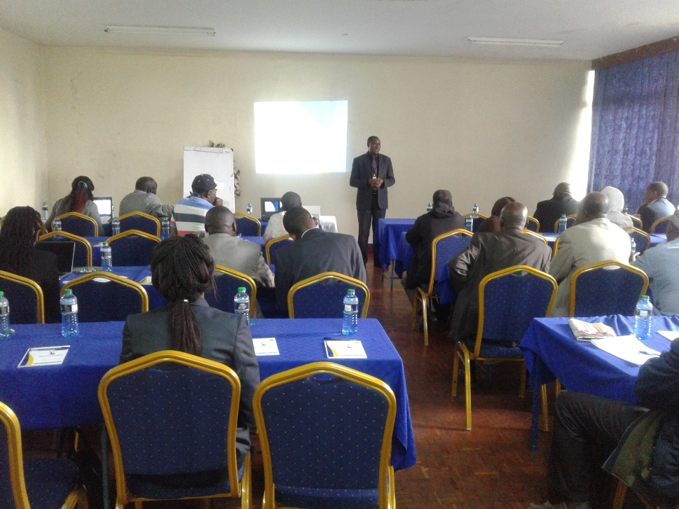

VENUE: STIMA MEMBERS CLUB, NAIROBI

DATE: 12TH SEPTEMBER 2018

MINUTES OF STAKEHOLDERS CONSULTATIVE MEETING FOR SAFEGUARD DOCUMENTS FOR KENYA ELECTRICITY SYSTEM IMPROVEMENT PROJECT (KESIP) HELD ON 12th SEPTEMBER 2018 AT STIMA MEMBERS CLUB, NAIROBI
Summary
The stakeholder consultative meeting was held to disclose and discuss the three environmental and social safeguards frameworks for KESIP. Participants were drawn from government agencies, civil society, Community based organizations (CBOs), Vulnerable and Marginalized Groups (IP/VMGs) and Indigenous People (IPs) representatives. The frameworks will outline how the potential environmental and Social impacts associated with the project will be addressed to ensure project sustainability.

The main issues addressed included: i) The components of the project which included power distribution lines, Power Distribution Substations, Customer connectivity, Slum electrification and technical support and capacity building. ii) The objectives of the project iii) Disclosure and discussion of the environmental and Social Safeguard frameworks (ESMF, RPF and IP/VMGF).

Kenya Power clarified that the project was guided by principles of the safeguard documents presented and various World Bank Operational Policies triggered. It was also clarified that the Transmission component for the project shall not be implemented by Kenya Power. The participants were informed that the company does not anticipate any kind of resettlement during construction phase of the project as the distribution lines would be constructed along road reserves while land acquisition for proposed substations would be on willing buyer will seller basis. Stakeholder involvement throughout the project phase would be transparent and inclusive for all communities affected.

During the presentation of the environmental and Social Safeguard frameworks, Kenya Power welcomed comments and suggestions from the stakeholders in relation to the proposed project and assured all in attendance that their proposals would be taken into consideration.

Stakeholders attending the meeting were in support of the project goals, objectives and mitigation measures proposed for potential environmental and social impacts of the project. Specific questions raised during the meeting are part of the minutes

AGENDA OF THE MEETING
- Preliminaries
- Overview of KESIP
- Plenary Session
- Vulnerable and Marginalized Groups Framework Presentation
- Plenary Session
- Environmental and Social Management Framework Presentation
- Plenary Session
- Resettlement Policy Framework Presentation
- Plenary Session
- A.O.B

MIN 1: 12/09/2018- Preliminaries
The meeting started at 0910hrs with welcoming remarks from Mr. Mwangangi who then asked one of the stakeholders to pray before commencement of the meeting. Mr. Mwangangi then laid down ground rules for the meeting to ensure that it was successful. The members were asked to introduce themselves and feel free to ask questions and give suggestions after presentations from Kenya Power team. Mr. Mwangangi also informed members that the meeting would involve presentations of Environmental and Social safeguard documents for KESIP and deliberations on the same and emphasized that the stakeholder suggestions would be put into considerations when improving the documents presented.

The Acting Manager; Network Management and Infrastructure Development-Eng. David Mwaniki gave the opening remarks for the meeting and welcomed all stakeholders and appreciated them for turning up on time and attending the meeting in large numbers. He informed the stakeholders that every development activity has an impact on our surrounding environments and thus environmental and social issues have to be discussed prior to project implementation. He also informed stakeholders that Kenya Power has the best interest of customers at heart and aims at supplying quality power to consumers. Eng. Mwaniki informed stakeholders that Kenya Power cannot achieve its mandate without collaborating with them, thus the meeting. He urged Kenya Power team of experts to emulate what has been done for KESIP when undertaking other projects.

MIN 2: 12/09/2018- Overview of KESIP
Eng. Njoroge informed stakeholders that World Bank had issued 250 Million USD for implementation of the project. 150 Million USD of the amount issued shall be used for implementation of the Last Mile component of the project while 100 Million USD shall be used for system reinforcement. He made it clear that the proposed project shall not have major environmental impacts as it will mainly involve construction of Low voltage lines which shall be done along road reserves.

Eng. Njoroge also informed the stakeholders that the project was on preliminary stages and the definite areas where the projects would be implemented had not yet been identified.

Mr. Koech clarified to the stakeholders that KESIP aims at improving power supply in Kenya and supplying power to all potential consumers. World Bank as a financier, in its requirements shall consider environmental and social concerns during implementation of the project. Thus, the meeting was held to create awareness about the project as well as seek stakeholder views. The views sort shall be addressed to ensure that the project is environmentally and socially sustainable.

MIN 3: 12/09/2018- Plenary Session
King Wario: We have both pre-paid and postpaid services, which one are we discussing today?
Fatuma Kitule: Do other Last Mile projects draw funding from the project we are discussing?
Mr. Otta: Will the public also be involved after identification of specific project sites?

The questions were responded to by Mr. Abaya, Eng. Mwaniki and Eng. Njoroge as follows:

Issues Raised | Response
Agenda of the meeting | To disclose the three Environmental and Social Safeguard Frameworks and seek the participants views and comments on how to improve them to ensure KESIP is implemented in an environmentally and Socially sustainable manner.
Funding of other Last mile projects | Other four Last mile projects are independent of KESIP bust have the same concept of increasing customer connectivity, system reinforcement and reduction of technical losses in the electrical infrastructure system.
Identification of specific project sites | The company was yet to identify the actual sites where the project would be implemented, and the Communities shall further be involved in the implementation process and Kenya Power will also avail more information about the project with time.

MIN 4: 12/09/2018- Vulnerable and Marginalized Groups Framework (IP/VMGF) Presentation
Mr. Abaya informed members that IP/VMGF is a requirement by World Bank as stipulated under Operational Policy 4.10 and is prepared to take care of the interests and rights of vulnerable and marginalized persons who might be affected during project implementation. The document highlights how Kenya Power shall interact with vulnerable and marginalized communities during implementation of the project to preserve their dignity and ensure equal representation during consultative processes.

Mr. Abaya also informed stakeholders that the document provides the need for incorporating vulnerable and marginalized people’s views during implementation process of the project as well as while addressing grievances. He emphasized that the main idea of focusing on the vulnerable and marginalized persons is to enhance project benefits to them and avoid potential diverse impacts and increased marginalization.

In addition, he informed members that the document was prepared as specific project sites had not been identified, thus it will act as a guide for Kenya Power in the event that such communities are found within the project area or are among those affected. Specific Vulnerable and Marginalized Plans will then be developed as and when required.

The presentation of IP/VMGF included purpose of IP/VMGF; screening process of IP/VMGF; social assessment of vulnerable and marginalized groups; policies and legal frameworks; methodology and consultations in preparation of IP/VMGF; potential negative and positive impacts of KESIP on vulnerable and marginalized persons; free, prior and informed consultations; vulnerable and marginalized groups plans; strategy for participation and consultation of the groups; grievance redress mechanisms; monitoring and reporting arrangements for IP/VMGs.

MIN 5: 12/09/2018- Plenary Session
After presentation of the Vulnerable and Marginalized Framework, stakeholders raised concerns, asked questions and gave suggestions that were responded to as highlighted below.
King Wario, Mr. Dida Said and Mr. Rop: The tribe I represent is not included in the list of marginalized groups in the document but since we are present in the meeting it is in order that we are incorporated in the list. Other vulnerable and marginalized communities not listed should also be concluded and the project seems to affect IPs and IP/VMGP how will we be involved in the project?
Mr. Chepsoi: Pastoralist communities have concerns with land ownerships as most of them are communally owned, an issue that can hinder compensation processes during project implementation.
Mr. Chepsoi: Who is the owner of Prior Informed Consent, KPLC or Affected communities?
Eunice Lepariyo and Mr. Chepsoi: Vulnerable and marginalized communities also have technical expertise in carrying out work during construction of lines thus they should be prioritized for employment opportunities during construction phase of the project.
Eunice Lepariyo: there is a lot of insecurity in areas occupied by vulnerable and marginalized groups, which mechanisms are you going to employ to ensure they equally benefit from the project?
Nanta Mpaajei: What criteria will be used in identification of specific area for project implementation without marginalization?
Nanta Mpaajei: will there be involvement of stakeholders during implementation phase to avoid conflicts?
Nanta Mpaajei: What forms of compensation are you going to implement especially among people with communally owned land?
Nanta Mpaajei: When project passes through a communally owned land, is there a way of considering people who cannot afford the Kshs.15,000 connection fee?
Mr. Salau Rogei: it is high time Kenya Power considers benefit sharing with vulnerable and marginalized communities to prevent continued exposure to poverty even when projects are implemented on their communally owned land.
Mr. Solola: What mitigations do you have in place to ensure safety of electricity supplied to vulnerable and marginalized communities?
Please explain the additional taxes that appear on the electricity token purchase receipt.
Representatives of stakeholders currently in the meeting are in most cases excluded from further meetings during project implementation thus making it difficult for them to continue disseminating information about the project to the communities.
Mr. Mohamed: some projects are launched by Kenya Power but fail to be implemented in areas where they are launched thus making us feel marginalized such as the case of KOSAP.
The questions and concerns raised during the plenary session were answered as follows:

Concern Raised | Response
Public Consultation process | This is the very first consultation done for the proposed KESIP and a series shall follow during implementation process based on arrangements with affected communities
Involvement of stakeholder representatives | Stakeholder representatives present during the first meeting shall continuously be involved in subsequent meetings at community levels during project implementation.
Employment opportunities | The host community shall be given first priority during employment especially for semi-skilled labor and contractors shall be made aware of the requirement as Kenya Power has always done.
Inclusion of Vulnerable and Marginalized communities | As per the constitution of Kenya, only 14 counties are recognized to have vulnerable and marginalized communities, but Kenya Power is moving beyond the constitutionally recognized communities and that is why communities not listed in the constitution of Kenya are also invited to the meeting.  Some of the communities present today, although not in the list of vulnerable and Marginalized groups they do come from the mentioned counties hence they are covered and that is why KPLC welcomed them to the meeting
Destruction of vegetation cover | In areas with dense vegetation cover, the project can always be redesigned to ensure Kenya Power projects do not result into intense loss of vegetation cover
Grievance redress | In cases of grievances there will be methods for redress while involving communities. Thus Kenya Power shall highly work with communities to ensure their grievances are addressed in timely and satisfactory manner.  The company shall try to avoid areas that face land injustices until such a time that they are resolved
Prior Informed Consent | Prior Informed Consent shall be consultative between Kenya Power and Affected Communities. It will be an open and transparent process
Resettlement and Compensation | The proposed project shall mainly involve construction of low voltage lines and substations thus the company does not anticipate any form of resettlement to take place as the lines shall be constructed along road reserves and land for construction of substations shall be acquired on a willing buyer willing seller basis.  Do not associate land ownership and power connection. But for community lands affected by Kenya Power projects, the entire community shall be involved in negotiation process
What is the status of implementation of Kenya Off-grid Solar Access Project (KOSAP) | KOSAP is an ongoing project though still in preliminary stages.

MIN 6: 12/09/2018-Environmental and Social Management Framework (ESMF) Presentation
Mr. Koech while presenting ESMF document, highlighted the environmental and social impacts of the project to stakeholders. He went on and informed members that there shall be extensive stakeholder engagement at various stages of project implementation where informed consent shall be sought for access and wayleave acquisition among others. Mr. Koech also informed members that important bird areas shall be identified, and appropriate measures will be put in place to prevent negative impacts of the project on migratory bird routes.

The ESMF document presentation included background information of the proposed project, Purpose and objectives of ESMF, World Bank operational policies that will be triggered by the project, potential environmental and social impacts, mitigation measures, public consultation and participation and grievance redress mechanism.

Major social and environmental impacts are not anticipated during implementation of the project as it shall not have direct impacts on stakeholders’ means of livelihood and property.

MIN 7: 12/09/2018- Plenary Session
The session involved questions, suggestions, clarifications and response to raised concerns from stakeholders. Stakeholders and Kenya Power team of experts engaged extensively in a discussion on ESMF document presented. Questions and suggestions raised during the session are highlighted below while responses are presented on a table below.
Mr. Mchombo: insufficient public awareness has been done by Kenya Power in off grid areas thus consumers are not aware of requirements of electricity safety and safe connections
Mr. Kiptum from Nature Kenya: Kenya Power to adopt international best practices to mitigate impacts of transmission lines on birds.
Kenya Power to do sensitivity mapping during project implementation to ensure that important bird areas are protected.
Kenya Power in compensating trees that are cut during project implementation should ensure planting of similar tree species.
Representative of Kifundi Community: Kenya Power to help the Kifundi Community with fishing equipment as their main economic activity is fishing.
Mr. Faten Hassan: Compensation process should be transparent to allow affected communities understand the how valuation is done and the amount of money paid for lost property.
Kenya Power to be transparent on implementation process of projects as some projects were launched in vulnerable and marginalized communities’ areas but were never implemented.
Mr. Juma from National Museums of Kenya: Does Kenya Power compensate underground artifacts, heritage sites and burial sites?
There is need for Kenya Power to carry out heritage impact assessment
Kenya Power is concerned about accessibility of power but what about affordability?
Kenya Power should consider non-monetary compensations that benefit an entire community.
Ruth Kariuki from Communication Authority of Kenya (CAK): It would be good for Kenya Power to liaise with Communications Authority of Kenya while identifying proposed project sites to enable CAK construct masts in areas with electricity accessibility thus minimizing continued use of generators.
Mr. Muthusi from KURA: World Bank is transitioning from safeguards to standards, yet the document presented still make reference to safeguards. What is the position?
Mr. Moindi of KETRACO: Kenya Power projects to be designed in such a way that they are integrated to minimize impacts of construction of distribution lines on environment.
Expand the component of capacity building to other stakeholders.
Dorothy Kahiu from Ministry of Energy: there is a SEA process going on to map sensitive bird areas thus Kenya Power should acquire information from the report.
What is the relationship between KOSAP and KESIP?
Mr. Ali Mohamed and Mr. Dadi Said: There are many incidences of houses and electrical equipment loss due to electrical faults.
Qsn: we need to have policies on how to compensate people occupying community lands in a satisfactory manner
Mr. Ronoh from ERC: Kenya Power should always submit commencement and completion certificates for projects undertaken to ERC
It is advisable that Kenya Power used licensed or registered electricians and electrical contractors while undertaking their projects
It is also important that Kenya Power supervise implementation of their projects to ensure that they are undertaken as stipulated.
Mr. Koech and Mr. Thiaine responded to questions, suggestions and concerns raised thus:

Issues raised | Response
Electrical Safety and Accident Reporting and Awareness creation | Danger signs placed on electric poles are meant to warn the public on danger of electricity as it is transmitted through the conductors and supporting infrastructure including poles, stay wires, earthings and the wayleave trace for the power line.  In mitigating electrical accidents, Kenya Power carryout safety awareness in regions through roadshows, media adverts, public barazas and school visits  In case of electrical accidents, first report to Kenya Power offices via a designated phone number 9551/0703070707 and give your details as required, then a safety engineer shall be sent to your location to investigate the accident to determine the cause of accident
SEA on important bird areas | Suggestions for Kenya Power to refer to the ongoing SEA is good and shall be beneficial to the company while carrying out projects
Compensation of community land | Implementation of non-monetary compensation is also a good idea especially in the event community assets are affected in order maximize project benefit to the entire community.
Compensations for artifacts | As a matter of policy KPLC endeavors to avoid such areas e.g. graves and work with community members in identification of such sites. Other cultural property of national importance in case of chance find due process is followed through contacting the National Museums of Kenya
Integration of projects | The need for integration of power lines is a good idea and Kenya Power has embraced integration of lines in many parts of the country as it helps minimize on need for wayleave. This will continue and is always subject to technical feasibility before implementation.
KOSAP and KESIP | KOSAP is meant for off-grid areas, especially those not connected to national grid while KESIP is meant to connect the last customer and increase connectivity within National grid as well as improvement and stabilization of the power network

MIN 8: 12/09/2018-Resettlement Policy Framework (RPF) Presentation
It is a requirement by the World Bank operational policy 4.12 on Involuntary Resettlement to try and avoid resettlement. Consequently, Kenya Power prioritizes implementation of projects in unoccupied or less dense areas to minimize chances of involuntary resettlement. However, the framework has been prepared as a precaution in the event that any resettlement was to occur during project implementation. On the other hand, the kind of reports that accompany resettlement would vary based on the potential damages and number of people affected.

In an instance that only property is affected but not persons, a resettlement action plan is not prepared. When a few people -less than 200- are involuntarily displaced as a result of the project, then an abbreviated Resettlement Action Plan is prepared. While carrying out resettlement, public consultation is done where project affected persons are invited to a meeting at a convenient place and continuous consultations are carried out.

As already alluded to, KESIP will involve construction of Distribution Lines which will use the road reserve and therefore resettlement is not envisaged. Land for substation shall be purchased on a willing buyer willing seller basis.

The presentation included the purpose of the RPF, objectives of the RPF, methodology for RPF preparation; potential impacts; eligibility for compensation; valuation methods for compensation; resettlement action plans (RAP); stakeholder consultation and participation; RPF implementation; RPF implementation and monitoring; implementation budget and the grievance redress mechanism

MIN 9: 12/09/2018- Plenary Session
Mr. Ali Mohammed: we occasionally experience delays while purchasing electricity tokens and Kenya Power contact lines are also unreliable.
Question: During power connection, when I apply and pay for connection does other customers have to be connected first before I am connected in a case where we are many people without power connection occupying the same area?
Mr. Mohammed: There is an electricity supply project in Tana River that stalled after we were asked to purchase meter boxes and stay wires and await connection.

The concerns raised were addressed by Mr. Mwangangi as follows:

Issue Raised | Response
Delays | Delays only occur when there is technical hitch on the system however Kenya Power system for token purchase is instant and no delays are experience since its improvement
Power connection | Connection is done to customers who apply for the service and pays for the connection cost as provided in the quotation.
Stalled Projects | The stakeholders were requested to provide more details on the stalled projects including the locations, and their contact numbers after which Kenya Power would investigate the cause and where possible progress the projects.

MIN 10: 12/09/2018- Way forward
- The participants were assured that their comments from would be incorporated to improve the three documents i.e. ESMF, RPF and IP/VMGF.
- Once the sites are identified the necessary environmental and social documents will be prepared guided by the three documents (ESMF, RPF, and IP/VMGF)
- Other departments within KPLC concerned with identification and selection routes for the distribution lines should adhere to the principles outlined in the three frameworks.
- Specific project affected persons would be consulted throughout the project phases once the project sites are identified.
- The project proponent, Project Affected Persons and other stakeholders should adhere to the Grievance Redress Mechanism (GRM) prepared for the specific project and utilize all the provided options in the GRM in a systematic manner.

MIN 11: 12/09/2018- A.O.B and Closing Remarks
Mr. Mwangangi informed stakeholders that World Bank was aware of meeting although they were not able to attend due to other engagements.
Mr. Mwangangi also informed members that the documents presented to stakeholders shall be updated to incorporate their views, comments and minutes and will be posted on Kenya Power and World Bank websites.
King Wario from Myoyoya community appreciated Kenya Power for inviting the Vulnerable and Marginalized communities to the meeting and requested that next time the company should consider having the meeting for two days to allow for more understanding and comprehension of the concept. He also informed Kenya Power that representatives of vulnerable and marginalized stakeholders have accepted the project and shall inform the communities of the same.
Eng. Njoroge also appreciated stakeholders for attending the meeting and openly expressing their views on the project. He assured them that their views shall be taken into consideration and the company shall ensure that the project is implemented satisfactorily.

Adjournment
There being no other business the meeting was adjourned at 1620hours with a word of prayer from one of the stakeholders.

Photo Gallery

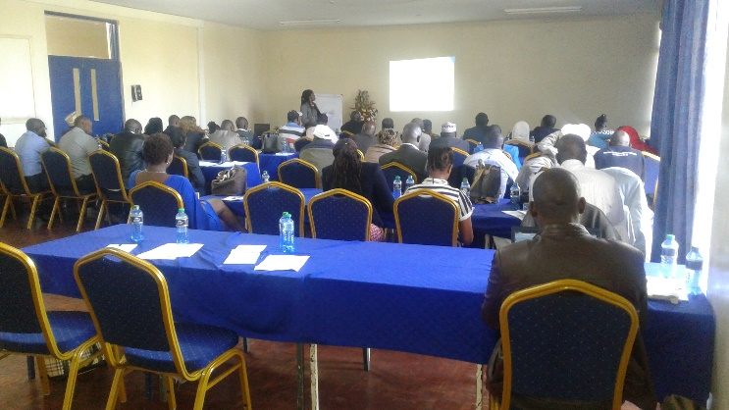 | 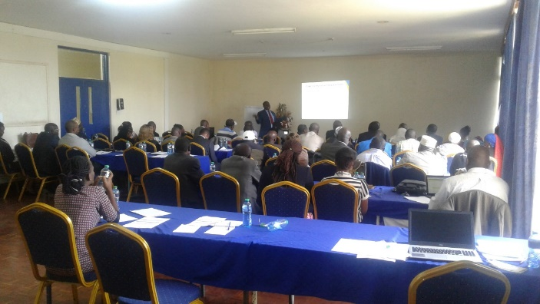
RPF presentation by Socio economist | ESMF presentation by Environmental & Social Specialist
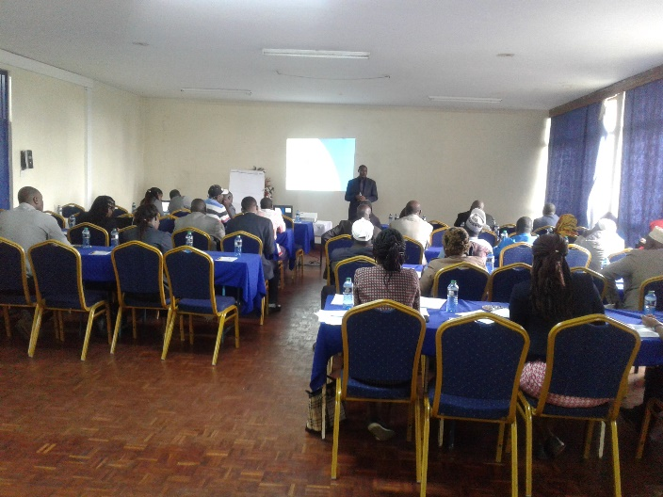 | 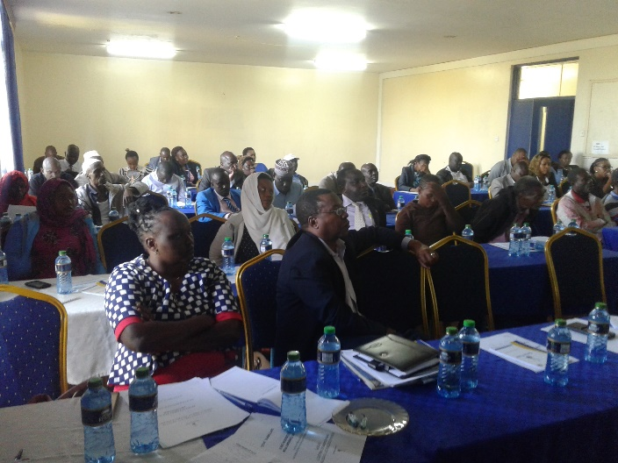
GM Network Mgt & Infrastructure addressing Stakeholders | Stakeholders keenly following proceedings during stakeholder consultation forum
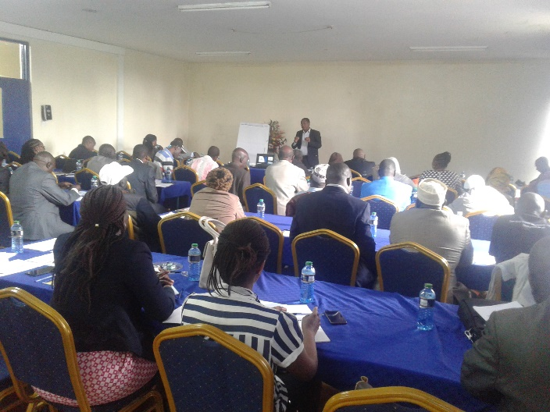 | 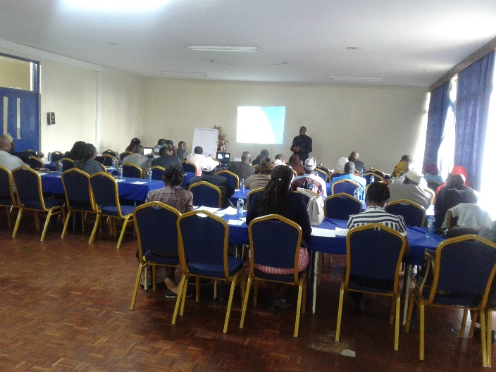
Chief Engineer Projects addressing participants

List of Attendance
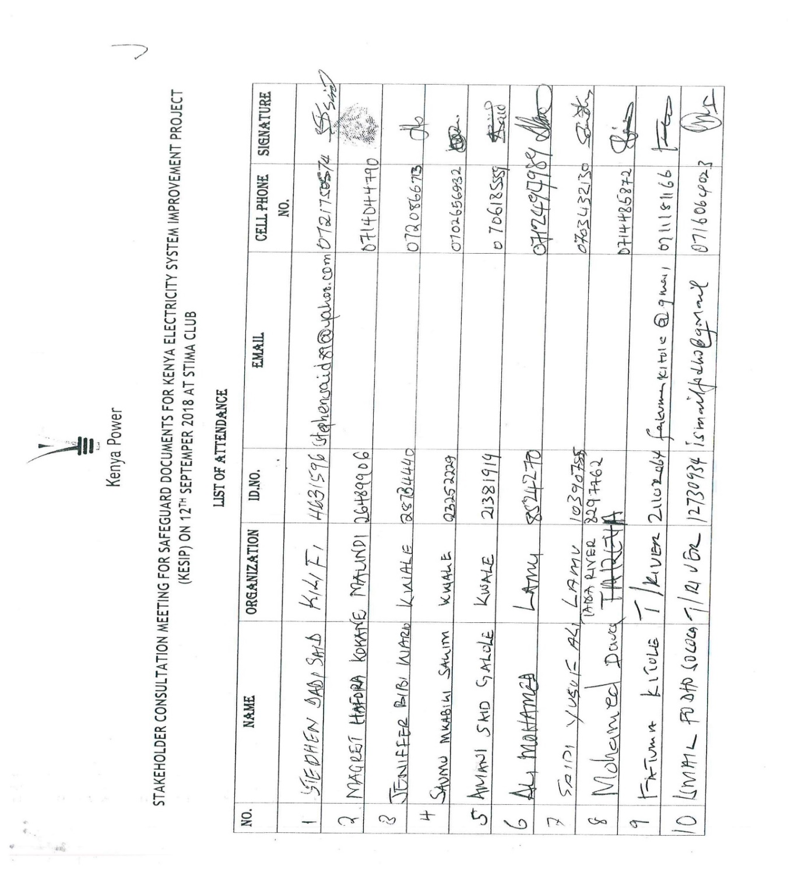
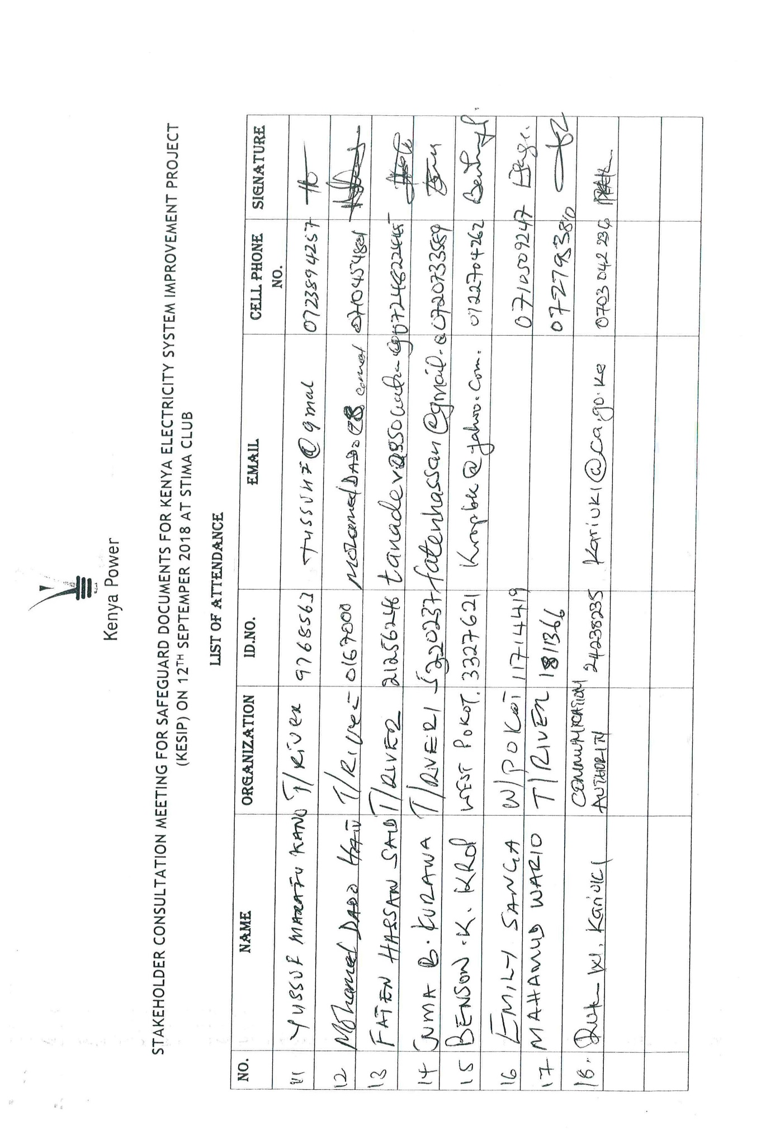
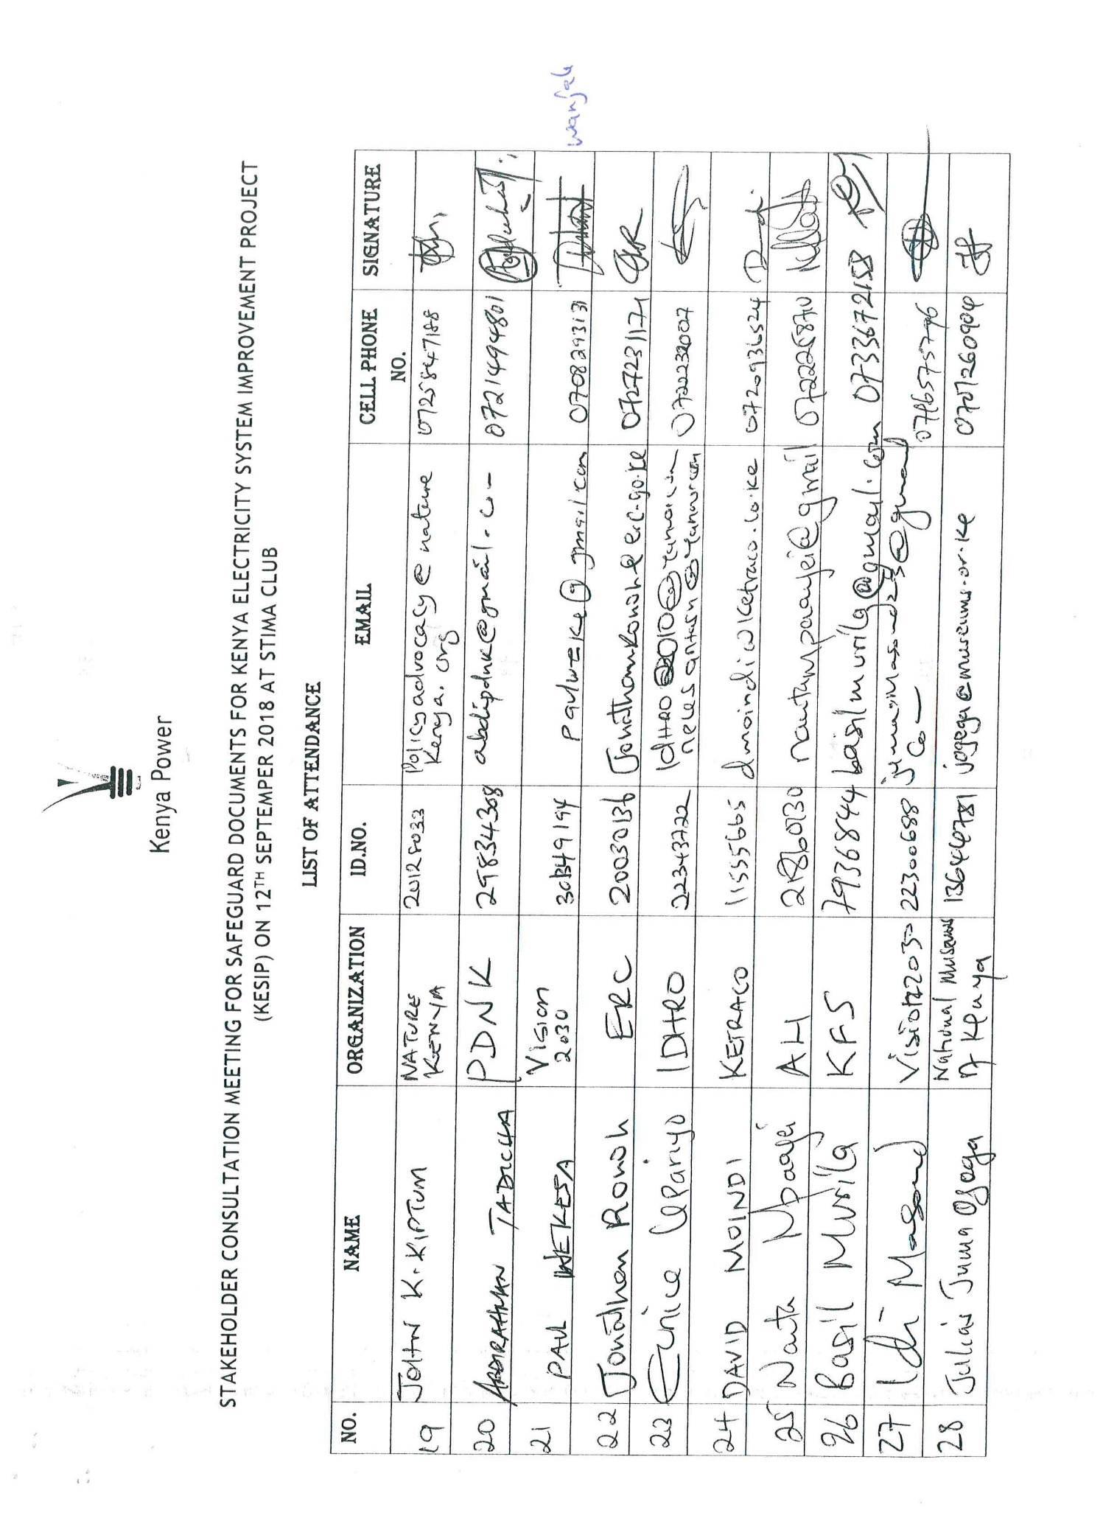
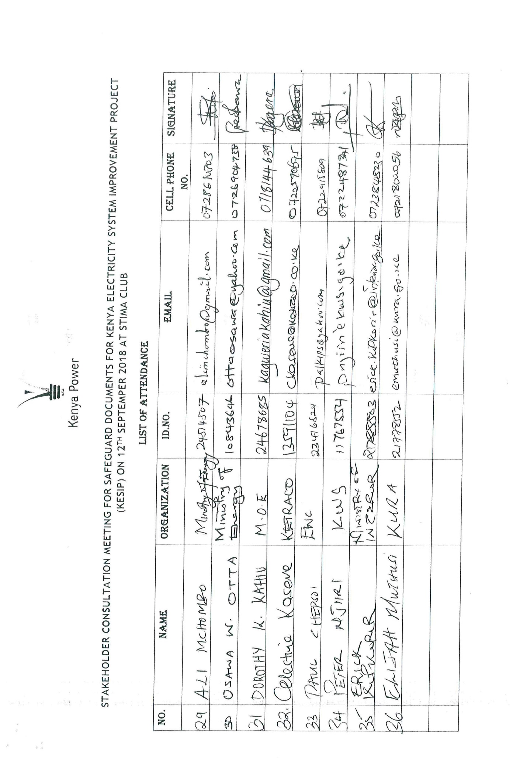
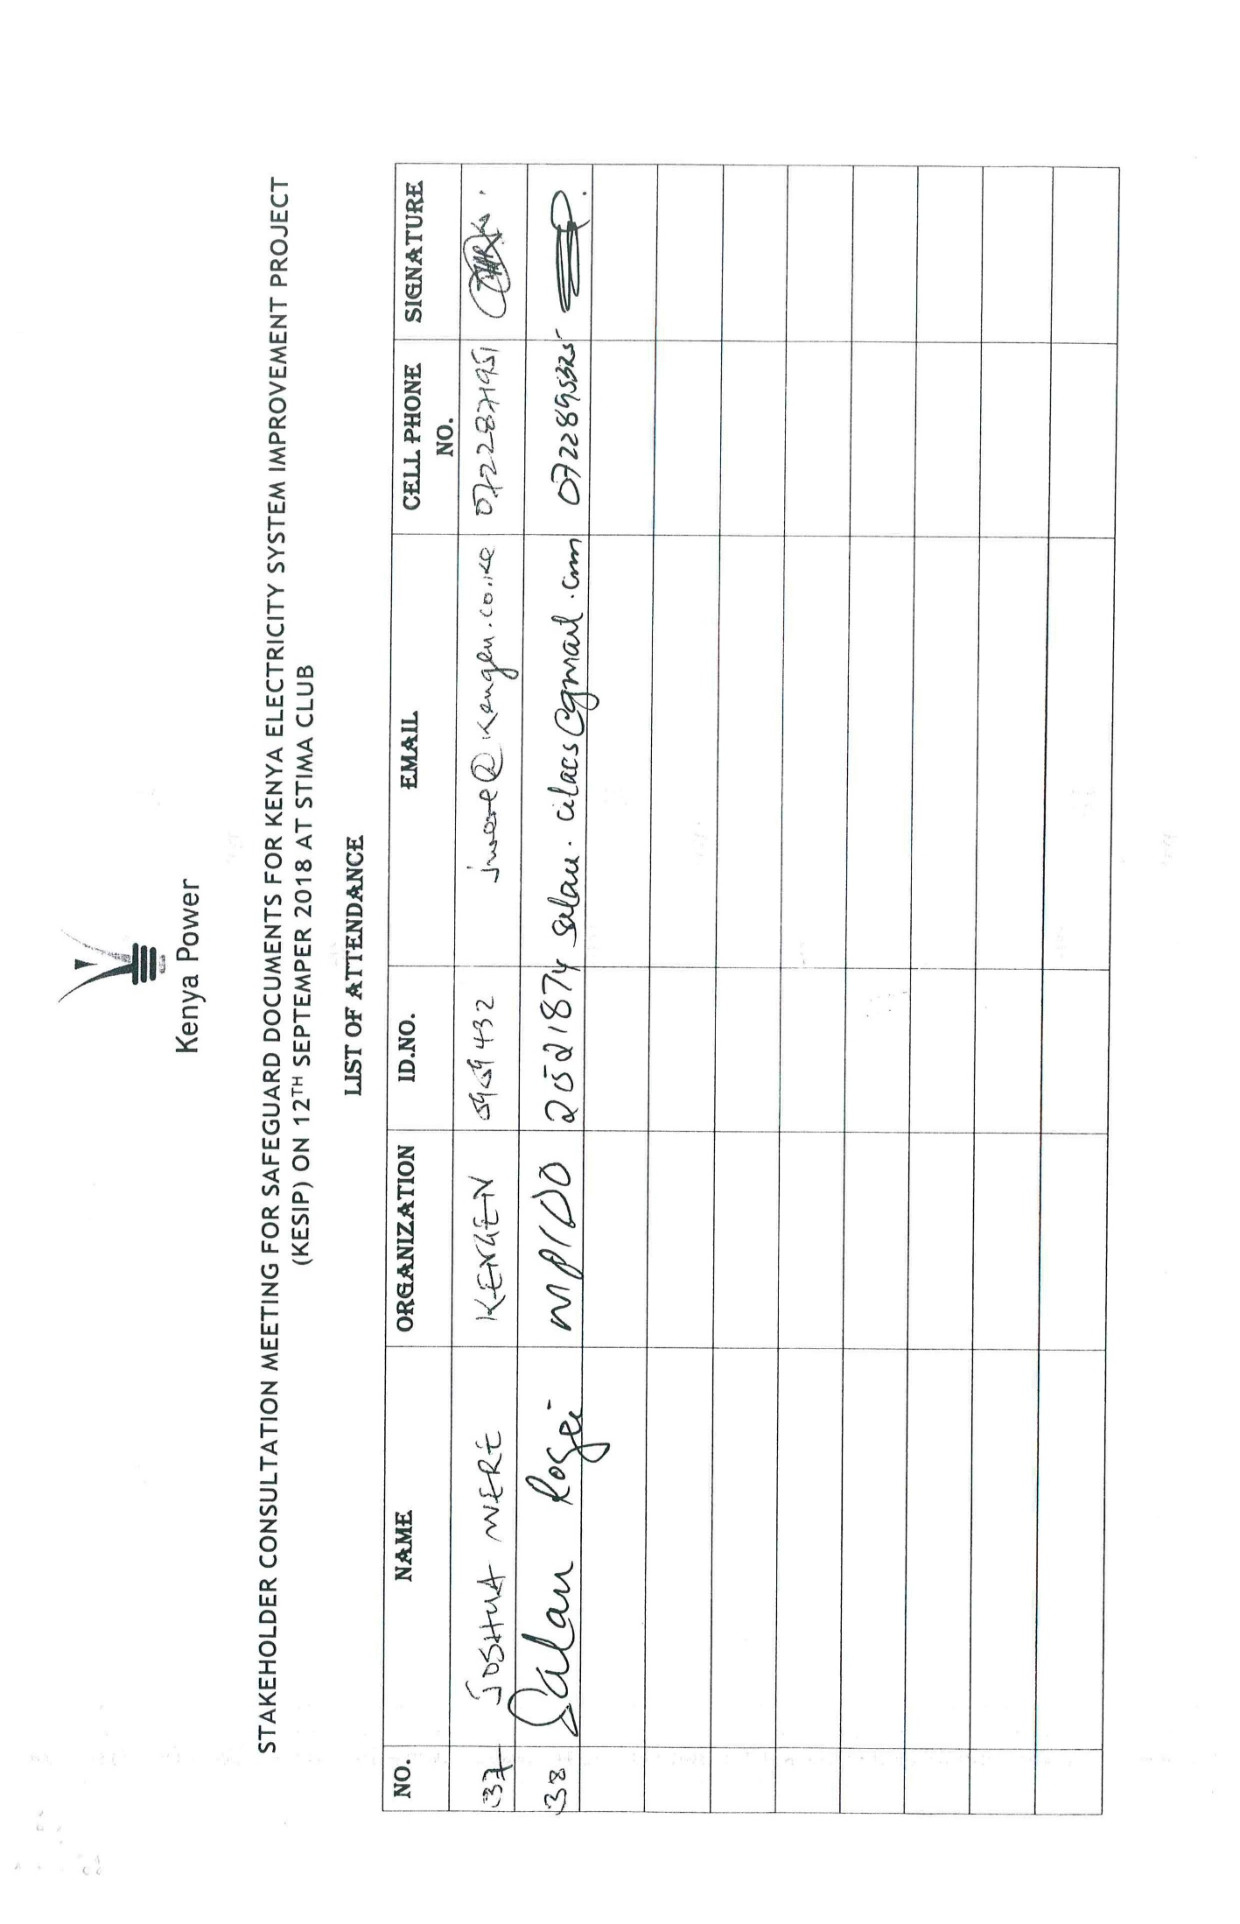
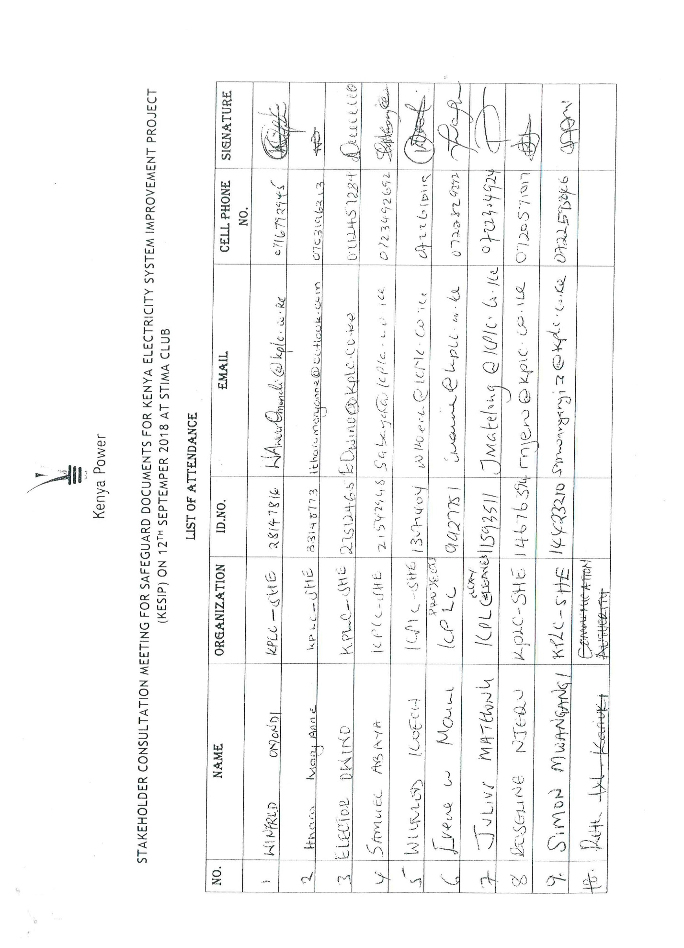

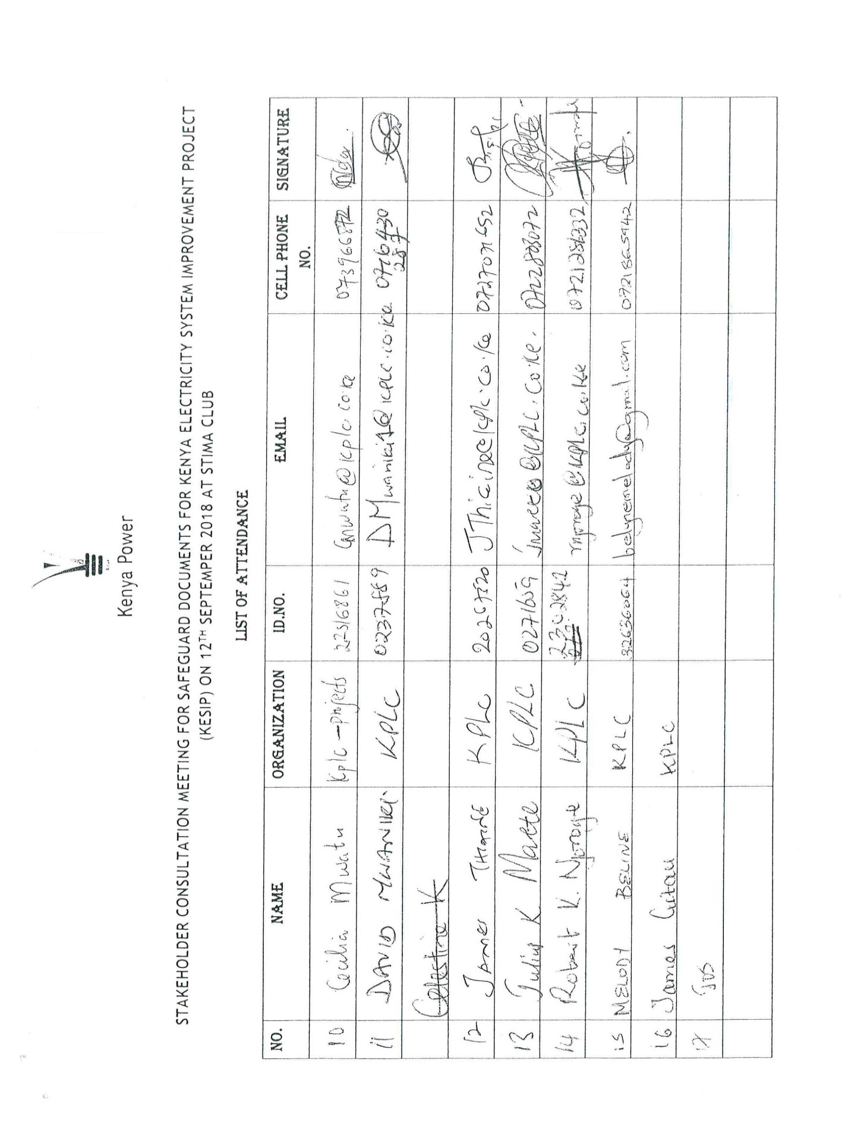

REFERENCES
- ‘The hunter-gatherer “revisionist” debate’, Anthropology Today 8(2): 13-17.1992.
- ‘The past and present of hunter-gatherers in Kenya’, Kenya Past and Present, 25: 39-45.
- ‘When will we be people as well? Social identity and the politics of cultural performance: the case of the Waata Oromo of East and Northeast Africa’, Social Identities 6(2): 189-206.\1911.
- ‘Notes on the Wa-Sania’, Journal of the Royal Anthropological Institute 41: 29-39.
- African Commission’s Working Group of Experts on Indigenous Populations & Communities ACHPR 2005: 114).
- Amin, M. The Beautiful People of Kenya. Nairobi, Kenya: 1989.
- Anderson, Dave (2002) Eroding the Commons: The Politics of Ecology in Baringo, Kenya, 1890-1963; James Currey.
- Anonymous (2001). Ogiek: Evicted and displaced. Nomadic News 2001(1):17.
- Anonymous (n.J.) The Okiek of Kenya. http://www.ogiek.org/indepth/Okiek.pdf.
- Bashuna, A.B. 1993. ‘The Waata, hunter-gatherers of Northern Kenya’, Kenya Past and Present 25: 36-38.
- Bassi, M. 1997. In Barich, B.E. & M.C. Gatto (eds.). ‘Hunters and pastoralists in East Africa: the case of the Waata and Oromo-Borana’, in Dynamics of populations movements and responses to climatic change in Africa. Rome: BonisgnoriEditore, pp. 164-176.
- Baxter, P.T.W. 1983. ‘The problem of the Oromo, or the problem for the Oromo?, in Lewis, I.M. (ed.). Nationalism and self-determination in the Horn of Africa. London: Ithaca Press, pp. 129-147.
- Beachey, R.W. 1967. ‘The East African ivory trade in the nineteenth century’, Journal of African History 2: 1-11.
- Blackburn, R. (1974) The Okiek and their History, Azania vol 9:132-153.
- Blackburn, R. (1976) Okiek history. In B. A. Ogot (ed.), Kenya before 1900. Nairobi: East African Publishing House.
- Blackburn, R. (1982) in the land of milk and honey. In E. B. Leacock and R. B. Lee (eds.), Politics and history in band societies, pp. 283-305. Cambridge: Cambridge University Press.
- Bodley, J.H. 1988. ‘Editorial comment to Maybury-Lewis’, in Bodley, J.H. (ed.) Tribal peoples and development issues.A global view. Mountain View, Ca.
- Cerulli, E. 1922. ‘The folk literature of the Galla of Southern Abyssinia’, Harvard African Studies III, Varia Africana. Cambridge, Mass. Pp. 11-228.
- Chang, C. 1982. ‘Nomads without cattle: East African foragers in historical perspective’, in Leacock, E. & R. Lee (eds.). Politics and history in band societies. Cambridge: CUP, pp. 269-282.
- Coldham, S. 1978. The effect of registration of title upon customary land rights in Kenya, J. African Law, 22(2): 91 - 111.
- Constitution of Republic of Kenya, 2010
- Dalleo, P.J. 1979. ‘The Somali Role in Organized Poaching in Northeastern Kenya, c. 1909-1939’, International Journal of African Historical Studies 12 (3): 472-482
- ERMIS Africa Ethnographic Survey of Marginalized Groups, 2005-2012
- Fedders, A. and C. Salvadori. Peoples and Cultures of Kenya. Nairobi, Kenya: Transafrica Book Distributors, 1979.
- Forthcoming. Black Poachers, White Hunters. London: James Currey.
- Stiles, D. 1981. ‘Hunters of the Northern East African coast: origins and historical processes’, Africa, 51(4): 848-61.
- Forthcoming. The Waata. Halle: Max Planck Institute
- Foucault, M. 1980. Knowledge/power. Selected interviews and other writings 1972-1977, edited by C. Gordon. London: Harvester Wheatsheaf
- Francis, Paul &Amuyunzu-Nyamongo, Mary (2005) Bitter harvest: The social costs of state failure in rural Kenya. Paper presented at the workshop “New Frontiers of Social Policy: Development in a Globalizing World” Arusha / Tanzania12th-15thof December, 2005.
- Galaty, J. 1986. ‘East African hunters and pastoralists in a regional perspective; an “ethnoanthropological” approach’, Sprache und Geschichte in Afrika 7(1): 105-31
- Gloor,Rolf (1986) IlChamus-Njemps;Zetzwil,Switzerland:Schüch-Verlag, 1986
- Government of KenyaKenya’s Vision 203
- Government of Kenya, 2012, Land Act, Government Printers
- Hastrup, K. & P. Elsass. 1990. ‘Anthropological advocacy. A contradiction in terms?’ Current Anthropology 31(3): 301-311.
- Heine, B. 1981. The Waata Dialect of Oromo. Grammatical Sketch and Vocabulary. Language and Dialect Atlas of Kenya, 4. Berlin: Dietrich Reimer Verlag.
- Henriksen, G. 1985. ‘Anthropologists as advocates: promoters of pluralism or makers of clients?’, in Paine, R. (ed.). Advocacy and anthropology. St. John’s: Institute of Social and Economic Research, Memorial University of Newfoundland.
- Hobley, C.W. 1912. ‘The Wa-Langulu or Ariangulu of the Taru Desert’, Man 8-9: 18-21.
- Holman, D. 1967. The Elephant People. London: John Murray
- Huntingford, G. W. B. (1929). Modern hunters: some account of the Kamelilo -KapchepkendiDorobo (Okiek) of Kenya colony. Journal of the Royal Anthropological Institute 59:333-76
- Huntingford, G. W. B. (1954). The political organization of the Dorobo.Anthropos 49:123-48.
- Huntingford, G.W.B. 1955. The Galla of Ethiopia.The kingdoms of Kafa and Janjero. London: C. Hurst and Company
- Identities on The Move: Clanship and Pastoralism in Northern Kenya. Nairobi, Kenya: Gideon S Were Press, 1994.
- Ingold, T. 2000. The perception of the environment. Essays on the livelihood, dwelling and skill. London: Routledge.
- Kassam, A. 1986. ‘The Gabbra pastoralist/Waata hunter-gatherer symbiosis: a symbolic interpretation’, Sprache und Geschichte in Afrika 7(1): 189-204.
- Kassam, A. and G. Megerssa. 1994. Aloof alollaa: the inside and the outside. Booran Oromo environmental law and methods of conservation’, in Brokensha, D. (ed.). A river of blessings: essays in honor of Paul Baxter. Syracuse, New York: Maxwell School of Citizenship and Public Affairs, pp. 85-98.
- Kenny, M. 1981. ‘A mirror in the forest’. The Dorobo hunter-gatherers as an image of the other’, Africa 51 (1): 477-495.
- Kenrick, J. 2001. ‘Present predicament of hunter-gatherers and former hunter-gatherers of the Central African rainforests’, in Barnard, A. & J. Kenrick (eds.). Africa’s Indigenous Peoples: ‘First Peoples’ or ‘Marginalized Minorities’? Edinburgh: Centre of African Studies, pp. 39-59.
- Kenya Human Rights Commission. 2002. The Forgotten People Revisited. Human rights abuses in Marsabit and Moyale districts. Nairobi: KHRC.
- Kotile, D.G. 2002. ‘Victims of the Ethiopian government raids on the Moyale-Kenya/Ethiopia border: calculated political strategies?’, Journal of Oromo Studies 9(1-2): 1-26.
- Lamphear, J. 1986. ‘The persistence of hunting and gathering in a “pastoral” world’, SUGIA, 7(2).
- Legesse, A. 1983. Gada. Three approaches to the study of African society. New York: Free Press.
- Marginalisation of the Waata Oromo Hunter–Gatherers of Kenya: Insider and Outsider Perspectives AneesaKassam and Ali BallaBashuna
- Maybury-Lewis, D. 1988. ‘A special sort of pleading’ in Bodley, J.H. (ed.) Tribal peoples and development issues. A global view. Mountain View, Ca. pp. 375-390.
- Megerssa, G. 1993. 1993. Knowledge, identity and the colonizing structure: the case of the Oromo of East and Northeast Africa’, Ph.D dissertation, University of London, School of Oriental and African Studies.
- Minority Rights Group International, World Directory of Minorities and Indigenous Peoples-Kenya: Hunter-gatherers, November 2012, available at: http://www.refworld.org/docid/49749cf84a.html [accessed 8 January 2015]
- Nash, R. F. 2001 [1967]. Wilderness and the American Mind. New Haven: Yale University Press. 4th edition.
- Organization for the Development of Lamu Communities
- Parker, I. & M. Amin. 1983. Ivory crisis. London: Chatto and Windus.
- Robinson, P.W. 1985. ‘Gabra nomadic pastoralism in nineteenth and twentieth century northern Kenya: strategies for survival in a marginal environment’, Ph.D. dissertation, Northwestern University.
- Saugestad, S. 2001. ‘Contested images: “first peoples” or “marginalized minorities” in Africa?’, in Barnard, A. & J. Kenrick (eds.). Africa’s Indigenous Peoples: ‘First Peoples’ or ‘Marginalized Minorities’? Edinburgh: Centre of African Studies, pp. 299-322.
- Sheriff, A. 1987. Slaves, spices and ivory in Zanzibar. Oxford: James Currey.
- Singer, M. 1990. ‘Another perspective on advocacy’, Current Anthropology 31(5): 548-550.
- Sobania, N. 1979. ‘Background History of the Mt. Kulal Region of Kenya’, UNESCO/UNEP Integrated Project in Arid Lands (IPAL) Technical Report A-2.
- ‘Pastoralist migration and colonial policy: a case study from northern Kenya’, in D.H. Johnson and D.M. Anderson. The Ecology of Survival. Case Stides from Northeast African History. London: Lester Crook Academic Publishing, pp. 219-239. 1988.
- ‘Social relationships as an aspect of property rights: Northern Kenya in the precolonial and colonial periods’, in Baxter, P.T.W. and R. Hogg (eds.). Property, poverty and people: changing rights in property and problems of pastoral development. Manchester: International Development Centre, University of Manchester, pp. 1-19.
- Spear, T. & R. Waller (eds.). 1993. BeingMaasai. London: James Currey.
- Steinhart, E. I. 1989. ‘Hunters, poachers and gamekeepers: towards a social history of hunting in colonial Kenya’, Journal of African History 30: 247-264.
- Spencer, P. Nomads in Alliance - Symbiosis and growth among the Rendille and Samburu of Kenya. London: Oxford University Press, 1973.
- Spencer, P. 1973. Nomads in Alliance. Oxford: OUP. 1993.
- Van Zwanenberg, R. 1976. ‘Dorobo hunting and gathering: a way of life or a mode of production?’ African Economic History 2: 12-24.
- Stauffacher, G. Faster Beats the Drum. Kijabe: Kesho Press, 1977.
- Tablino, P. Christianity Among the Nomads - The Catholic Church in Northern Kenya. Limuru: Paulines Publications Africa, 2004.
- The Gabra - Camel Nomads of Northern Kenya. Limuru: Paulines, 1999.
- UN Human Rights and Indigenous Issues: 92
- Unreached People of Kenya Project, Turkana Report. Nairobi, Kenya: Daystar Communications, 1982.
- Woodburn, J. 2001. ‘The political status of hunter-gatherers in present-day and future Africa’, in Barnard, A. & J. Kenrick (eds.). Africa’s Indigenous Peoples: ‘First Peoples’ or ‘Marginalized Minorities’? Edinburgh: Centre of African Studies, pp. 1-14.
- World Bank 2011, Implementation of the World Bank’s Indigenous Peoples Policy A Learning Review (FY 2006-2008)
- World Bank Country Partnership Strategy (CPS) for Kenya (March 2010-2012).
- World Bank Indigenous Peoples Policy OP. 4.10

Sessional Paper No. 3 of 2009, Ministry of Lands
The Land Act No. 6 of 2012, the Land Registration Act No. 3 of 2012, and the National Land Commission Act No. 5 of 2012.
This benefit will only be realized if children are guided on the programs to watch and if they do not spend a lot of time sedentary glued to the screen.
Adapted from UN Permanent Forum on Indigenous Interests (UNPFII), the Tebtebba Foundation, the International Indian Treaty Council and others.
In addition to any coverage of VMGs areas by the national grid and/or KOSAP, KESIP will strive to accelerate coverage of VMGs areas with electricity connection as part of its mandate under component 1, with a view to achieving the governments universal electricity access by 2022.

